
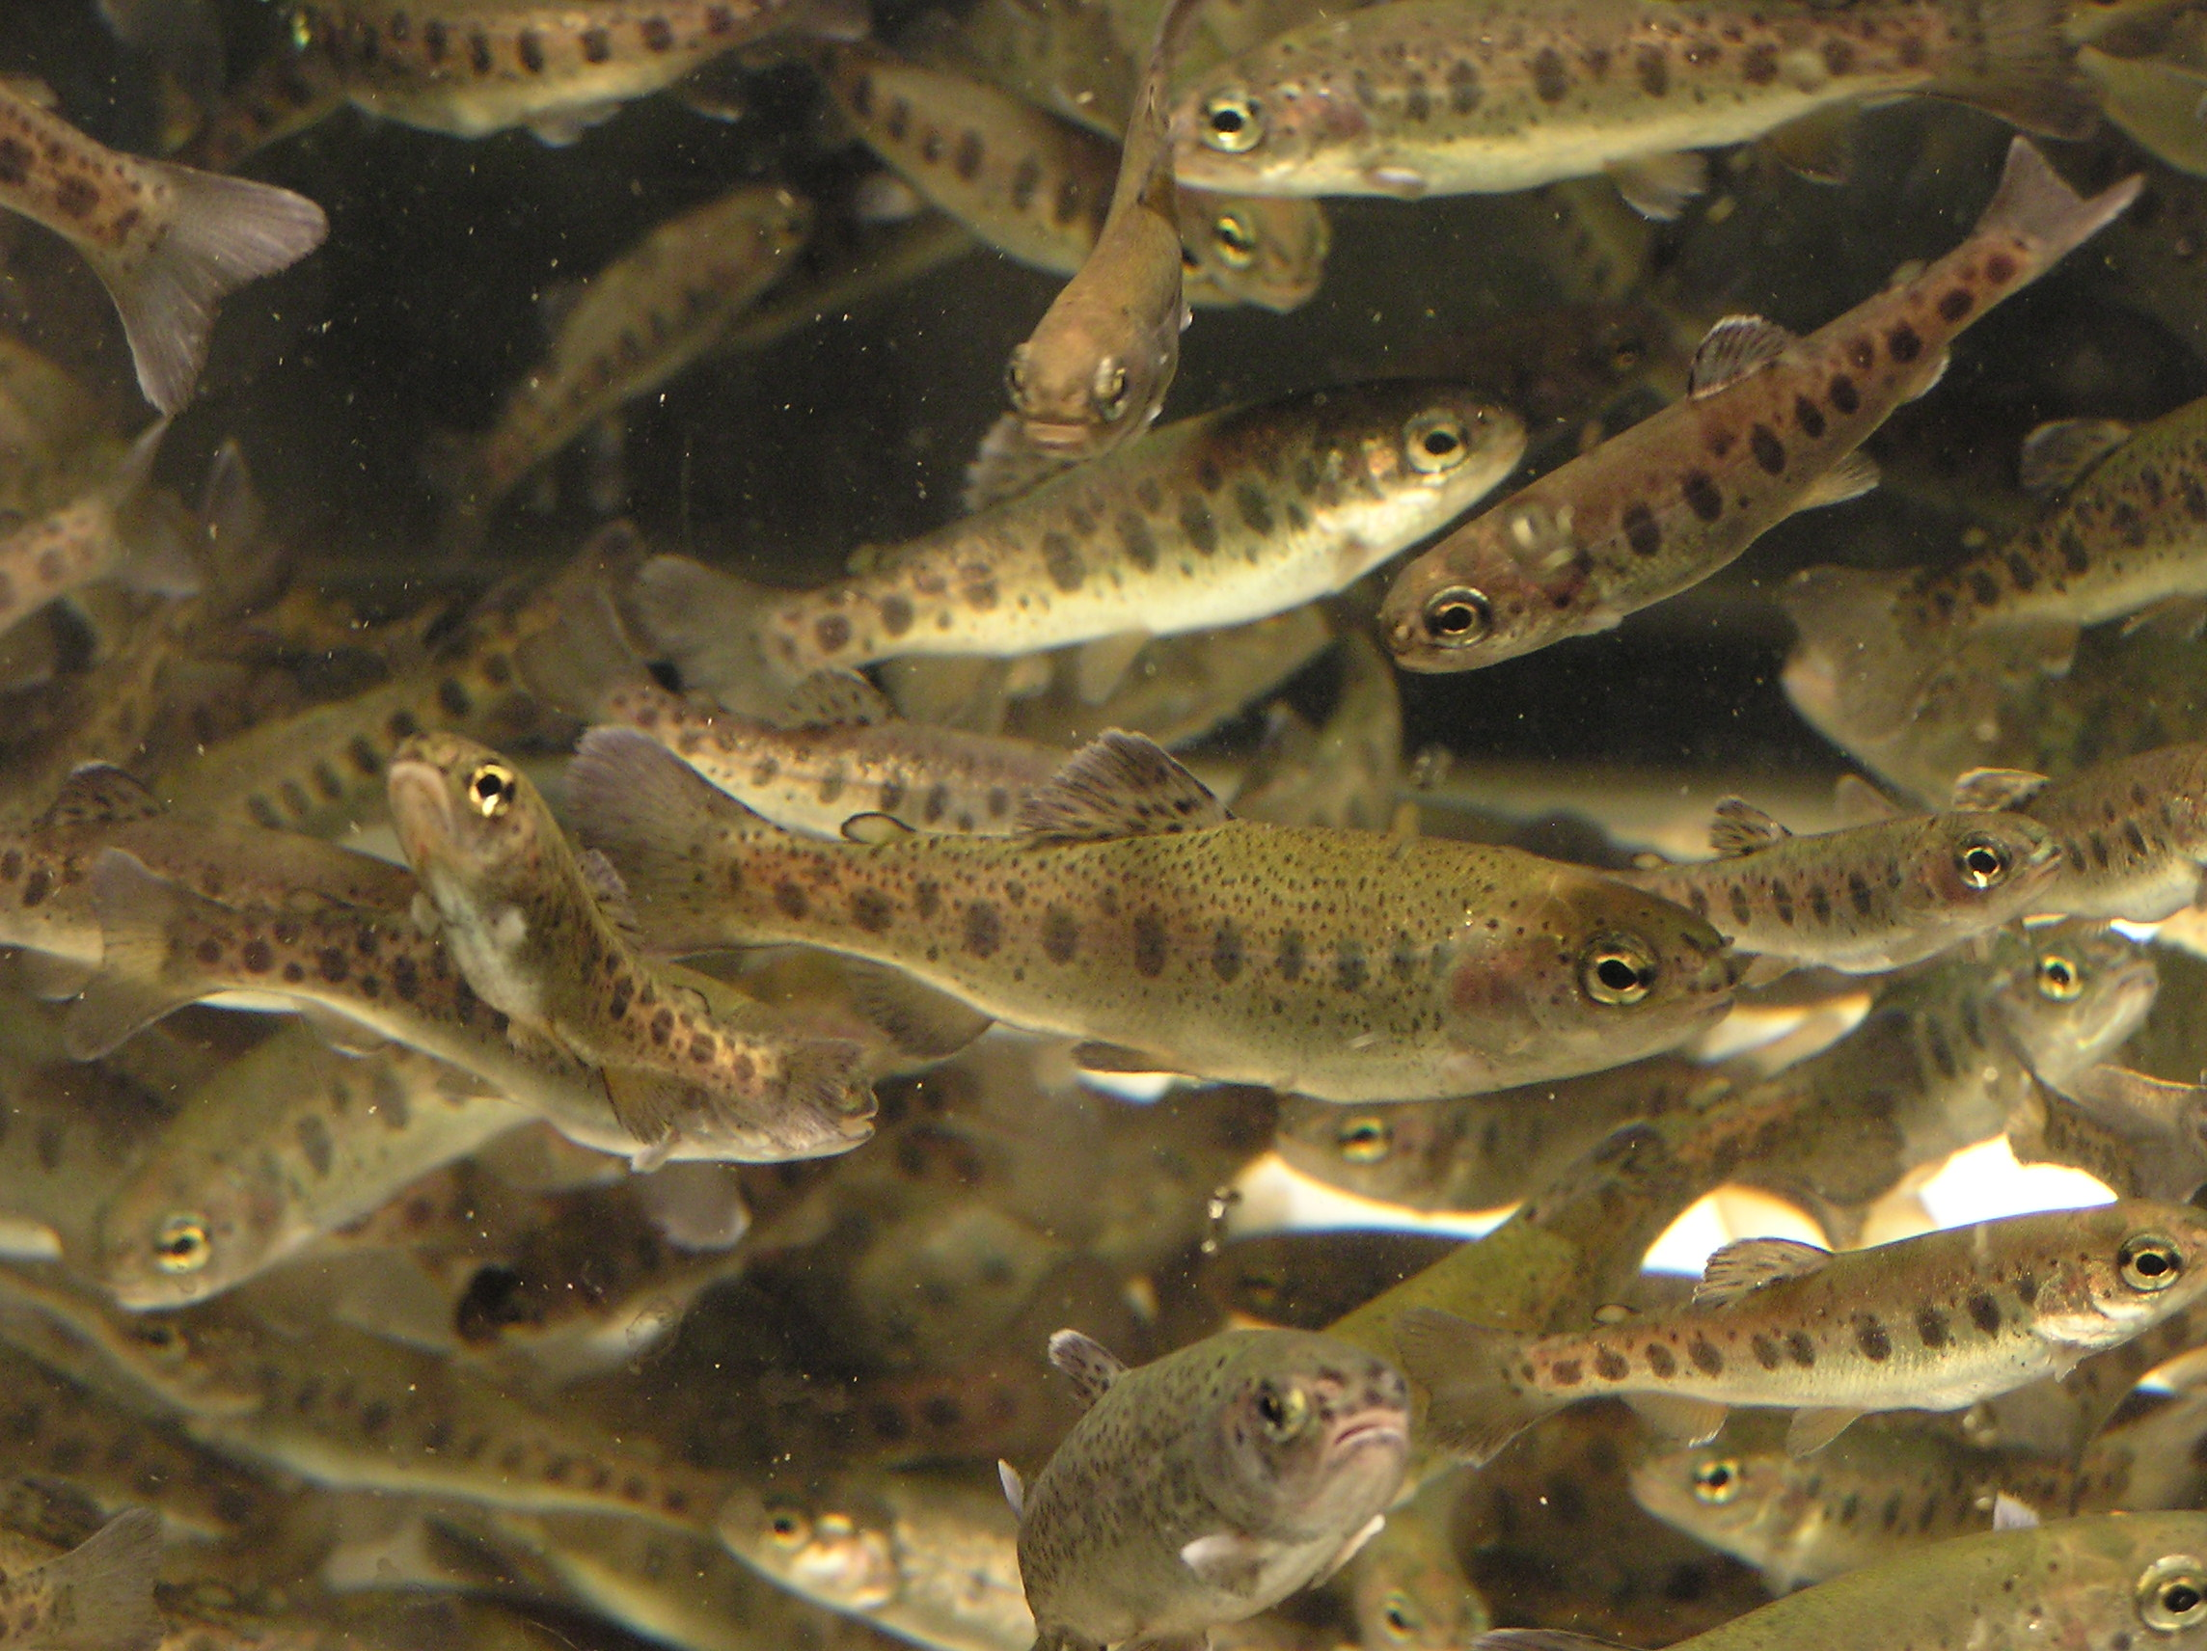

Workshop in Surveillance and epidemiology of Aquatic Animal diseases

Copenhagen,

November 23-24. 2011

Hosted by the Community reference laboratories for
fish, shellfish and mollusc diseases.
Directed by the OIE collaborating centre for
Aquatic Epidemiology and Risk Assessment.

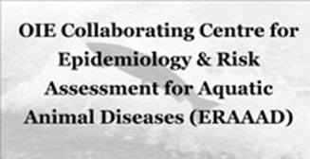

Contents
Introduction and short summary 3
Programme 4
Basic epidemiological principles 5
The purpose of surveillance and control of diseases in aquaculture 5
Basic concepts in sampling and testing for aquatic diseases 11
Examples of risk categorization of farms according to EU-legislation 18
Proposal for a risk based surveillance program of Swiss fish farms 18
Epizootic risk analysis of lower Saxony Aquaculture production businesses 23
Special challenges related to shell and mollusc surveillance 27
Practical part: Parallel sessions with group-work and practical examples 35
Screening strategies & tracing of pathogens 35
Special challenges regarding surveillance in shell & molluscs 36
Design of surveillance programmes 38
Risk factors and risk categorization 41
Disease risk in space and time –Implications for surveillance 43
Use of molecular epidemiology in tracing disease 49
Economic aspects of surveillance programmes 50
Workshop wrap-up 54
Evaluation of workshop 54
References 57
Closing remarks 58

Introduction and short summary

The Workshop in Surveillance and epidemiology of Aquatic Animal diseases took place in the auditorium of the National Veterinary Institute in Copenhagen on November 23-24, 2011.
A total of 50 participants from 25 countries attended, with 5 invited experts. The workshop was organised by the European Union Reference Laboratory for Fish Diseases, together with the OIE collaborating centre for Aquatic Epidemiology and Risk assessment, constituting of scientists from the Norwegian Veterinary Institute. The EURL´s for molluscs and crustacean diseases were involved as well reflecting that the workshop covered all aquatic animals. The Norwegian Veterinary Institute, took on the responsibility to plan the scientific programme while the EURL focused on the practical arrangements.

The overall purpose of the workshop was to give an introduction to some of the topics of surveillance and epidemiology with a special focus on the challenges for aquatic animal diseases.
After a welcoming and a general introduction the workshop was opened with a talk on the purpose of surveillance, followed by a presentation of concepts for sampling and testing for surveillance. After these basic principles and concepts had been presented, two talks were given on risk-ranking of aquaculture farms according to the new legislation on aquatic animal health. A special presentation was given on the challenges regarding surveillance in shellfish and molluscs.

In the afternoon, the workshop participants were divided into groups with the following four topics:
- Screening strategies & tracing of pathogens
- Special challenges regarding surveillance in shell & molluscs
- Design of surveillance programmes
- Risk factors and risk categorization
Within each group, concepts and challenges were discussed, and a summary of the groups’ discussions was presented on the second day of the workshop, in order to give all participants insight into the different topics.

On the second day of the workshop, presentations were given on how to use models of risk in space and time when considering surveillance and on molecular epidemiology for tracing the origin of disease outbreaks. A final presentation was given on concepts of economics with regards to surveillance programmes in aquatic animals.

After the workshop, an internet-based evaluation was carried out, with 30 responses. The overall impression is that the participants were satisfied with the outcome of the workshop, and there is a wish for more workshops on epidemiologic topics. The results of the evaluation are presented at the end of this report.

Presentations from the workshop were collected and are included in this report. For the group work, a synthesis of the discussions is presented. All presenters and facilitators have had the opportunity to correct misunderstandings before the report was finalised.

We would like to thank all the presenters and facilitators for their great contribution, and all the participants for their enthusiasm. Without them, the workshop would not have been a success.

Oslo and Århus, January 2012

Britt Bang Jensen and Niels Jørgen Olesen

Programme
Venue: Auditorium of DTU Vet, Bülowsvej 27,

Day 1 | Wednesday November 23.
9.00-9.15 | Welcome and introduction. Britt Bang Jensen / Niels Jørgen Olesen
9.15-10.00 | The purpose of surveillance and control of diseases in aquaculture: Angus Cameron
10.00-10.45 | Basic concepts in sampling and testing for aquatic diseases: Charles Caraguel
10.45-11.15 | Coffee break
11.15-12.00 | Examples of risk categorization of farms according to EU-legislation  - Proposal for a risk based surveillance program of Swiss fish farms: Beat von Siebenthal  - Epizootic risk analysis of lower Saxony Aquaculture production businesses: Dirk W. Kleingeld
12.00-12.30 | Special challenges related to shell and mollusc surveillance: Edmund Peeler
12.30-13.30 | Lunch
13.30-13.45 | Introduction to practical part of workshop and allocation into groups
13.45-16.30 | Practical part: Parallel sessions with group-work and practical examples
13.45-16.30 | Screening strategies & tracing of pathogens  Facilitators: Charles Caraguel & Peder Jansen | Special challenges regarding surveillance in shell & molluscs  Facilitator: Edmund Peeler | Design of surveillance programmes  Facilitator: Angus Cameron | Risk factors and risk categorization  Facilitators:  Britt Bang Jensen & Trude Lyngstad
16.30-17.00 | Preliminary wrap-up of discussions within the groups
Social event: Dinner at restaurant “Wining and Dining”
Day 2 | Thursday November 24.
9.00-9.15 | Introduction to day 2: Britt Bang Jensen
9.15-10.00 | Disease risk in space and time –Implications for surveillance: Peder Jansen
10.00-10.30 | Coffee break
10.30-11.15 | Use of molecular epidemiology in tracing disease: Trude Lyngstad
11.15-12.00 | Economic aspects of surveillance programmes: Britt Bang Jensen
12.00-13.00 | Lunch
13.00-15.00 | Discussion based on experiences from the practical part of workshop  15 minute presentation from each group.
15.00-15.30 | Workshop wrap-up and goodbyes

Presenters/facilitators:
- Dr. Angus Cameron, Director of AusVet Animal Health Services
- Dr. Charles Caraguel, University of Adelaide
- Dr. Edmund Peeler, Centre for Environment, Fisheries and Aquaculture Science
- Trude Lyngstad, Section for epidemiology, Norwegian Veterinary Institute
- Peder Janssen, Section for epidemiology, Norwegian Veterinary Institute
- Britt Bang Jensen, Section for epidemiology, Norwegian Veterinary Institute

Basic epidemiological principles

The purpose of surveillance and control of diseases in aquaculture
A. Cameron
AusVet Animal Health Services
140 Falls Road, Wentworth Falls, NSW 2782
Australia
E-mail: angus@ausvet.com.au

Presentation:

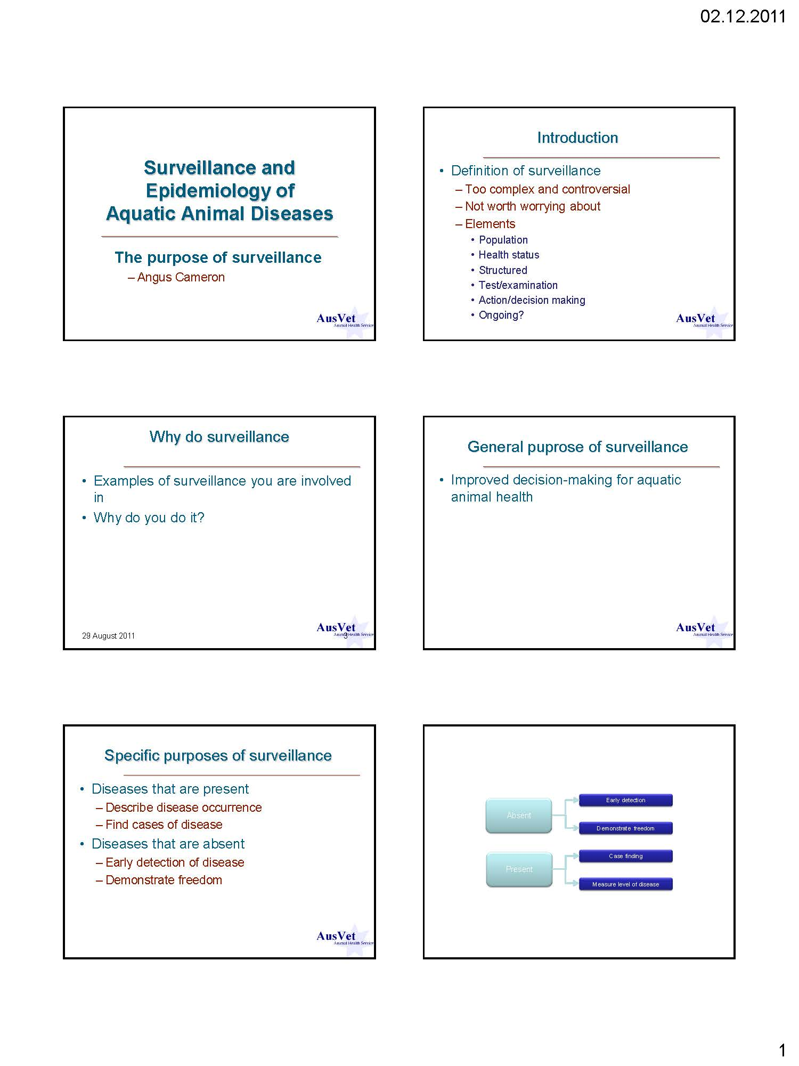
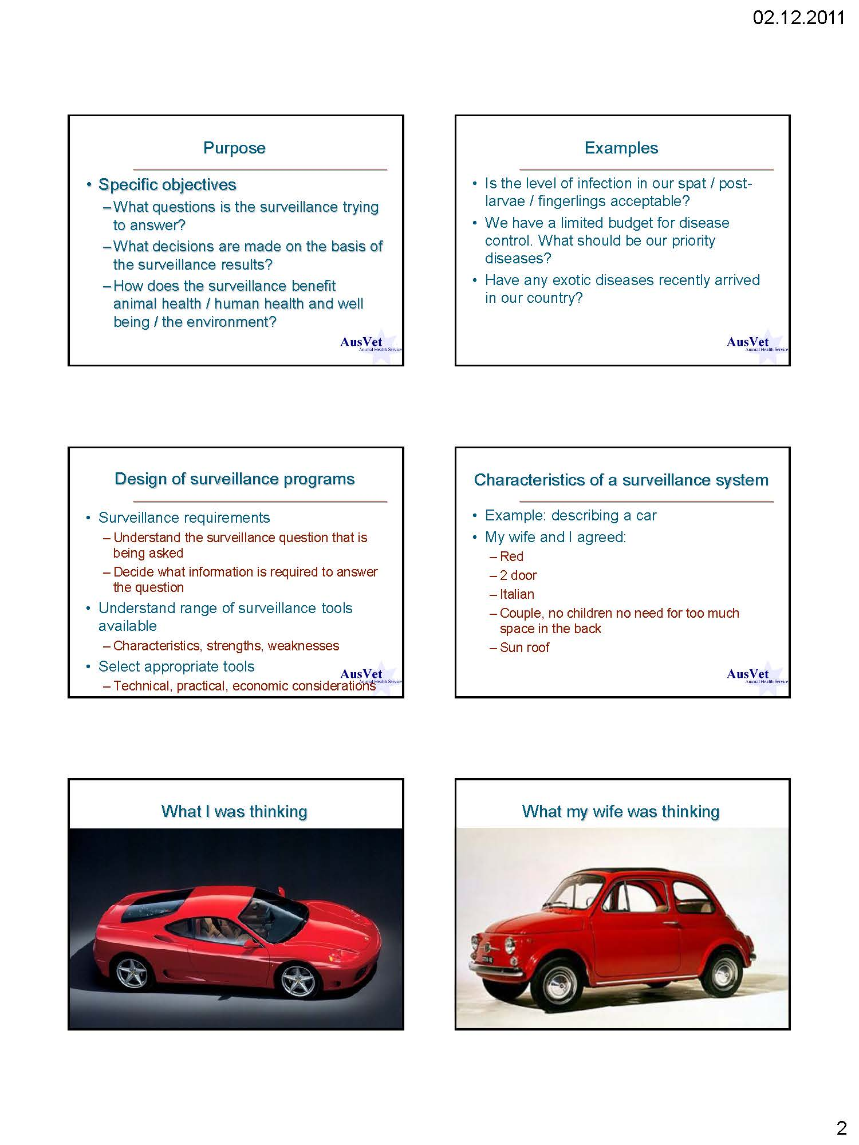
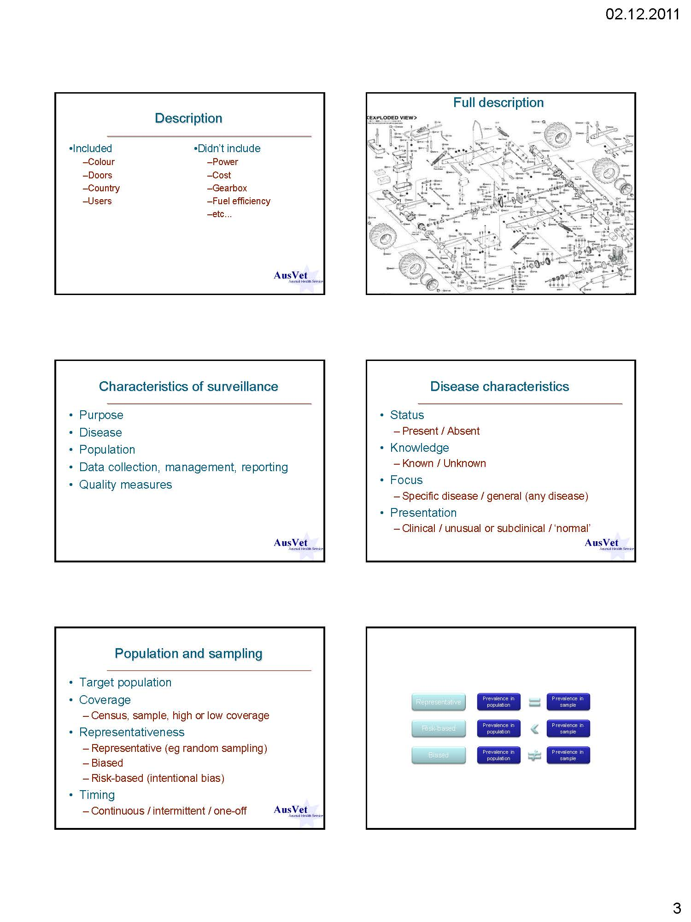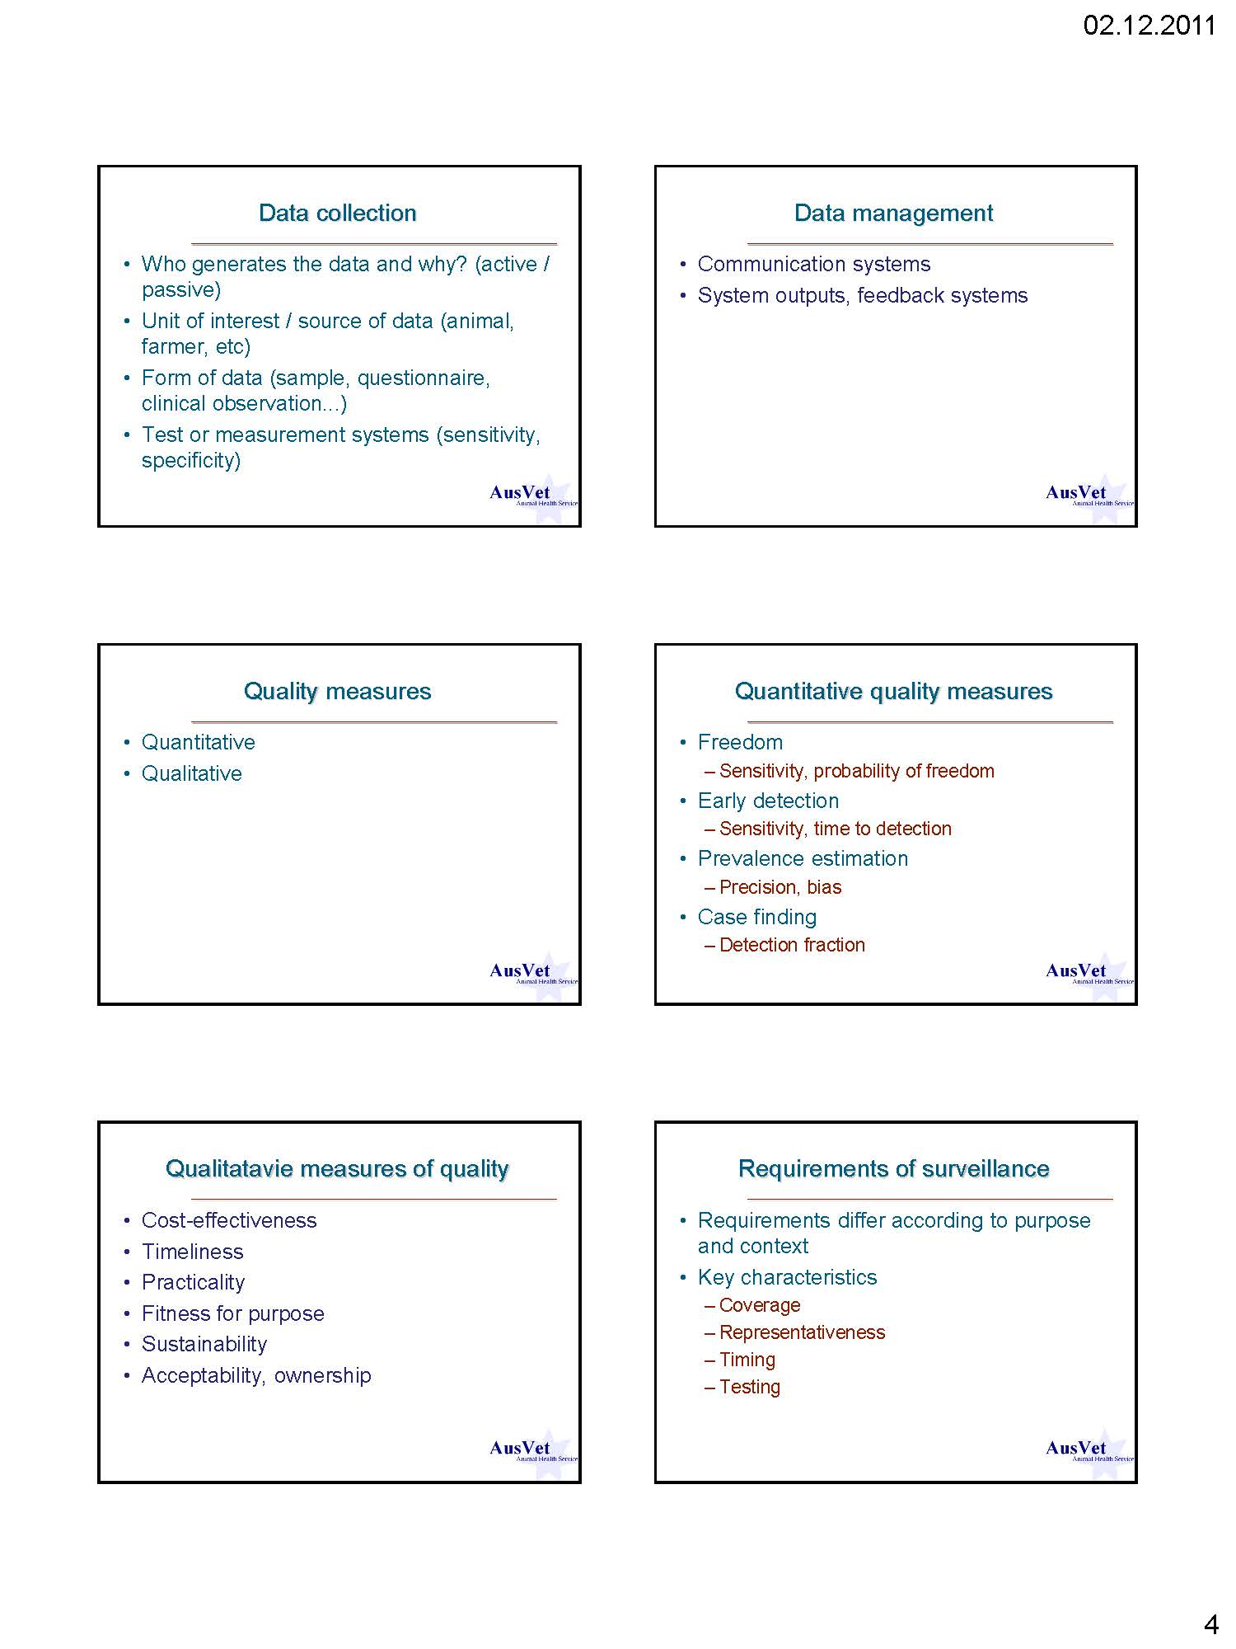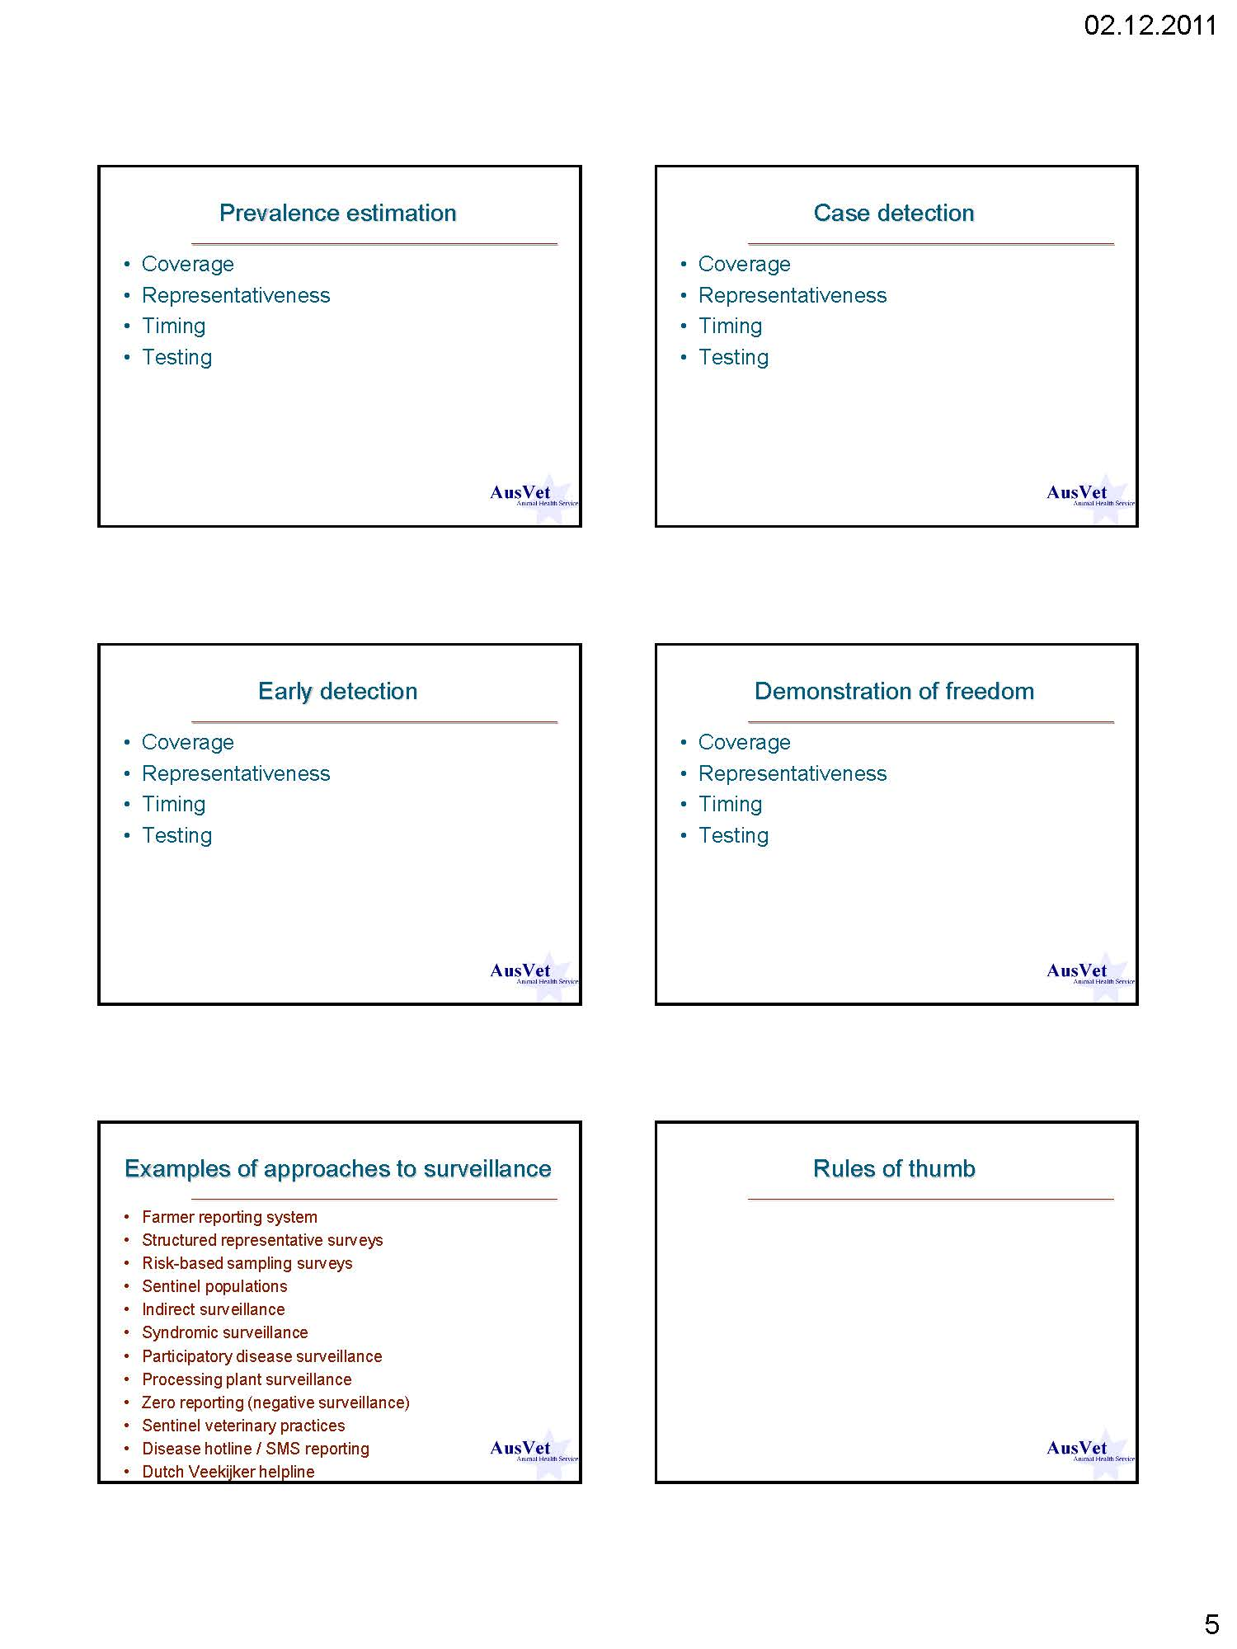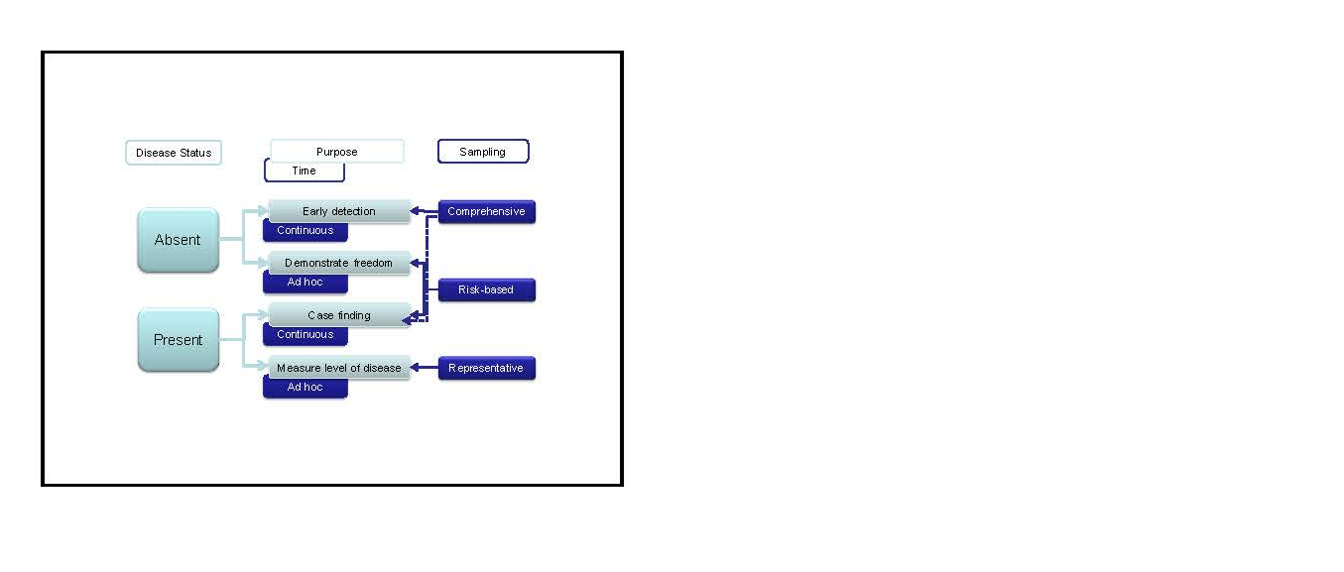

Basic concepts in sampling and testing for aquatic diseases

C. Caraguel
University of Adelaide
Roseworthy SA 5371
Australia
E-mail: charles.caraguel@adelaide.edu.au

Presentation:

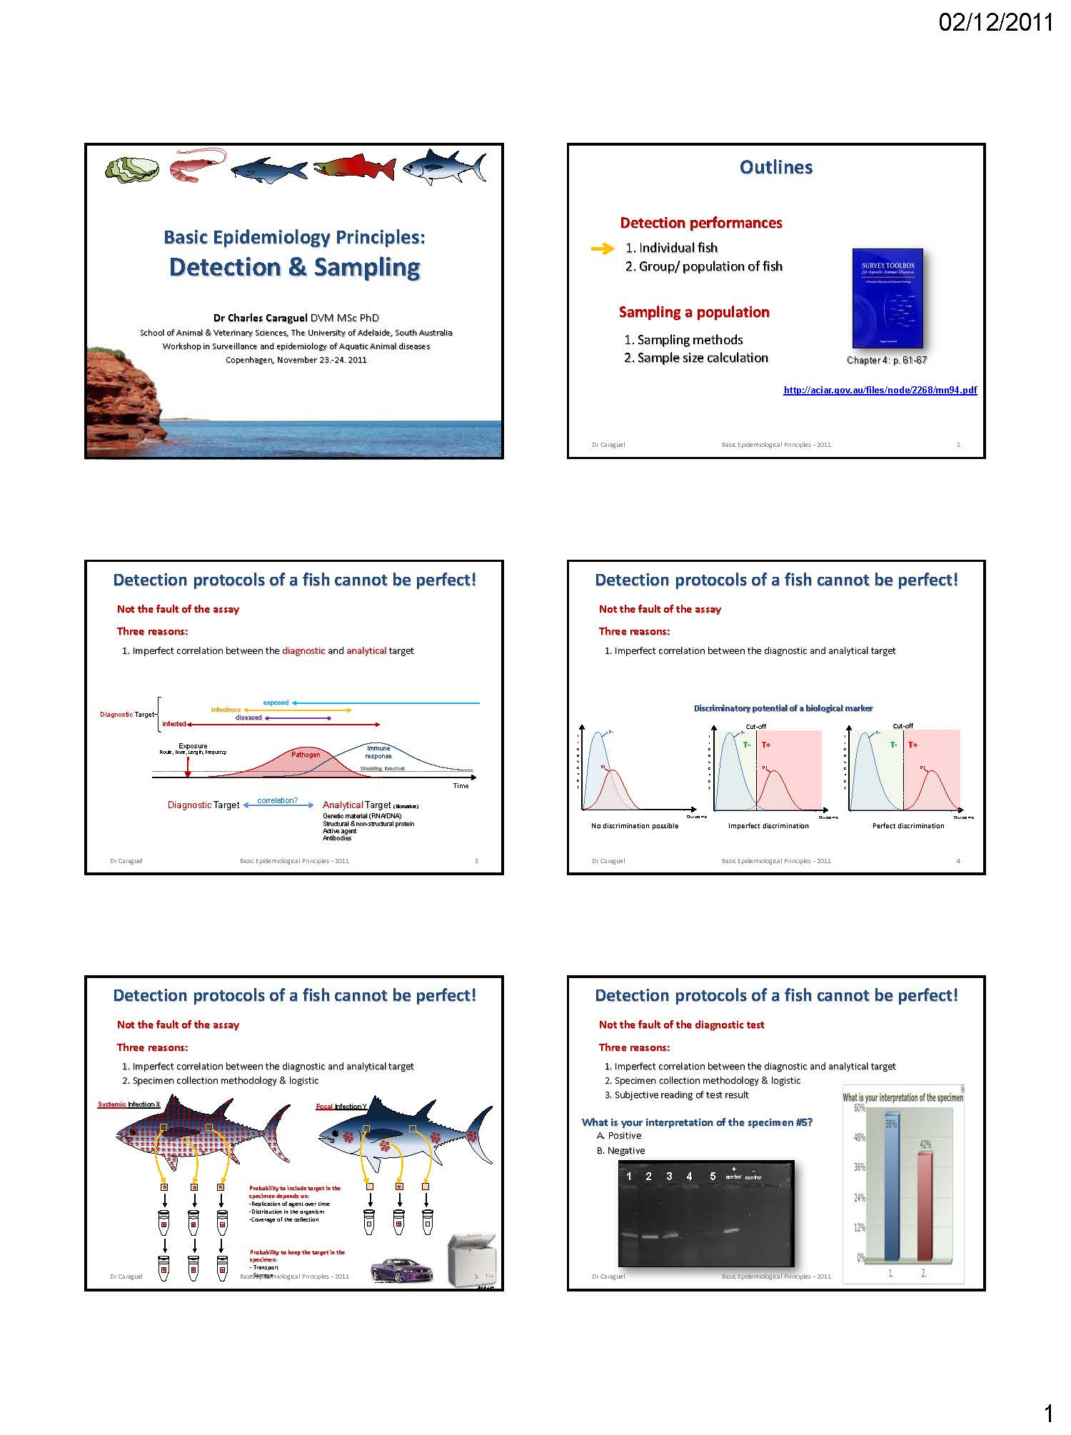

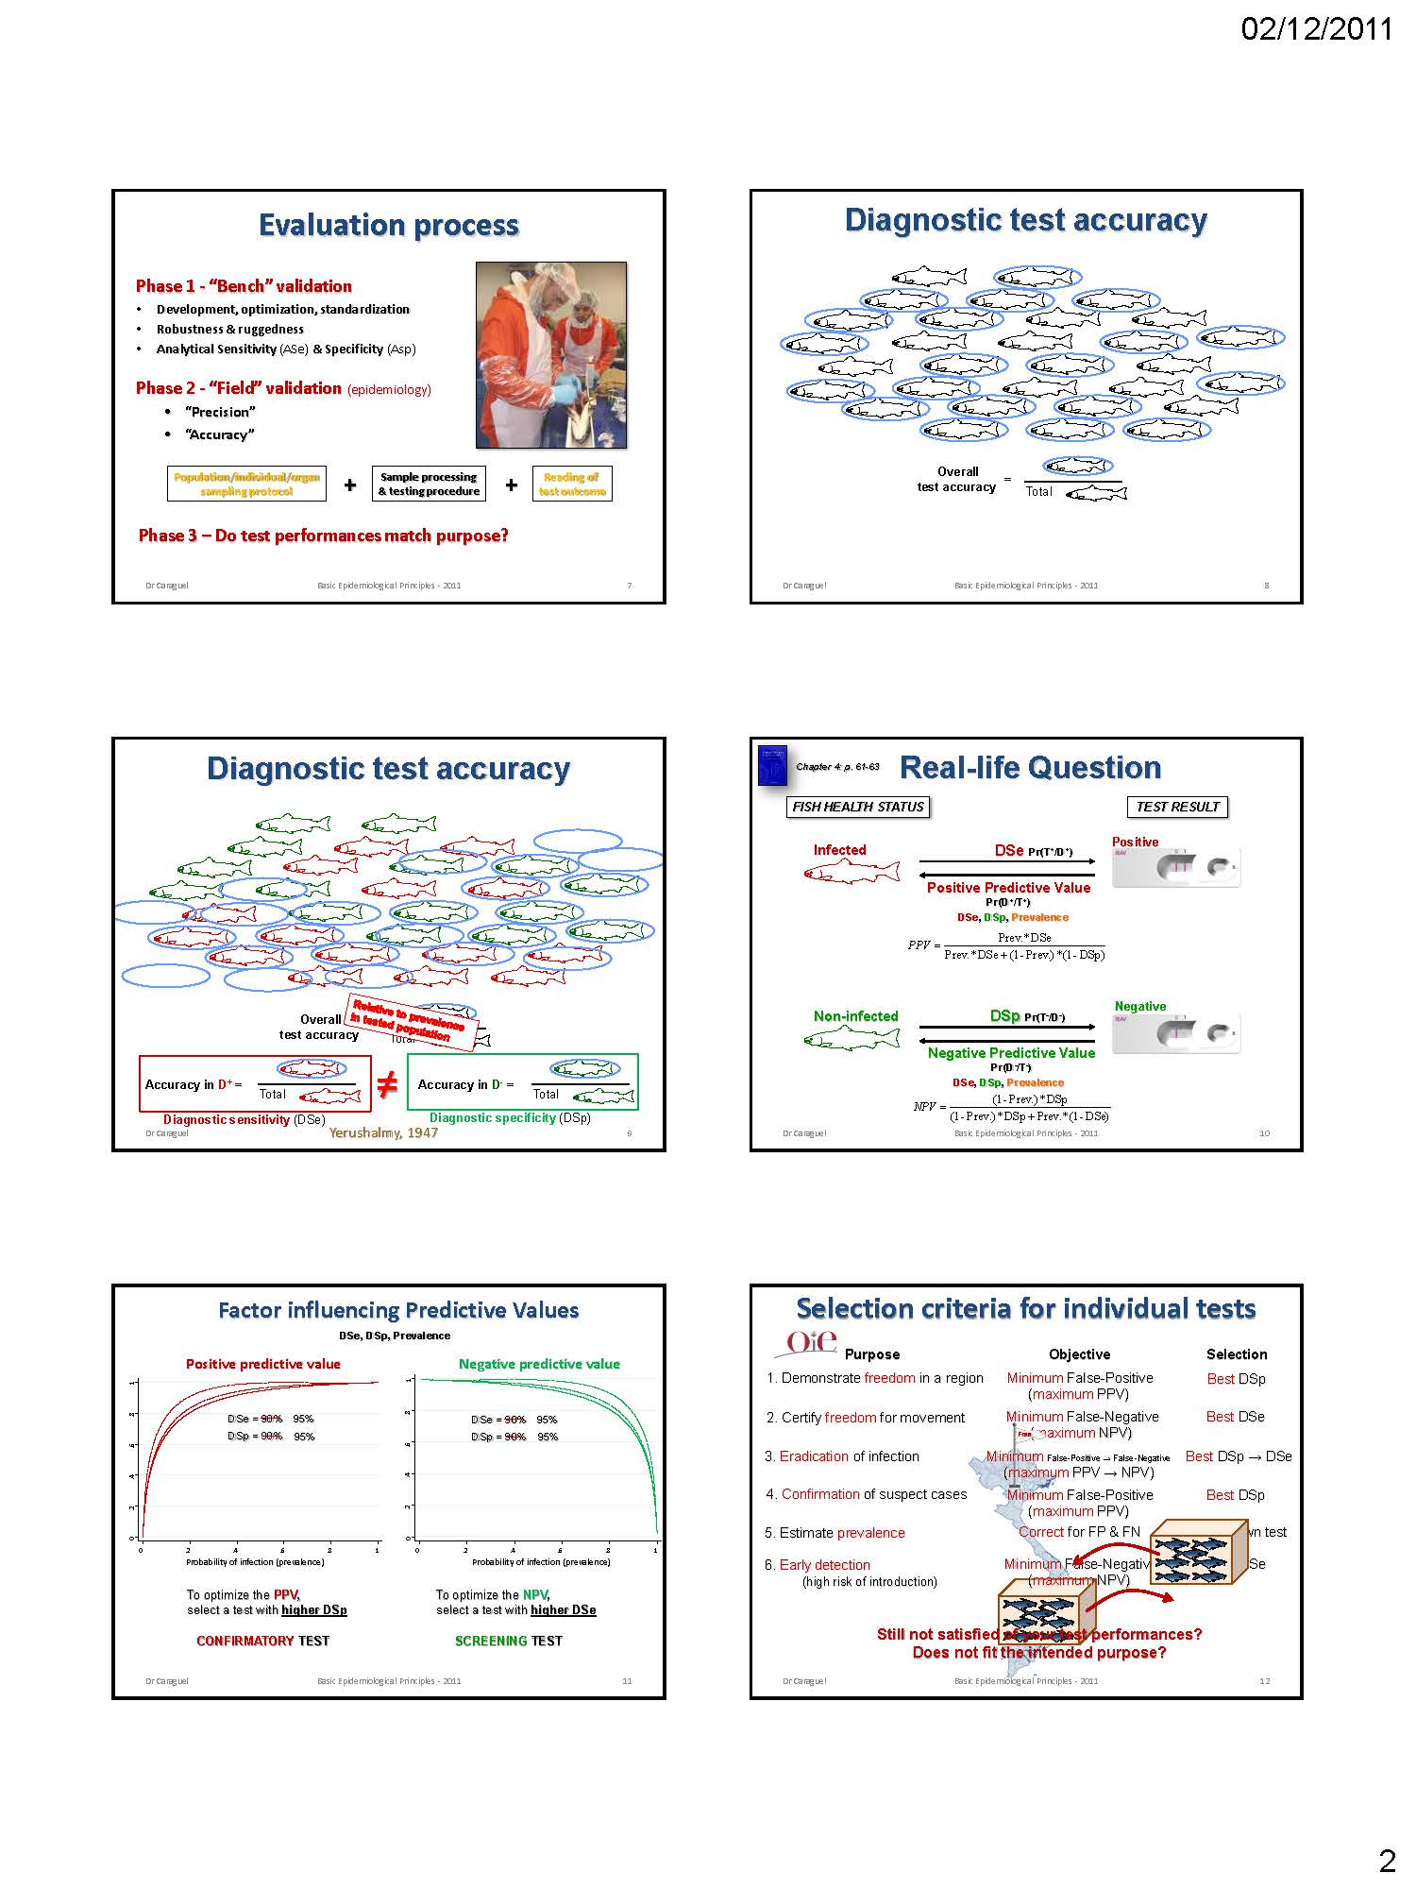

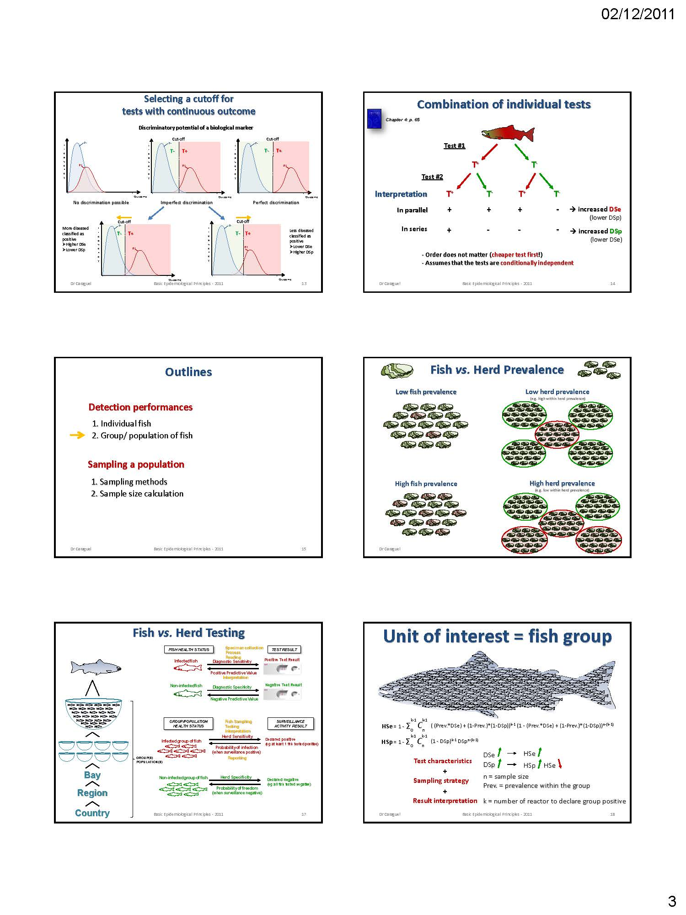

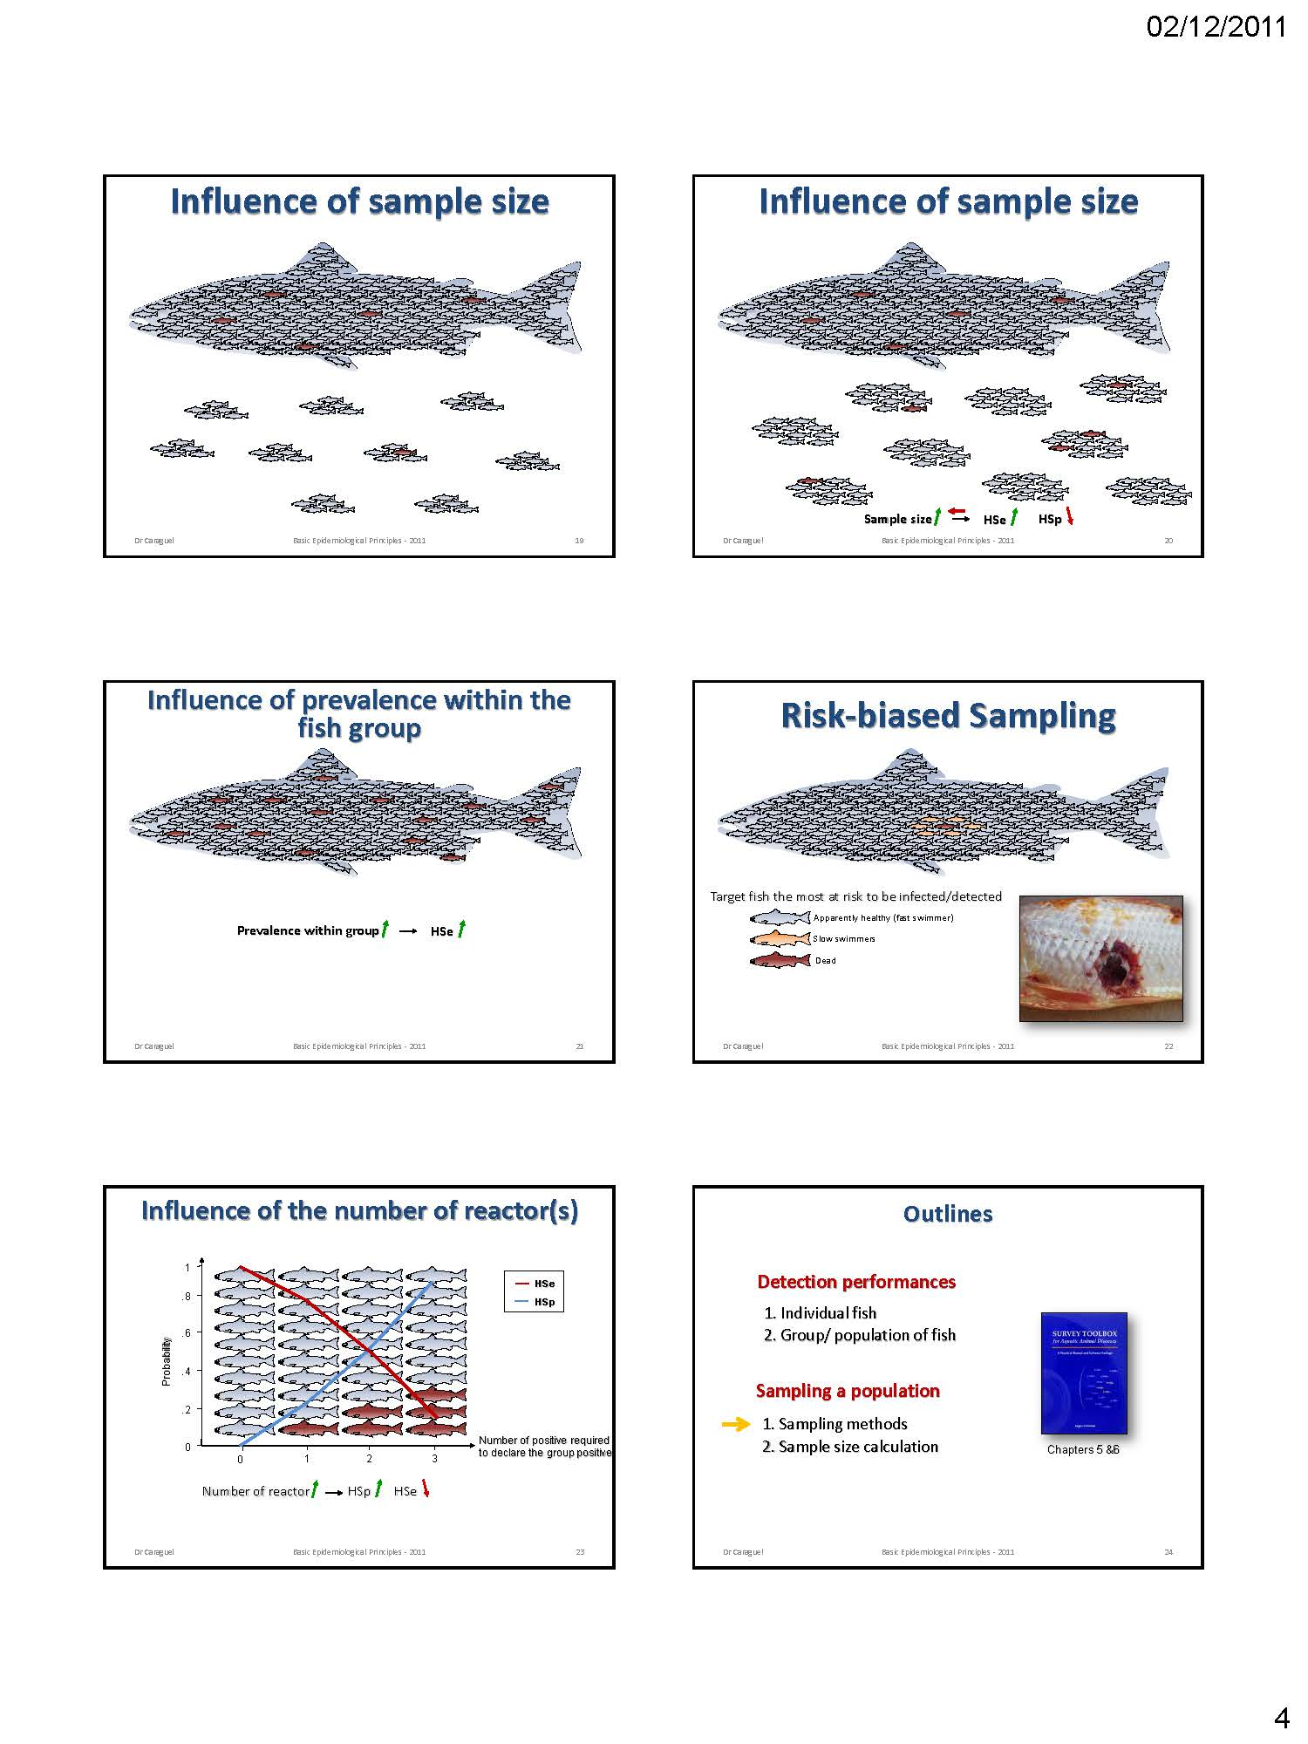

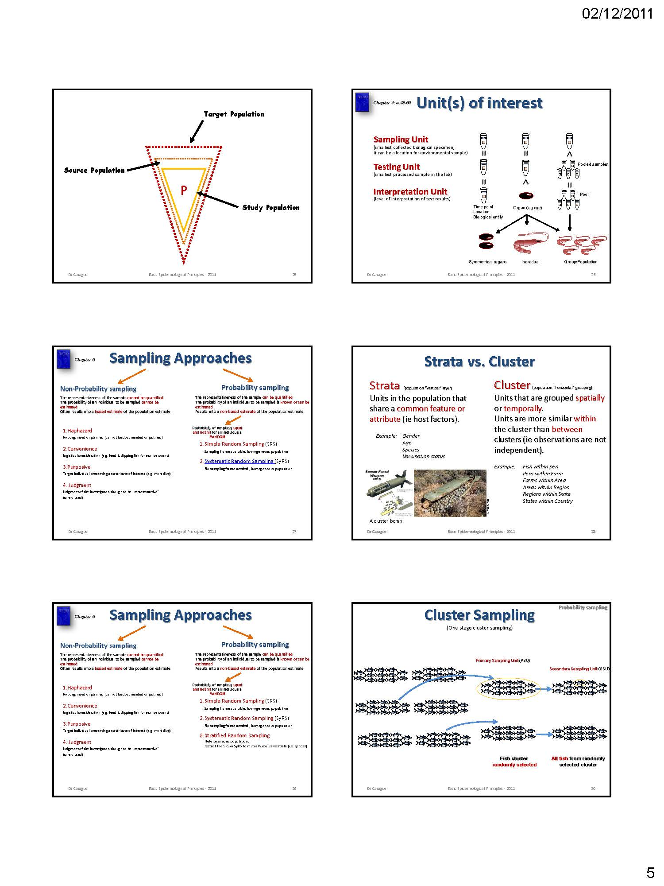

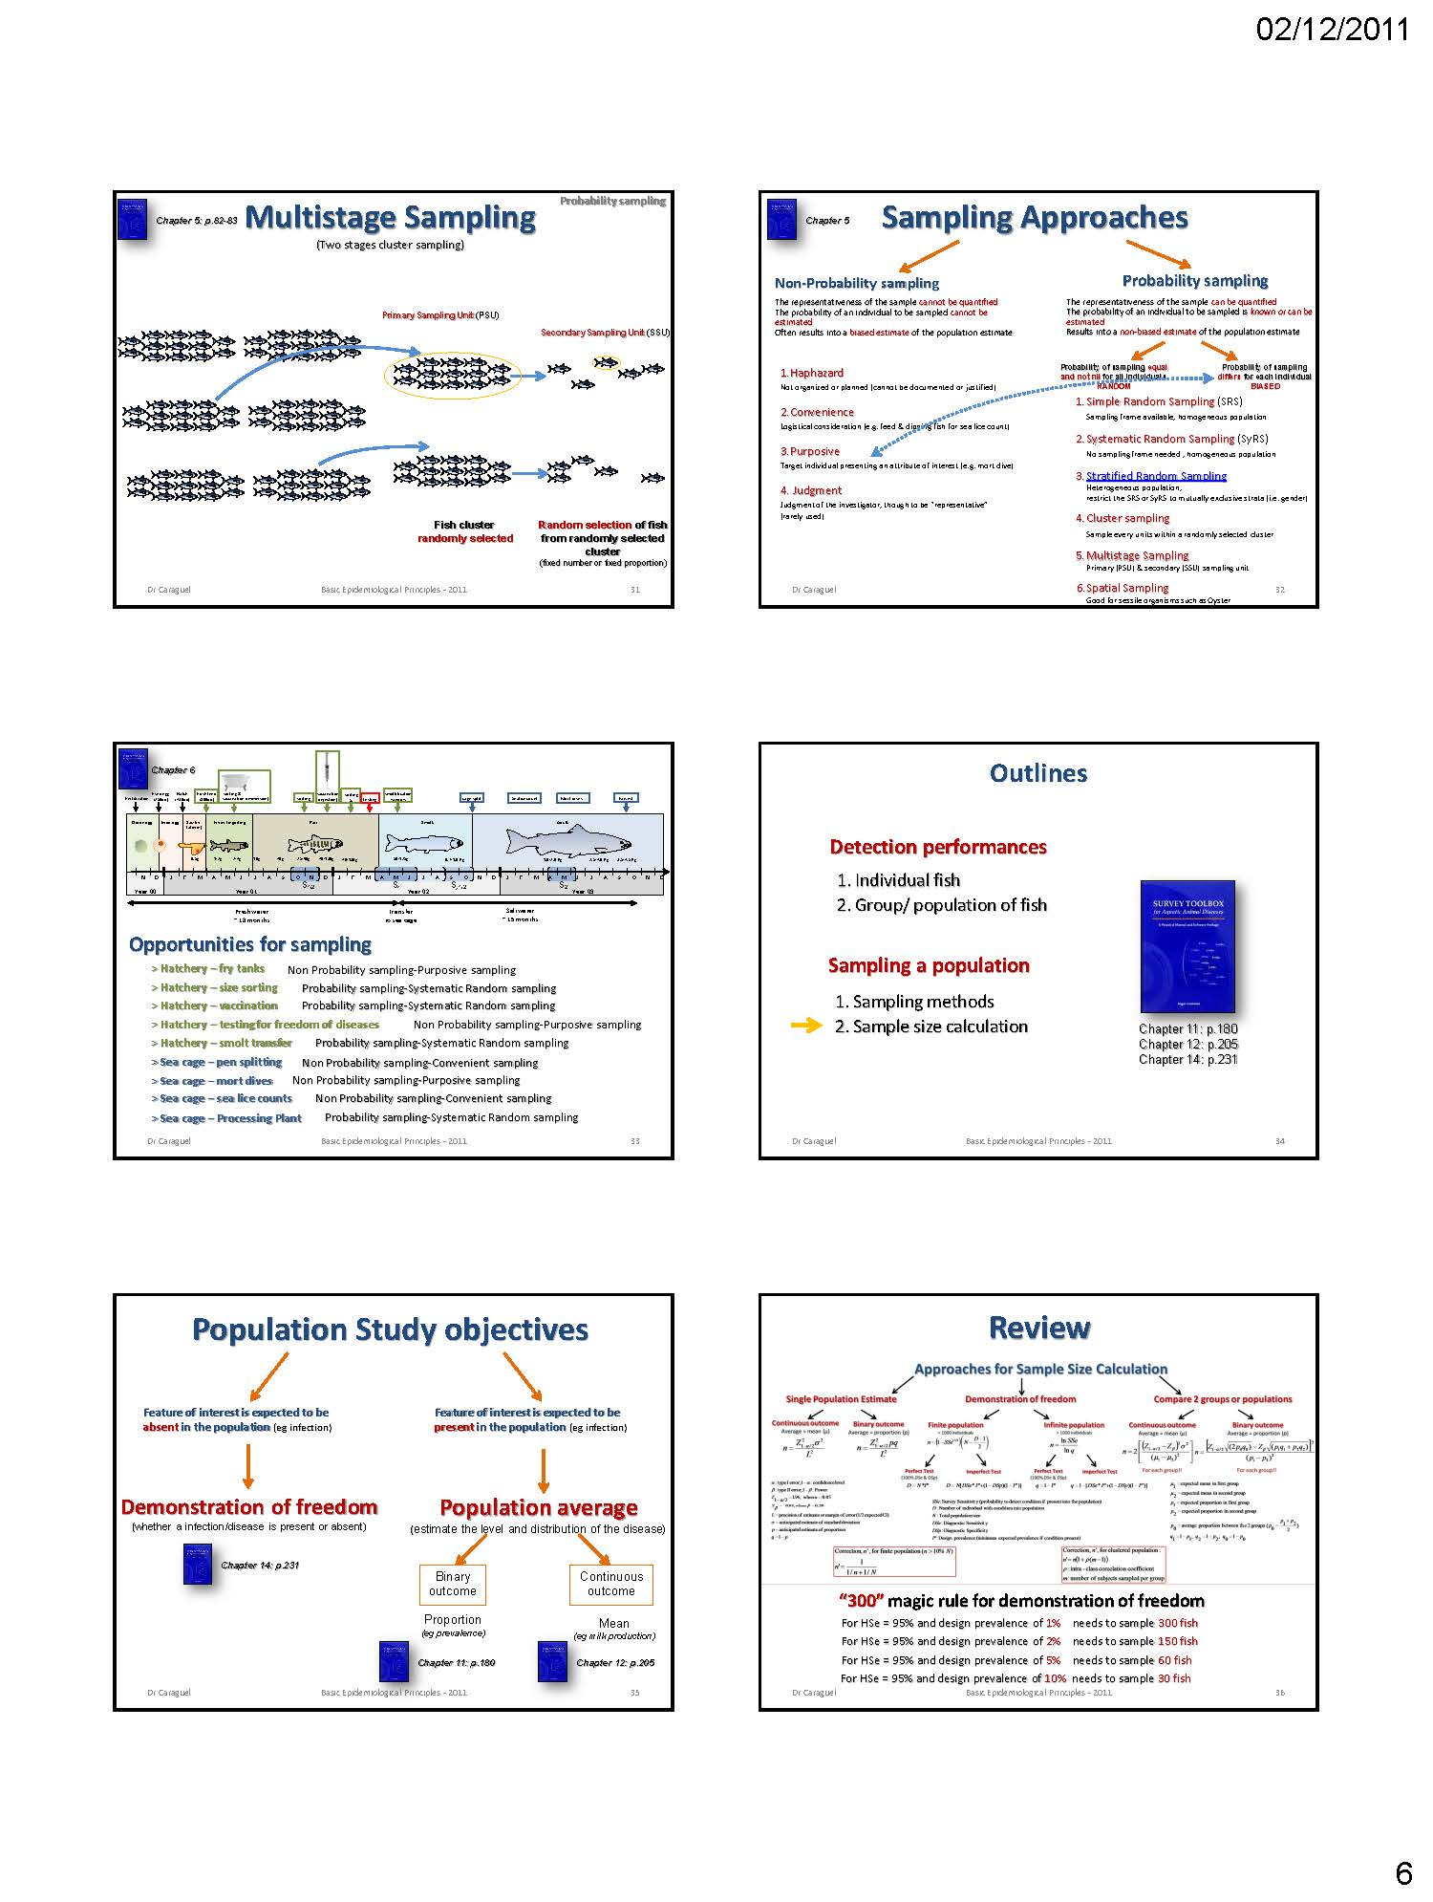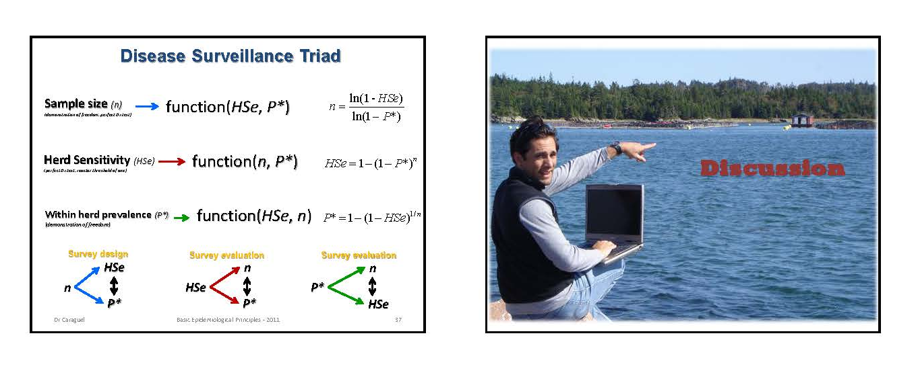

Examples of risk categorization of farms according to EU-legislation

Proposal for a risk based surveillance program of Swiss fish farms

B. von Siebenthal
N. Diserens¹, D. Bernet², G. Schupbach³, P. Presi³, T. Wahli¹

1 Centre for Fish and Wildlife Health (FIWI), Berne, Switzerland
2 Inspectorate of Fisheries, Münsingen, Switzerland
3 Veterinary Public Health Institute, Liebefeld, Switzerland

Presentation:

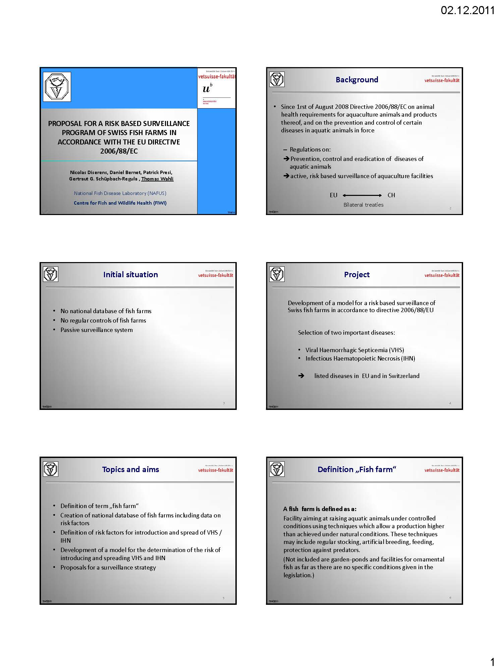
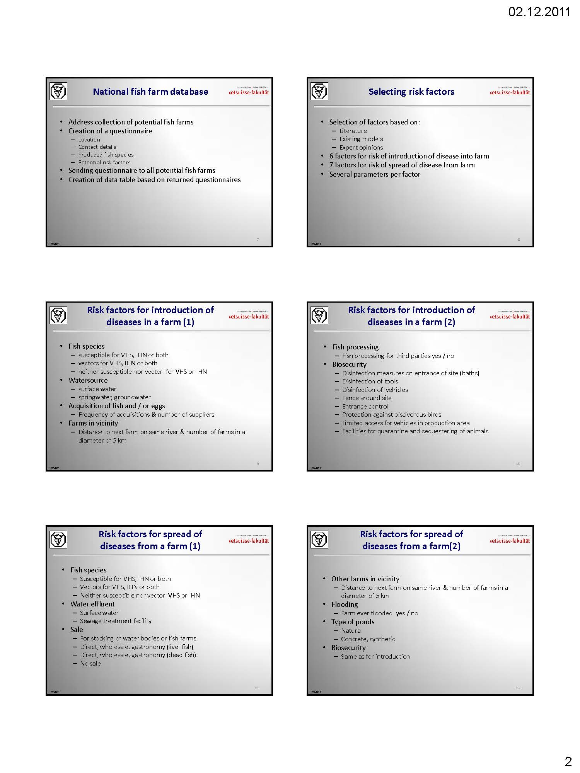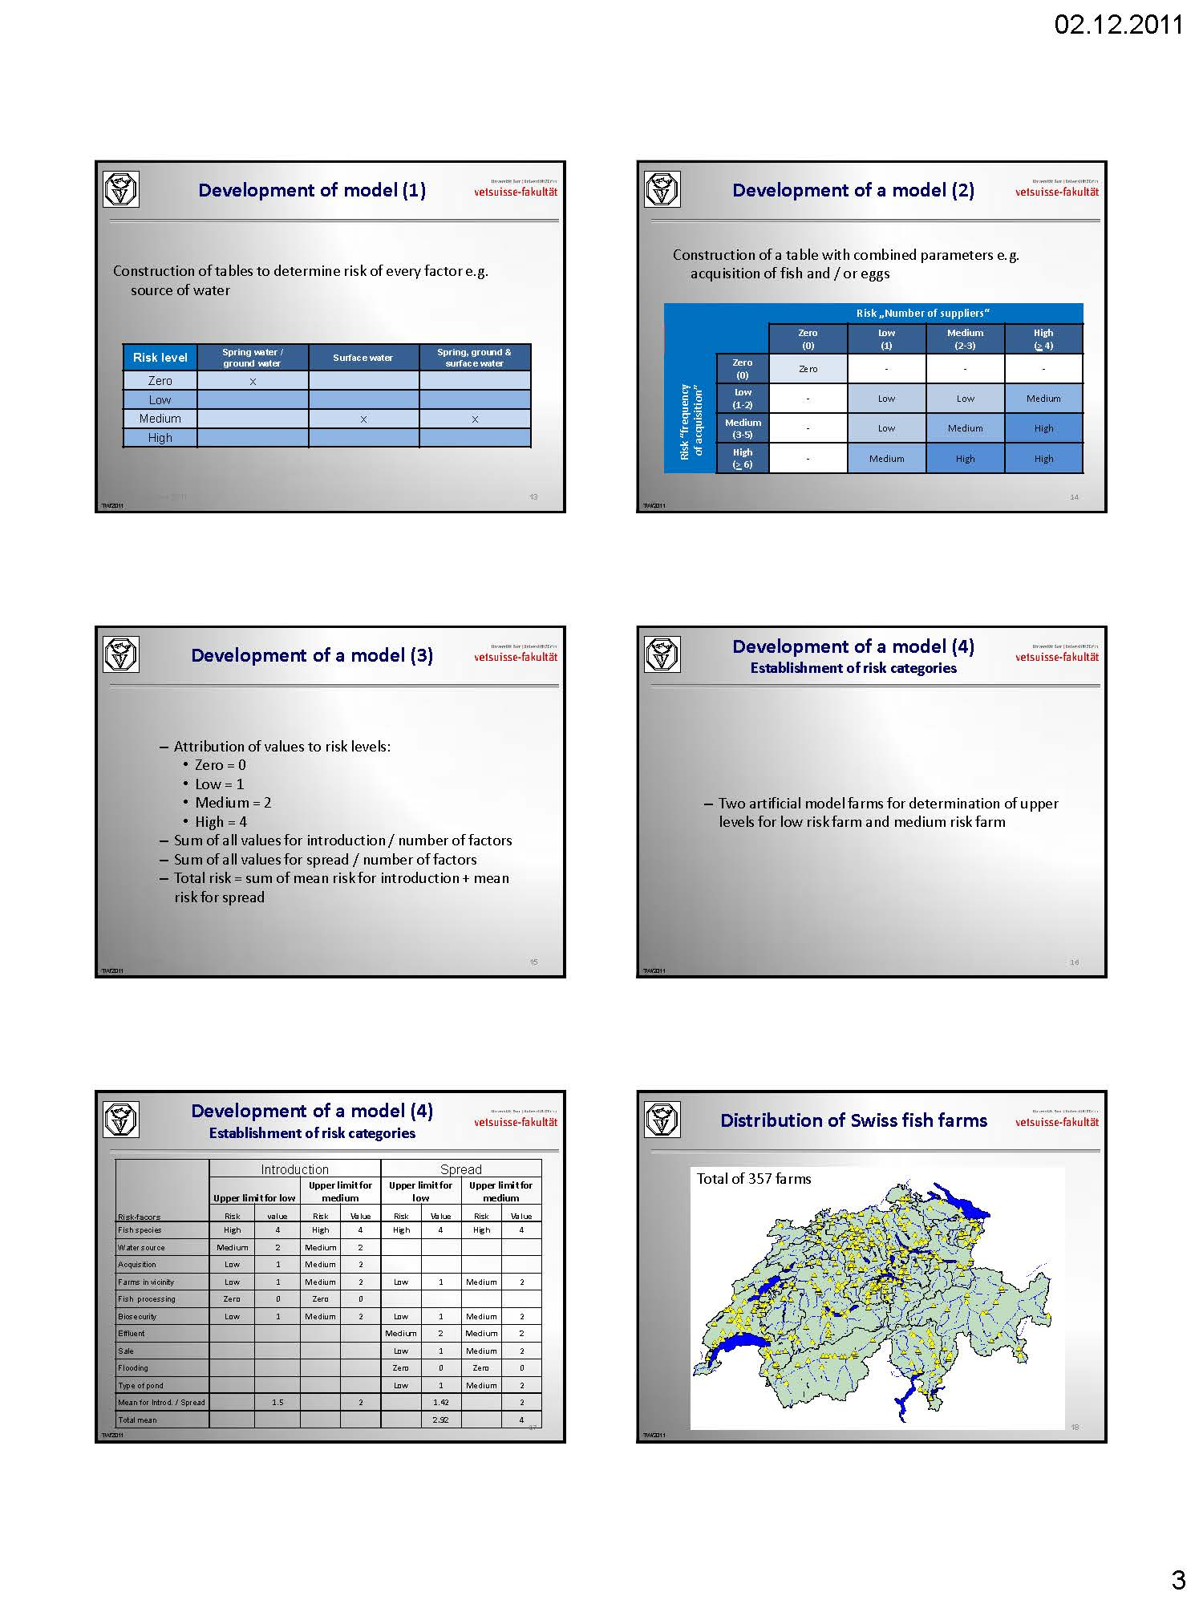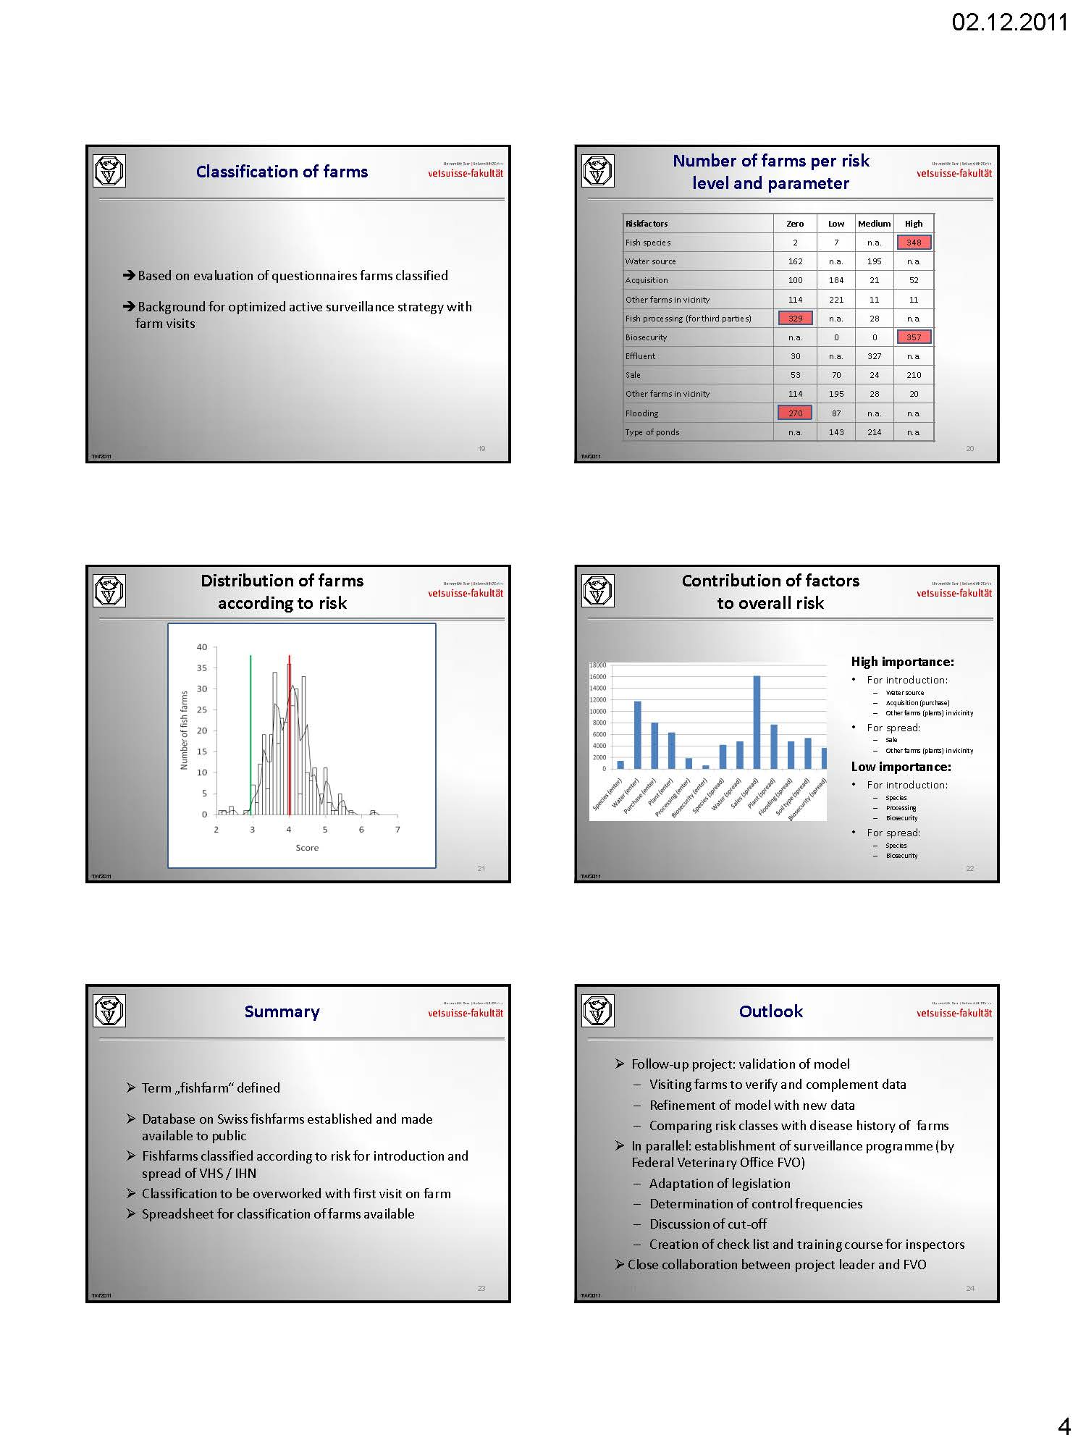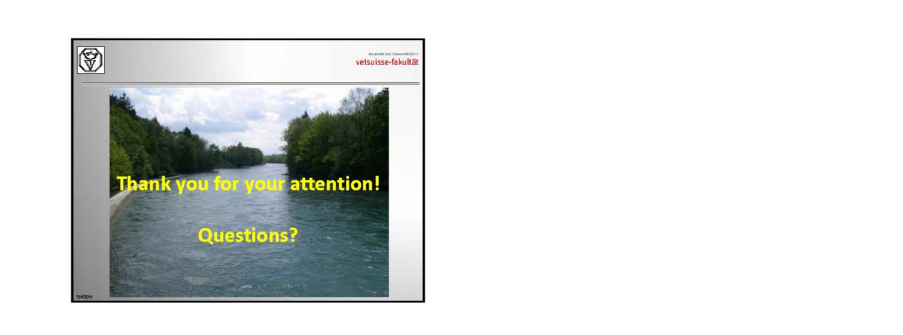

Epizootic risk analysis of lower Saxony Aquaculture production businesses

D.W. Kleingeld¹, G. Hörstgen-Schwark² und C.-P. Czerny³

1 Lower Saxony State Office for Consumer Protection and Food Safety Veterinary Task-Force, Fish Epizootics Control Service, Hannover, Germany
2 Georg-August-University of Göttingen, Department of Animal Sciences, Division of Aquaculture and Aquatic Ecology, Göttingen, Germany
3 Georg-August-University of Göttingen, Department of Animal Sciences, Division of Microbiology and Animal Hygiene, Göttingen, Germany

Presentation:

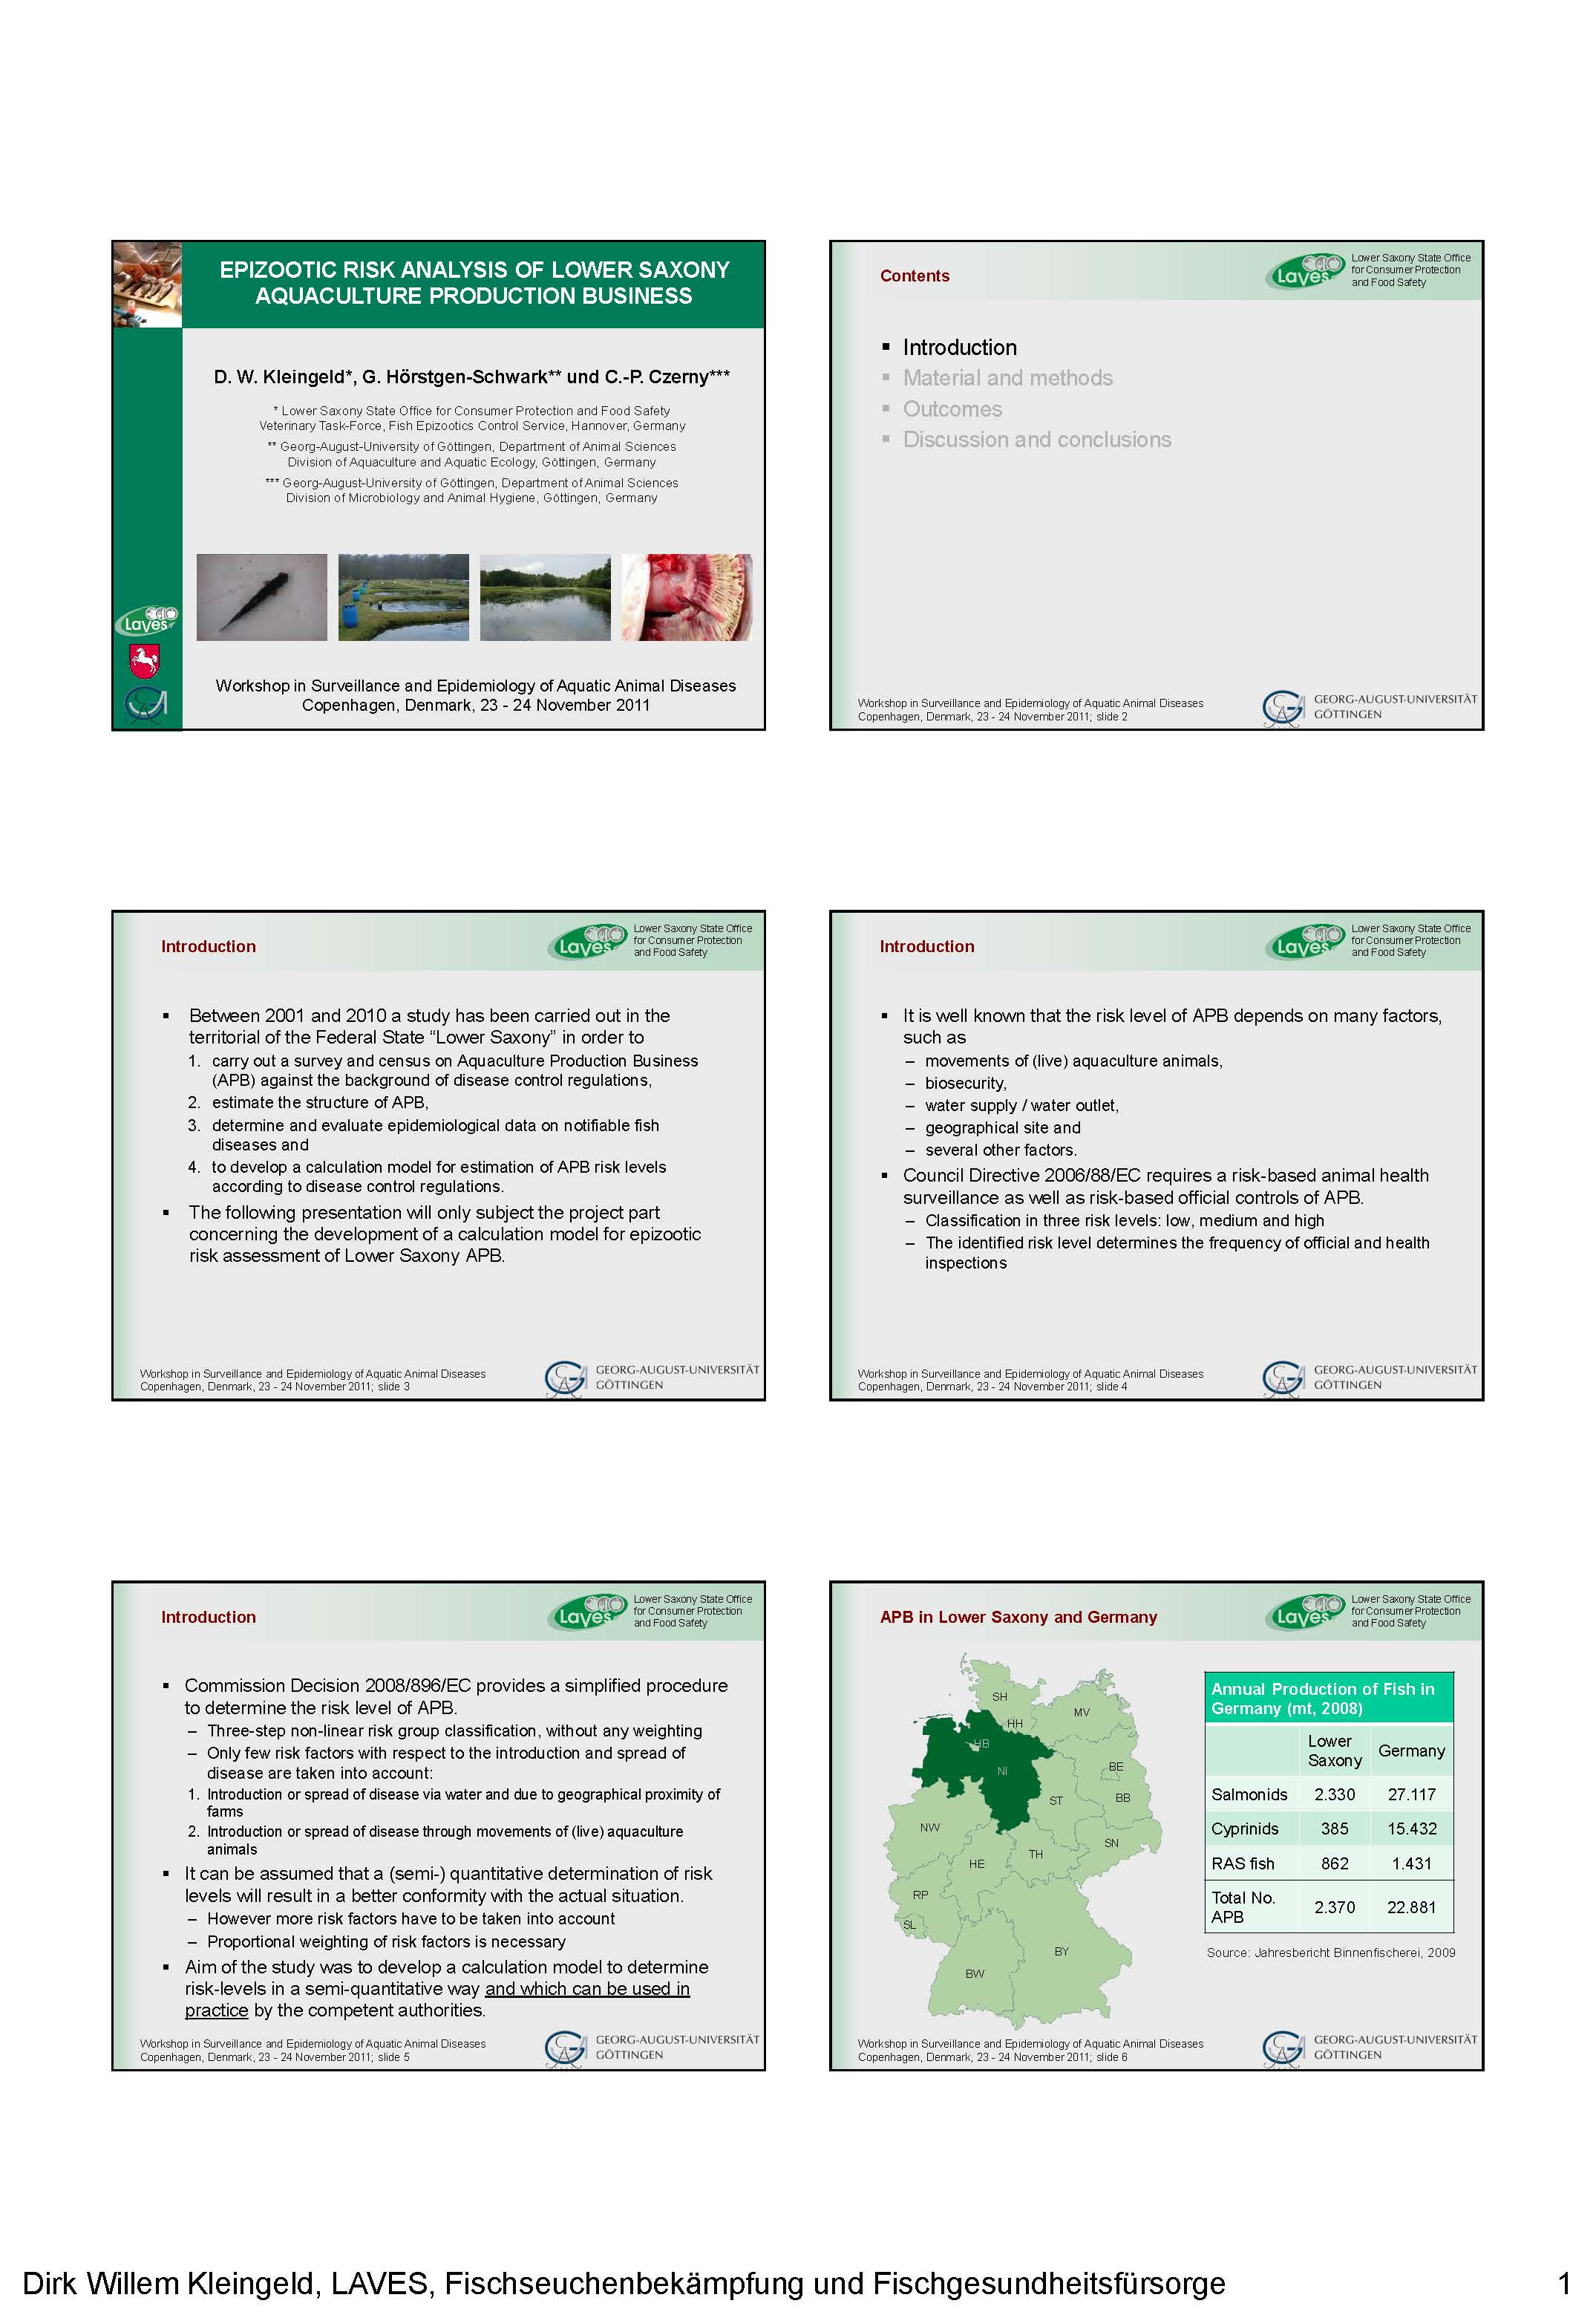
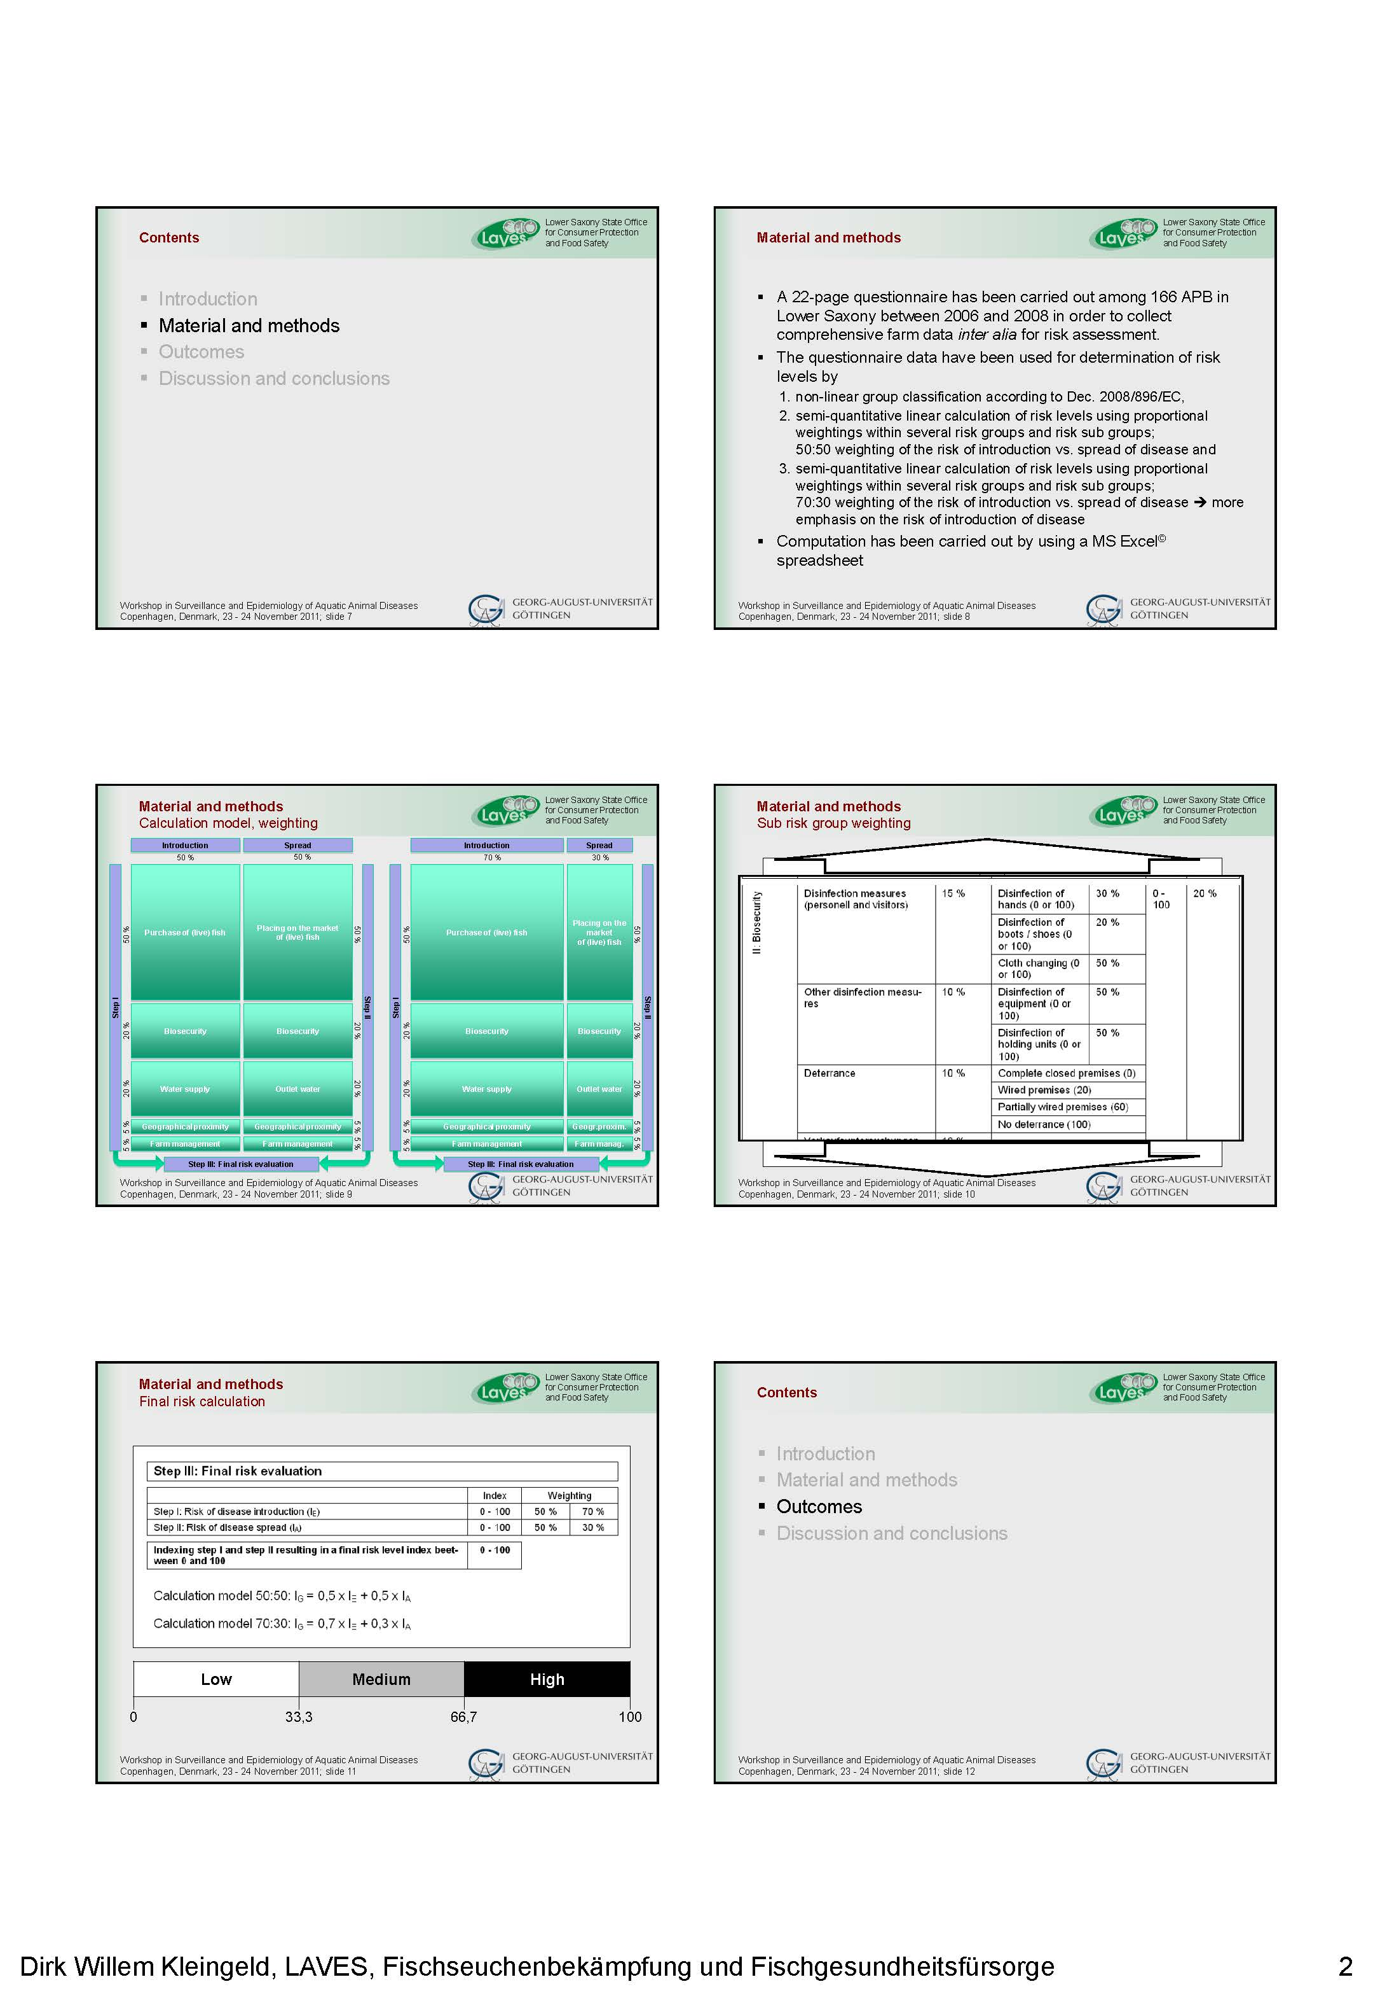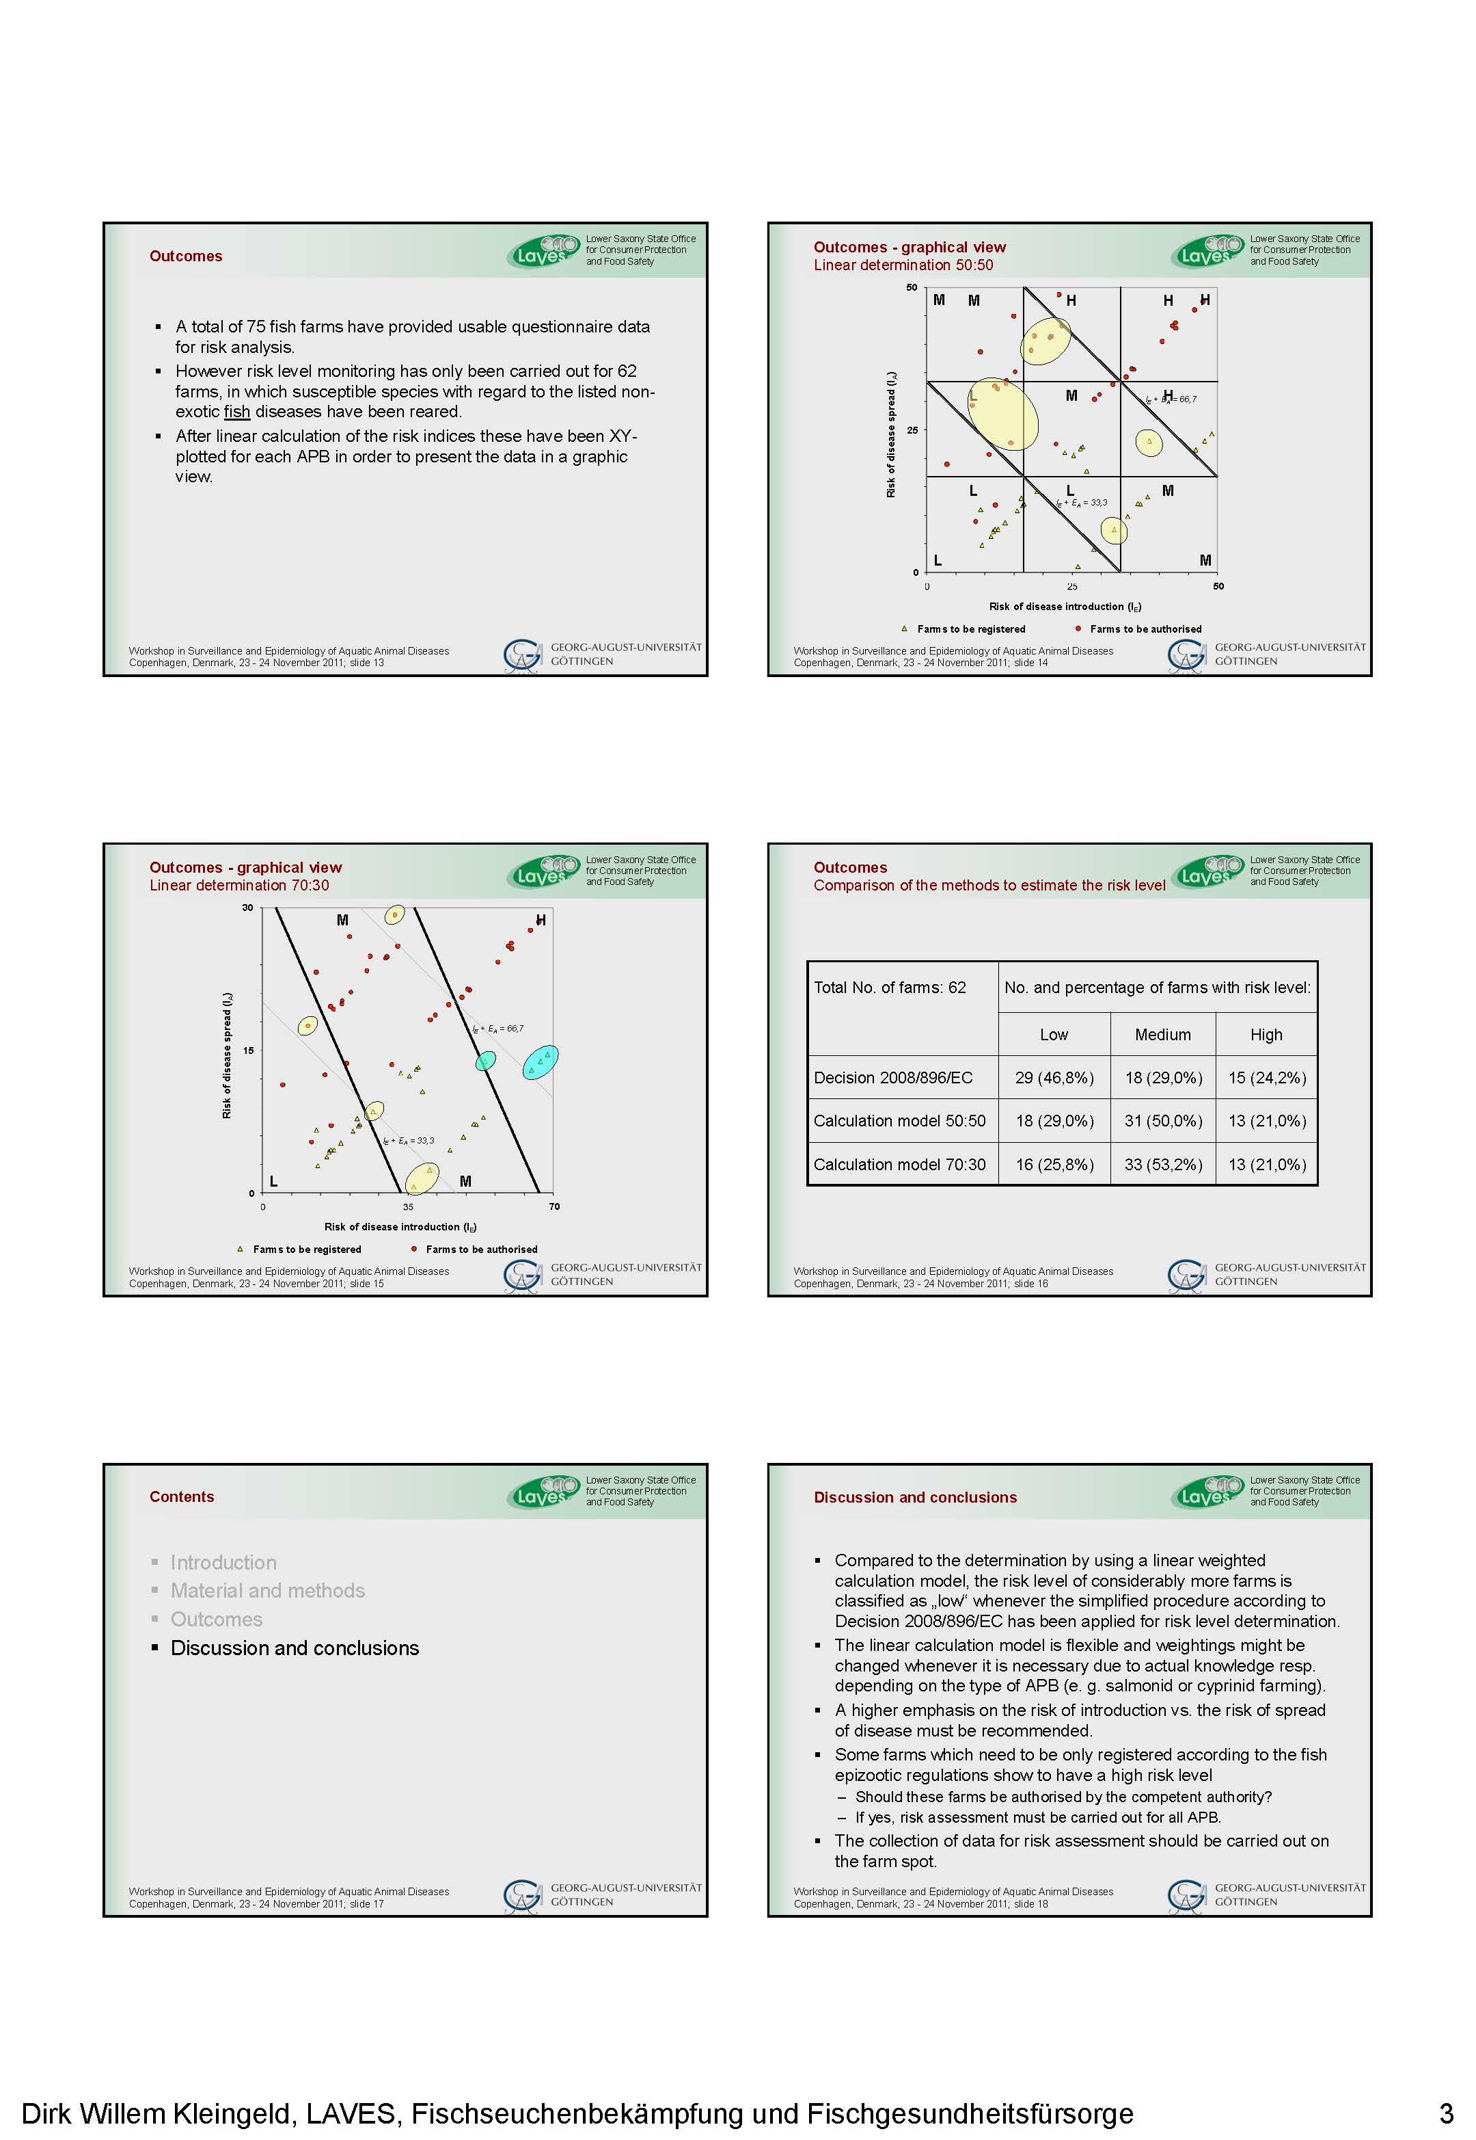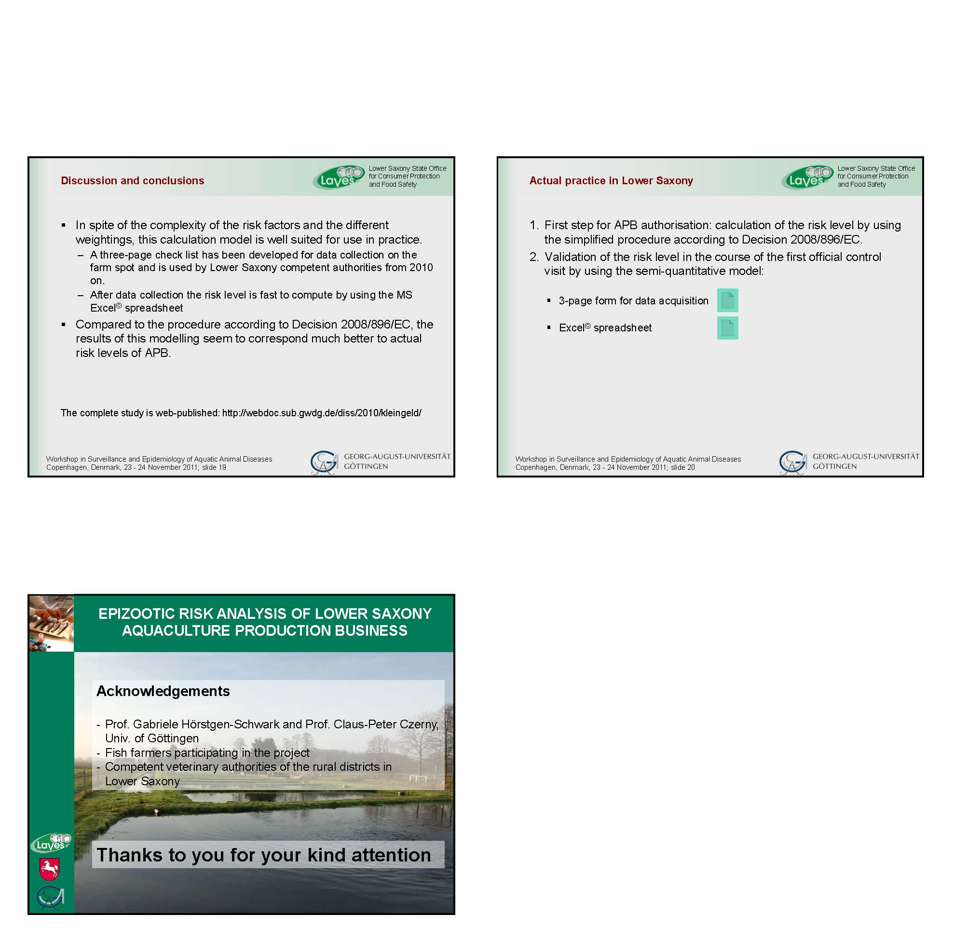

Special challenges related to shell and mollusc surveillance

E. Peeler
Centre for Environment, Fisheries and Aquaculture Science
Barrack Road, Weymouth, Dorset, DT4 8UB
UK
E-mail: ed.peeler@cefas.co.uk

Presentation:

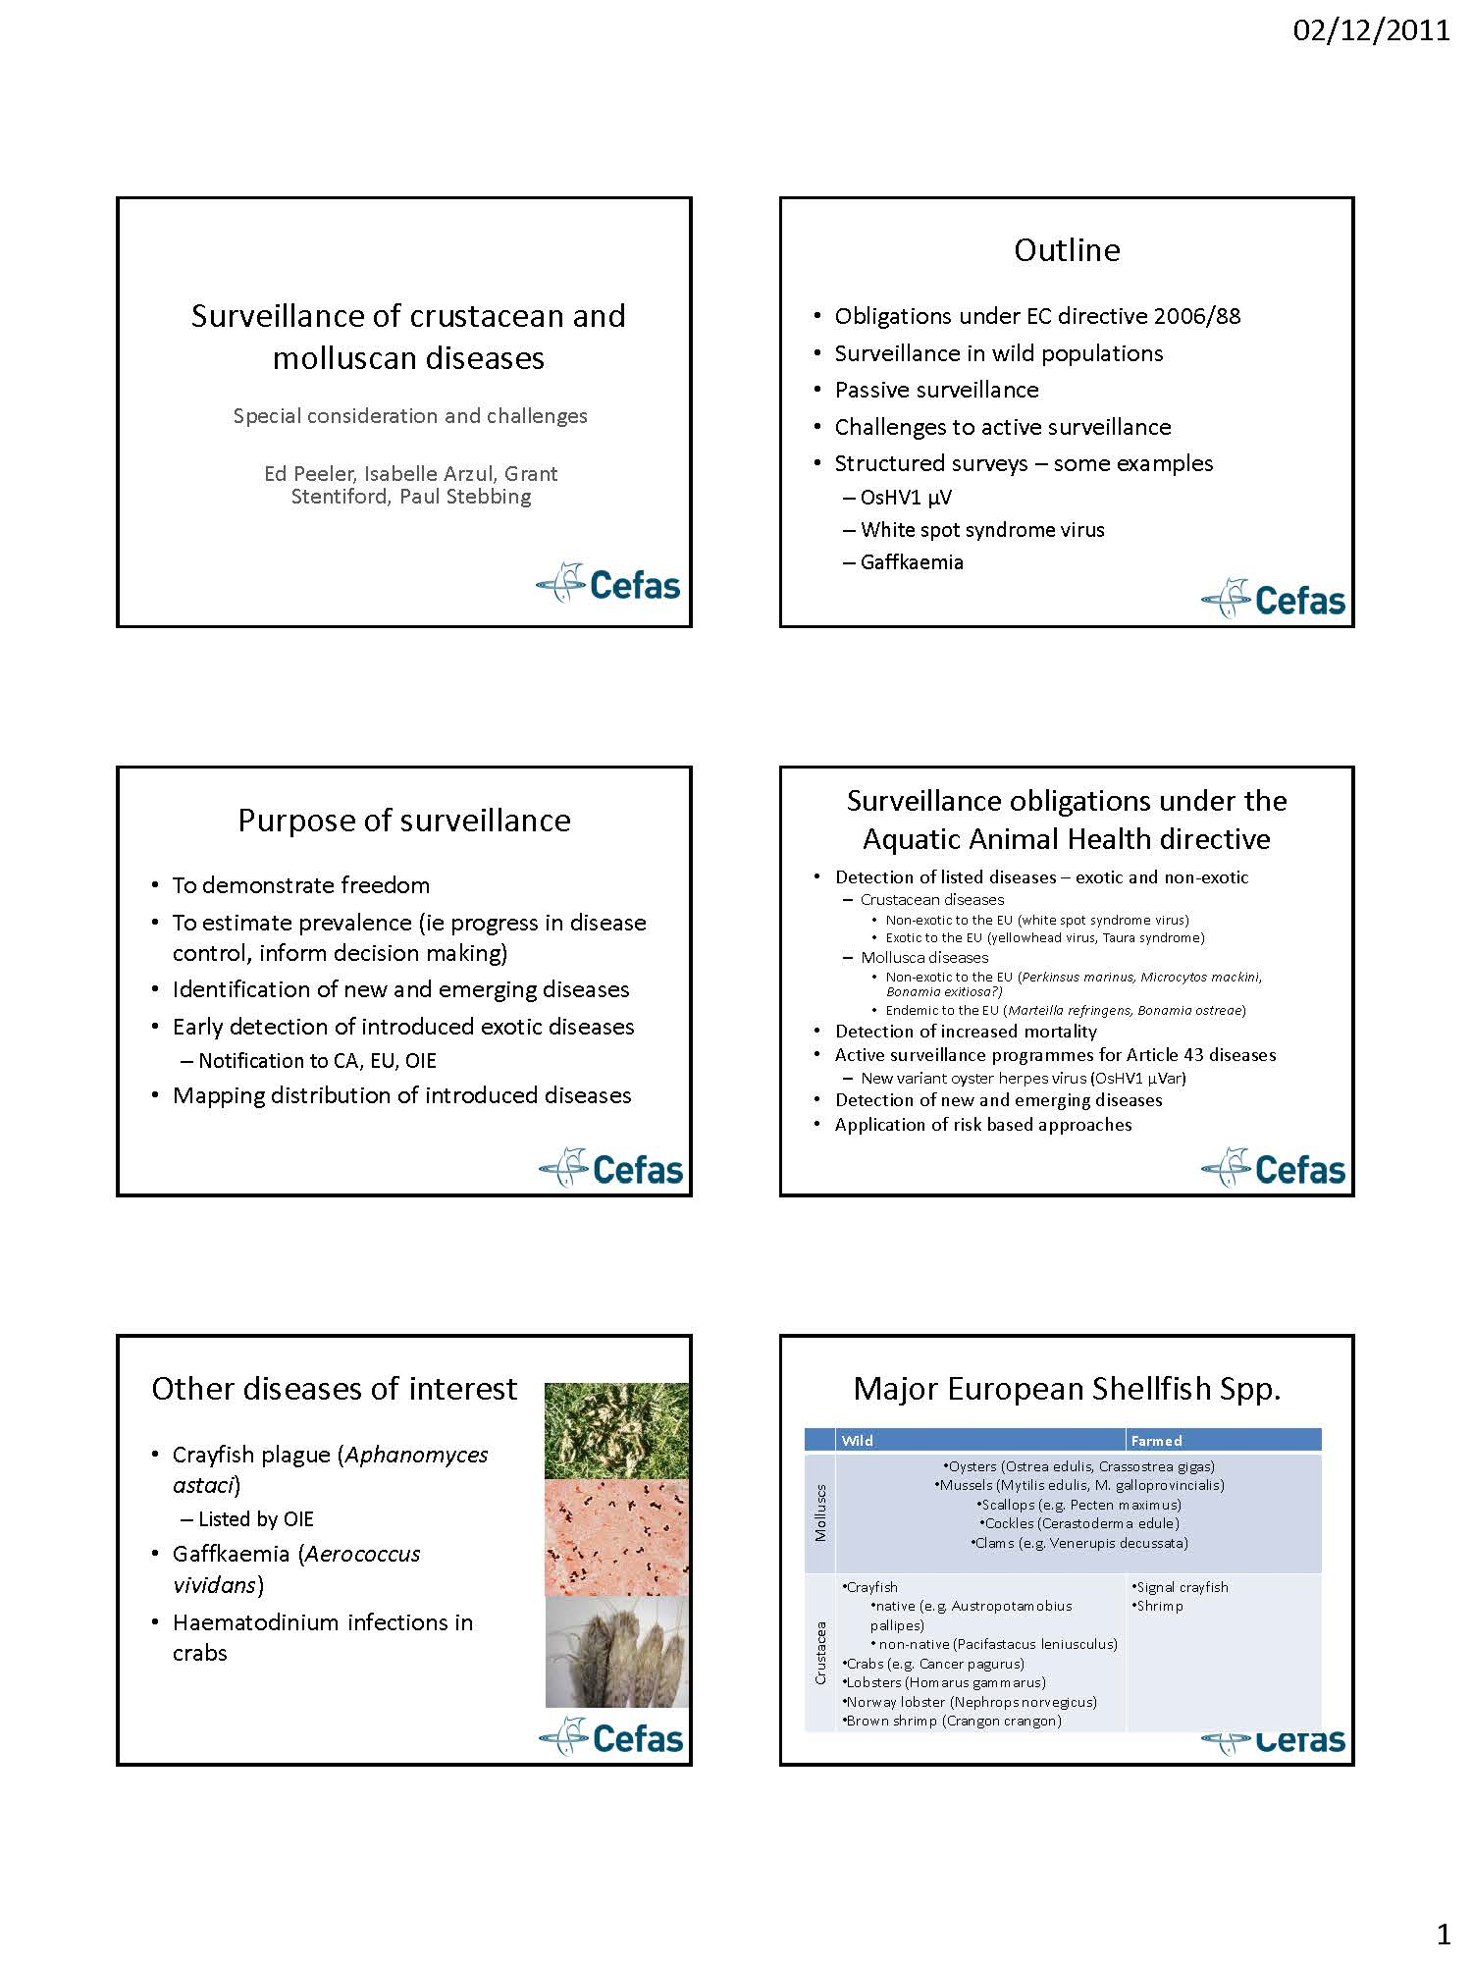
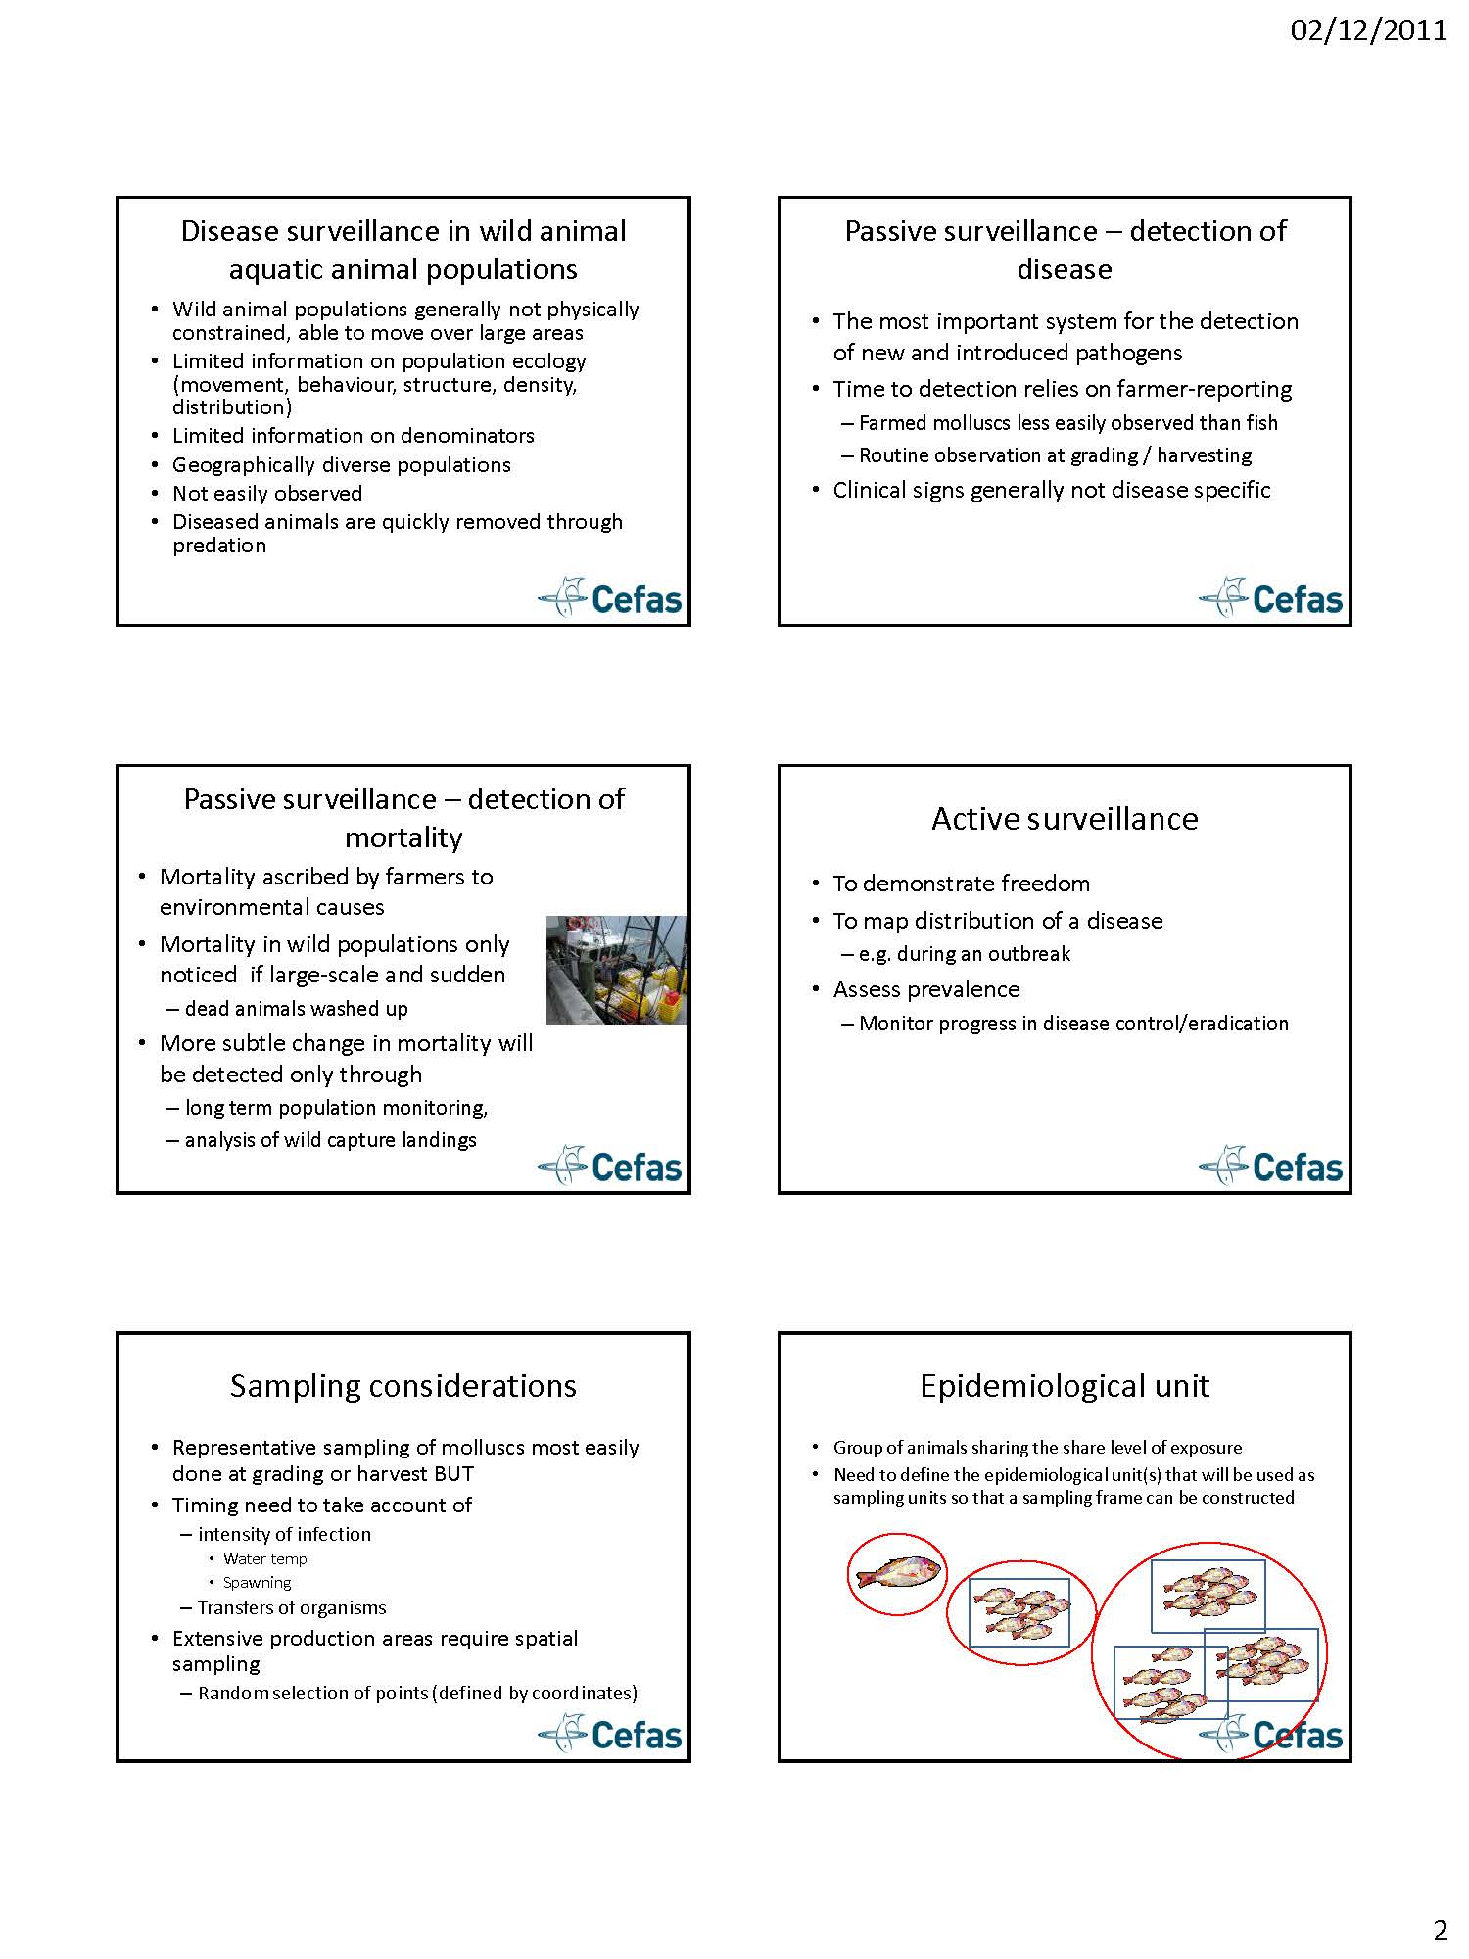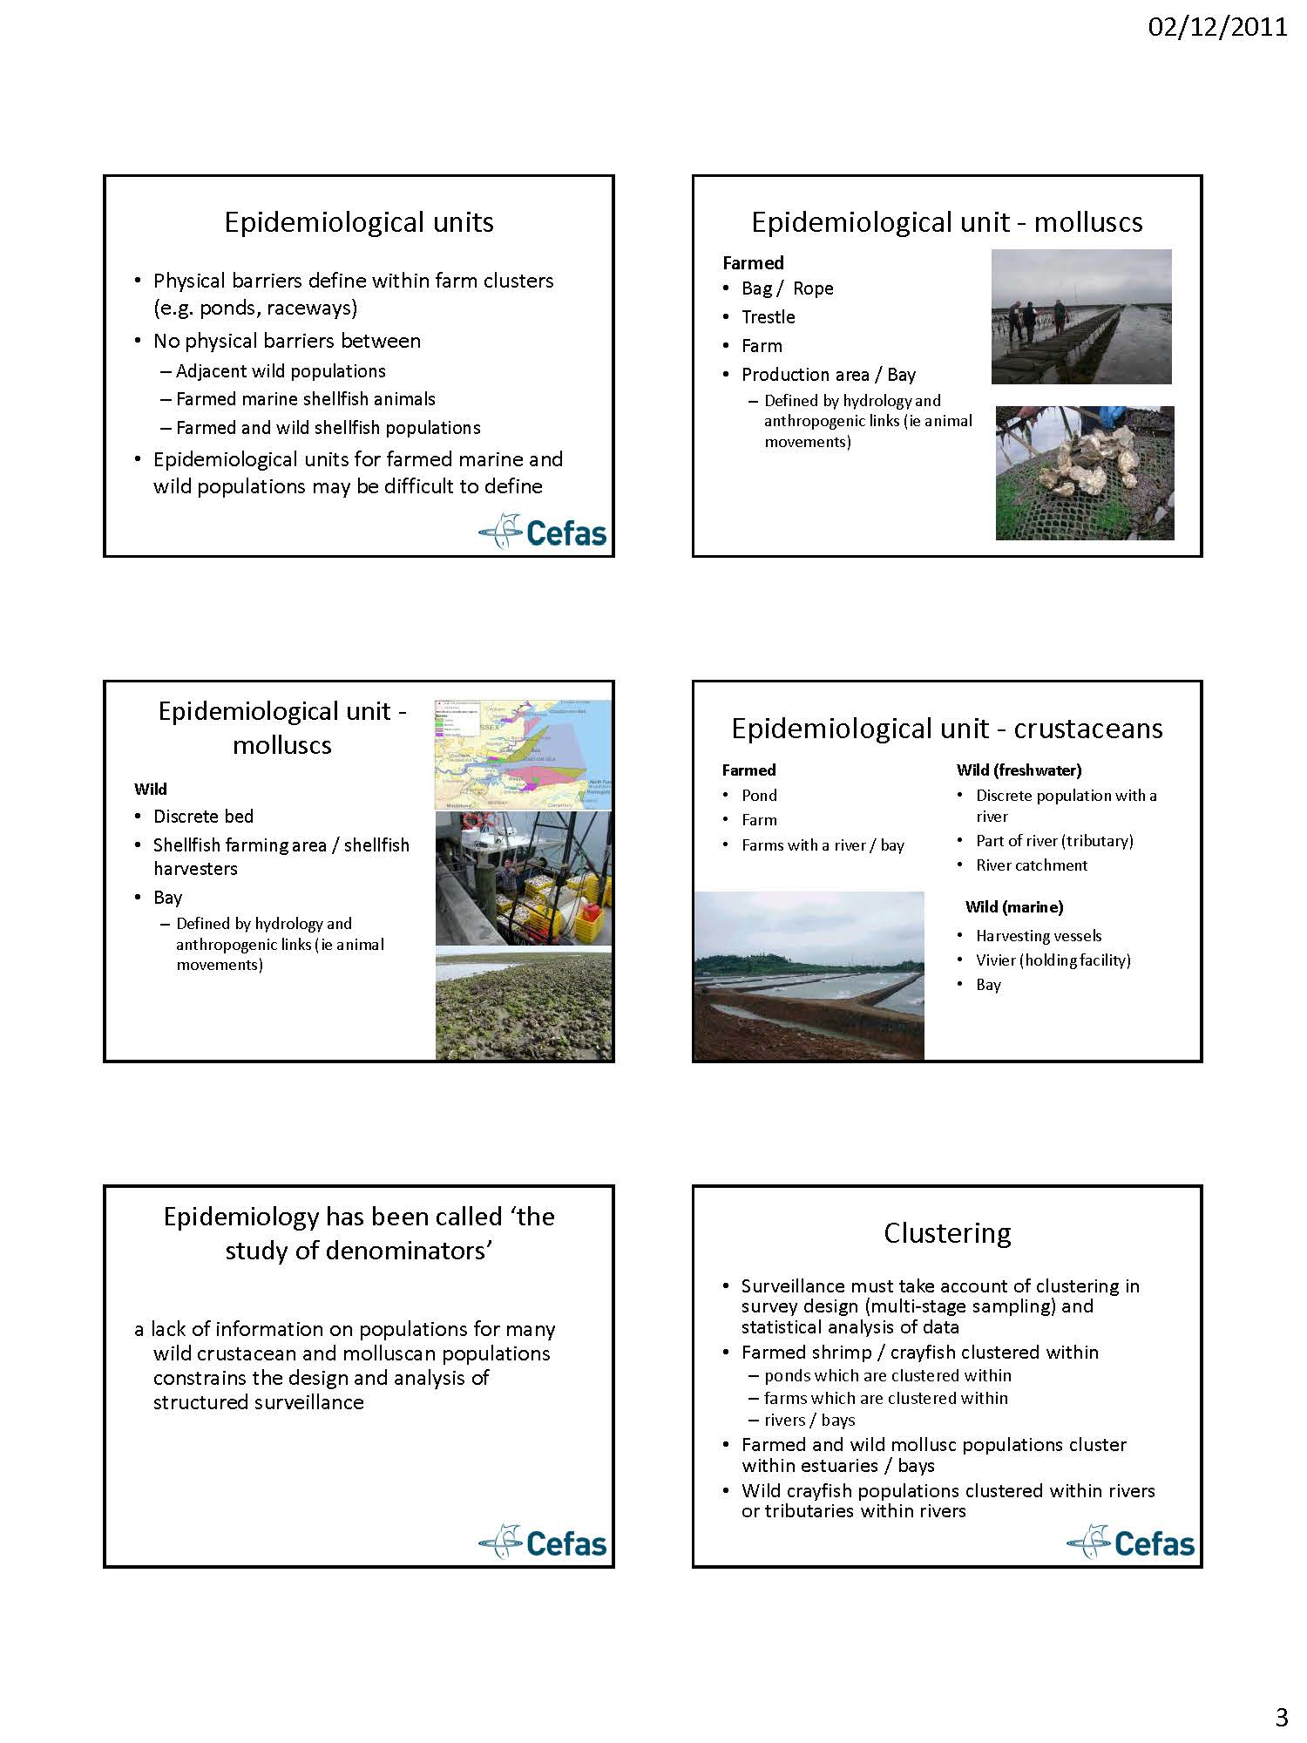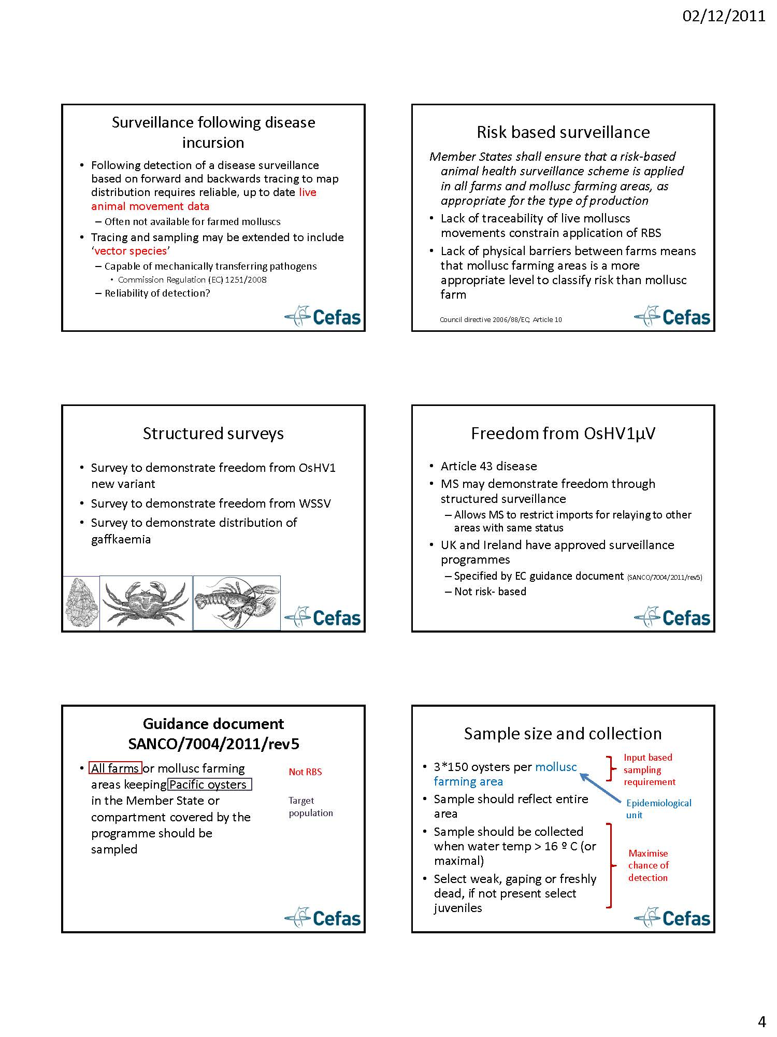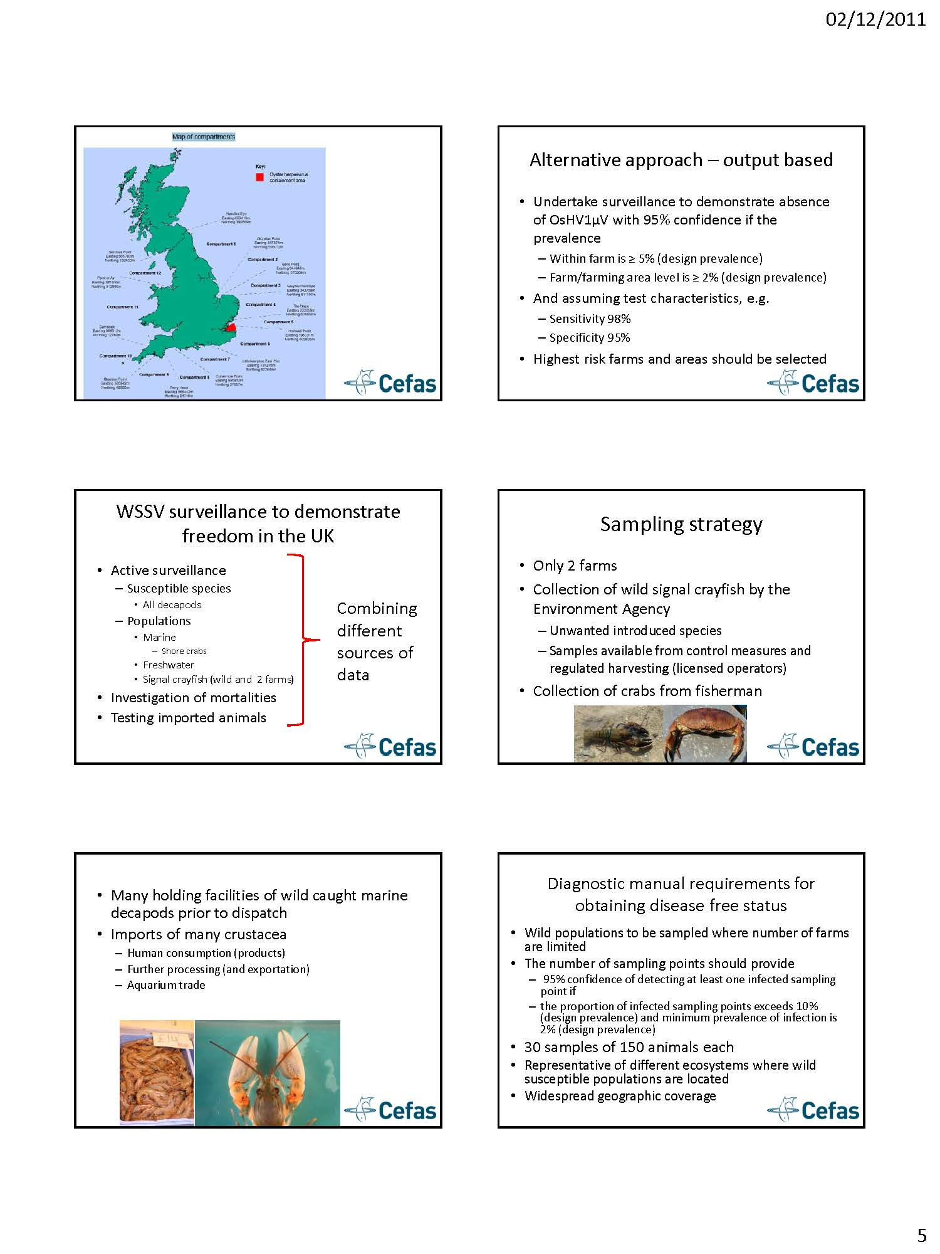
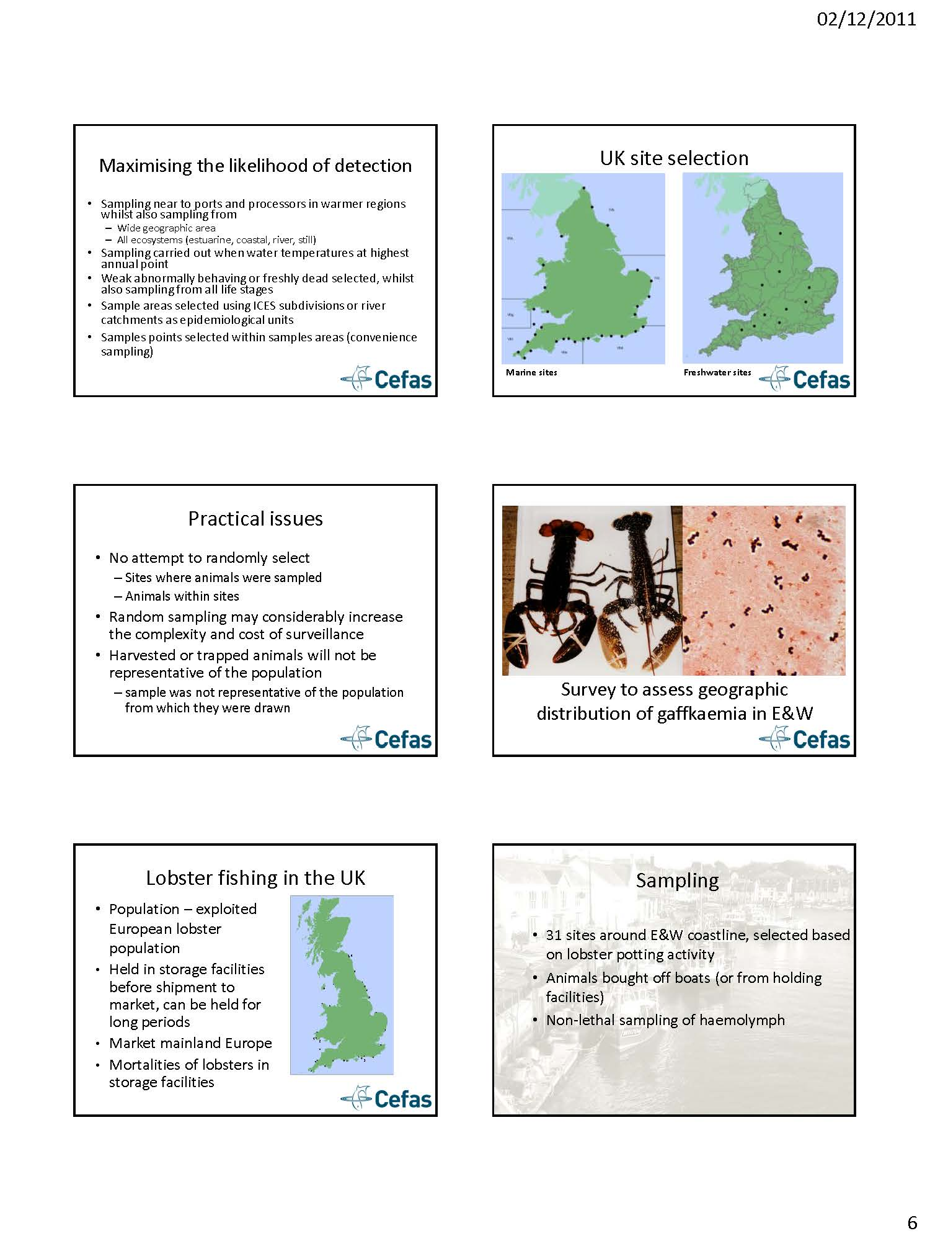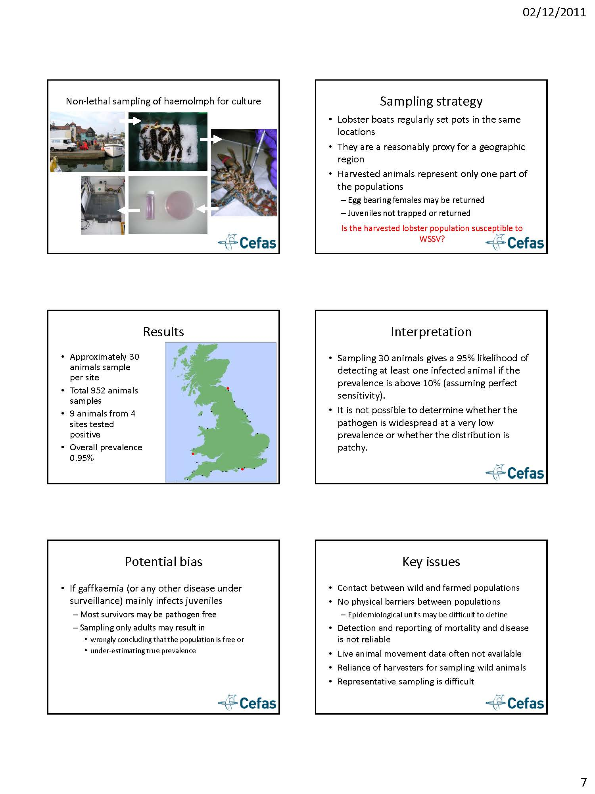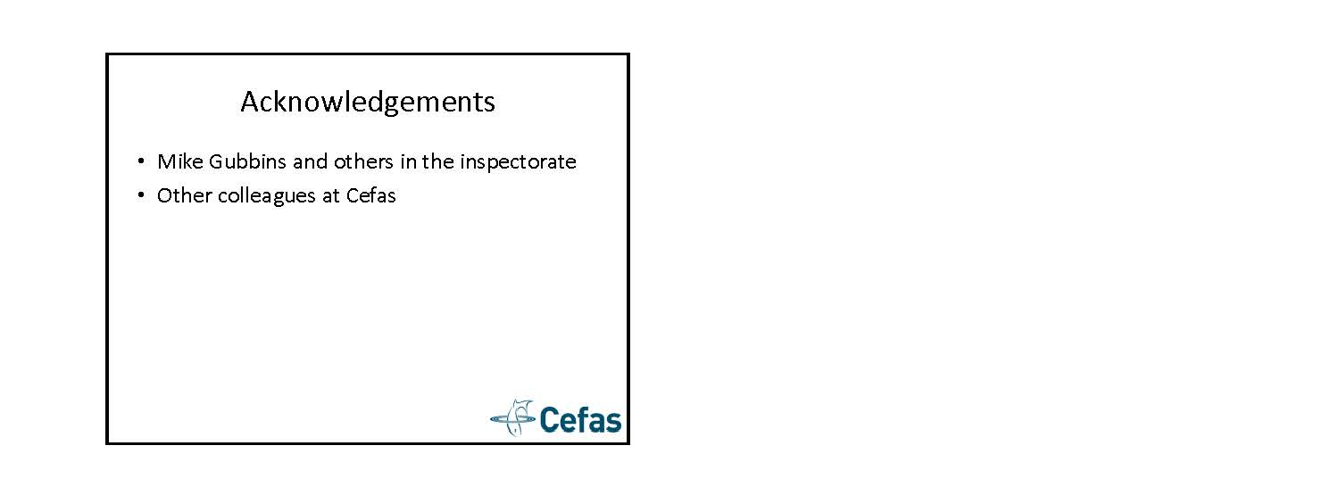

Practical part: Parallel sessions with group-work and practical examples

For this part, the participants were divided into four groups:
- Screening strategies & tracing of pathogens
- Special challenges regarding surveillance in shell & molluscs
- Design of surveillance programmes
- Risk factors and risk categorization
Within each group, several topics or scenarios were discussed, and a synthesis of the discussions was shared with the rest of the workshop in the discussion session on the second day. For ease of reading, the description of the group works, the discussions and comments from both days are all collected under each group below.

Screening strategies & tracing of pathogens
Facilitators: C. Caraguel & P. Jansen

In this group there were 12 participants.
The participants were presented with three scenarios, which were discussed within the group.

Scenario 1: A new disease syndrome emerges in salmon farming. Mortalities are very high. This situation needs to be managed, and this is up to you.
Question: What initial information would you seek?
Answers:
- Case definition (host/pathogen/environment)
- Mortality pattern
- Description of spatial and temporal distribution
- Outbreak investigation (risk factor analysis)
All with the purpose of seeking the disease natural history

Scenario 2: The disease turns out to be infectious and caused by a known virus. Spatial patterns of outbreaks are drawn, marking only farms that have had an outbreak of the disease recently. This shows a pattern with some clusters of diseased farms but also some isolated farms.
Question: What are the most likely transmission pathways, and how would you find out which it is?
Answers:
- Vertical transmission: Investigate association with hatcheries/smolt supplier. Screen broodstock & egg. Upstream (sea sites to hatchery) and downstream (hatchery to sea sites) investigation
- Fish transfer: Temporal. Spatial pattern. Identification of index case. Index case is the link among cases. Contact network analysis.
- Waterborne: Spatial pattern. Association with distance. Hydrodynamics modelling. Sentinel fish

Scenario 3: Local epidemics emerge – all outbreaks with the same virulent virus strain => horizontal spread between neighboring farms. Low-virulent ISAV found commonly and in all aquatic environments. No associations between smolt origin, brood stock origin and virulent ISAV found
Question: How would you manage this? I.e. with reference to:
- Restrictions on diseased farms
- Criteria for restrictions (diagnosis)
- Risk based surveillance
- Notification of non-virulent strains
Answers:
Regarding restrictions on diseased farms:
-Close the factory
-Isolate naive fish
-Lower the susceptibility of the host
Regarding surveillance:
If ISAV is not present (early detection):
- “Complete” coverage (population/space/time)
- Representativeness (given with coverage, except if resources are limited)
- Dx test as sensitive as possible (maximize NPV)
- Investigate potential false positive with confirmatory test: series interpretation (increase Dx and herd specificity to perfection?)
ISAV is common (case detection):
- “Complete” coverage (population/space/time)
- Representativeness (given with coverage, except if resources are limited eg harvest boat)
- “Only clinical outbreak”
- Dx test as specific as possible (maximize PPV)

Special challenges regarding surveillance in shell & molluscs
Facilitator: E. Peeler

In this group, the following three topics were addressed:
- Risk-based surveillance (RBS) for mollusc diseases
- Improving farmer-reporting of mortality
- Determining a cut-off for qPCR

Ad 1) RBS main issues for molluscs are
- Biosecurity
- Interface with wild
- Definition of epidemiological units
- Traceability live animal movements
Attitudes towards biosecurity and disease: Shellfish farmers have less interest in biosecurity and disease control compared with finfish farmers. Disease in farmed shellfish is often viewed as a natural event and cannot be prevented. Biosecurity in open water production is inherently poor, but hatcheries can maintain good biosecurity.
Authorisation / registration of aquaculture production businesses: Register of APBs in EU MS is incomplete. RECC review current situation of authorisation/registration in the EU, including methods of requiring data, main problems in implementation ( it is difficult to harmonise divergent data sources (regional, different ministries), there is a large number of farms), and can the database of APBs be regularly updated (costs)?
Surveillance could include other businesses: There are advantages to include other businesses in surveillance programmes. RECC need flexibility in to include businesses currently not authorized as APBs in RBS programmes.
Pathways of spread:
Introduction of mollusc diseases into a country:
- Illegal movements of juveniles across border easily done, lack of enforcement
- Diversion of animals imported for human consumption to aquaculture
- Import of used aquaculture equipment (note recent Australian reg re: disinfection)
Spread within a country:
- RECC: undertake risk ranking at level of the shellfish farming area (SFA)
- Focus attention on recording movements between SFA
- Currently data on movement of molluscs is poor e.g. movements between sites in different SFA owned by the same business often not recorded
Other factors influencing risk:
- Type of farm
  - Mix of age classes (Farms keeping all age classes higher risk (classify farms by type of animal sold))
  - Source of spat (Currently not clear if hatchery sources spat higher or lower risk than wild sourced)
  - Size of farm (Number of sites)
- Presence of vectors and susceptible in zone

Ad 2) Improving farmer reporting:
- Compensation
  - Lack of compensation discourages reporting of notifiable disease
  - Compensation may result in misreporting
  - Tie compensation to assessment of biosecurity
- Communication by CA about importance of reporting mortality
- Guidance on stock inspection
- Guidelines on definition of abnormal mortality (eg number of bags affected)
- Benefits to farmers: feedback results relies on a system to analyse data on annual or regional basis
Approaches: Work through producer organizations. Benefits to industry of early reporting, no benefit to the individual who reports. Need farmer funded insurance schemes

Ad 3) Setting a cut-off for a qPCR
- From OsHV-1 qPCR ring trial labs seem to use different cutt-off values.
- When conducting ring trials.Ask labs for information on cut-off points and ct values.
- Cutt-off depend on goal of test:
  - Declare freedom of disease
  - Estimate prevalence of pathogen

Design of surveillance programmes
Facilitator: A. Cameron

The content of the group work are included in the following presentation, which was given to the whole workshop on day 2: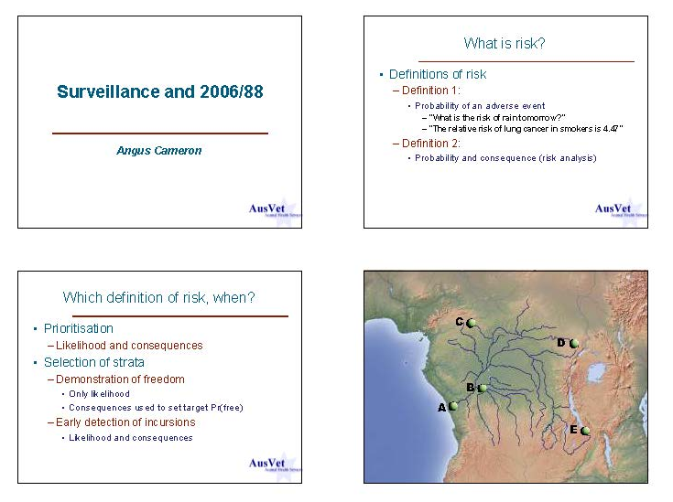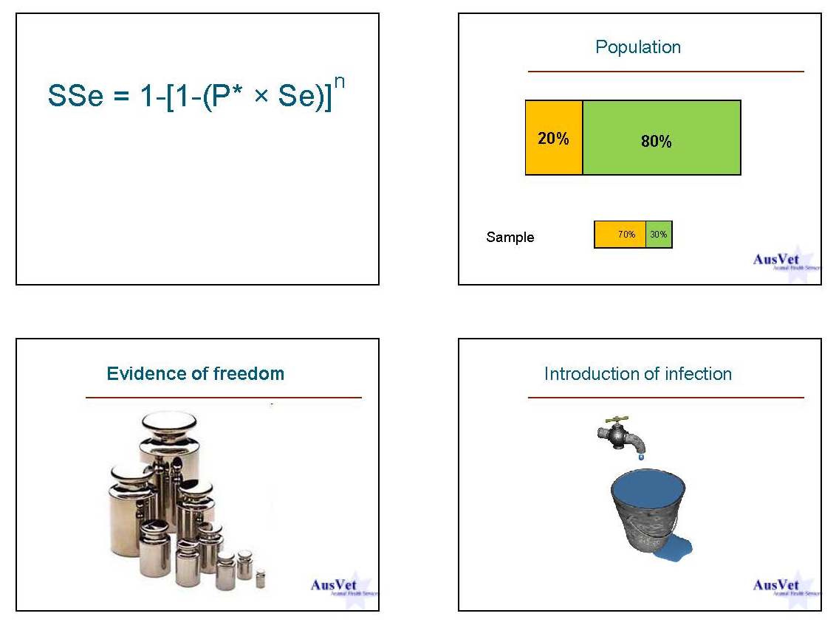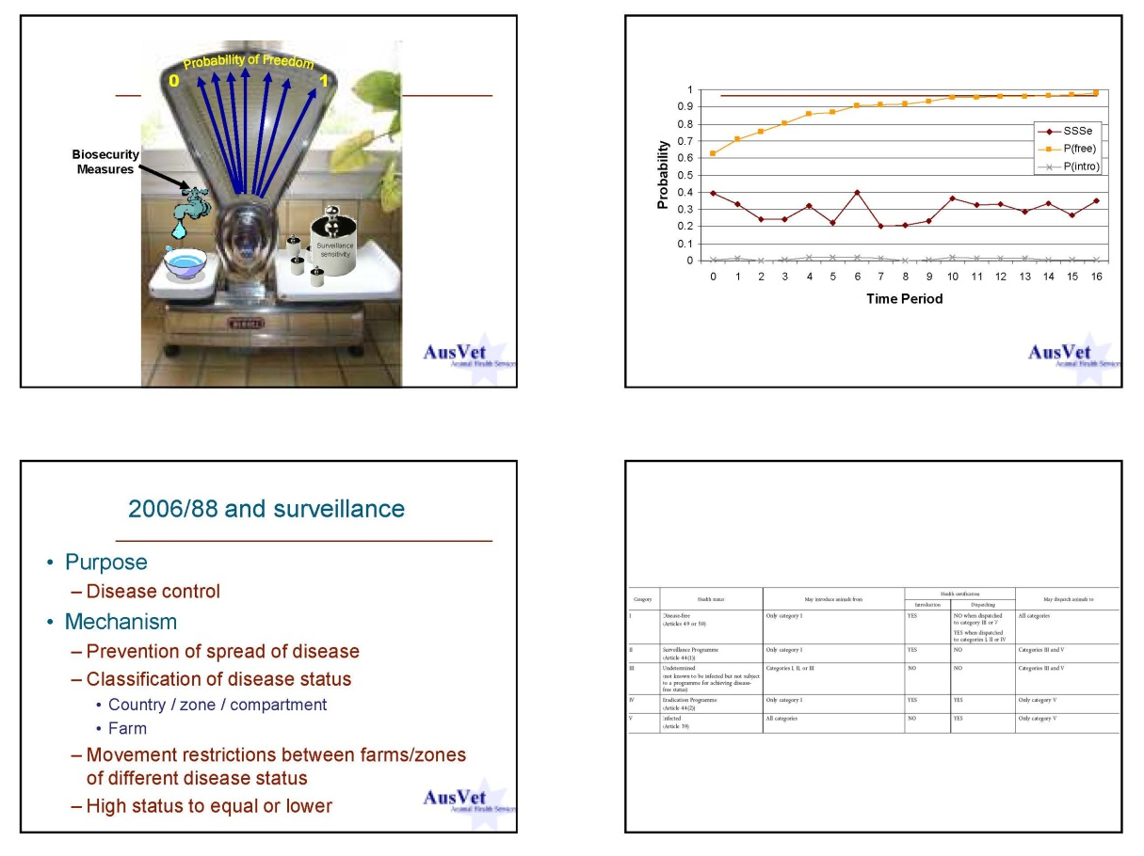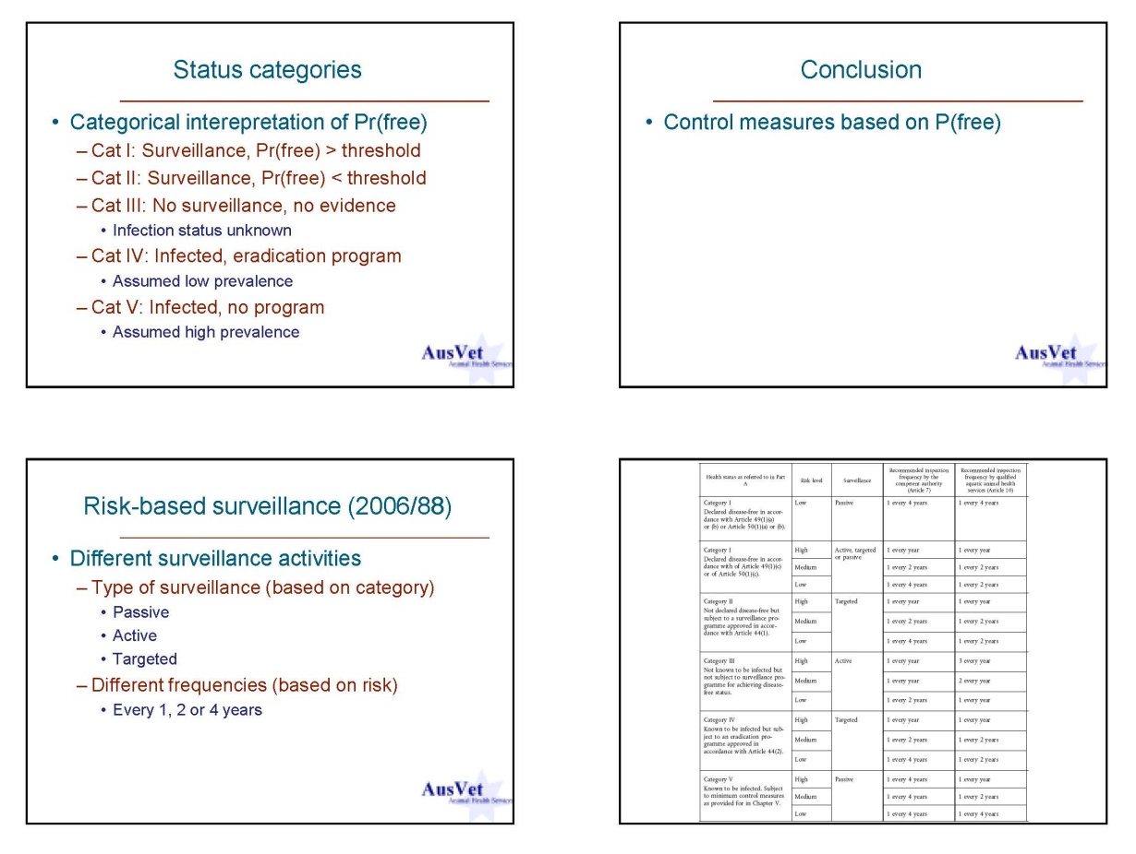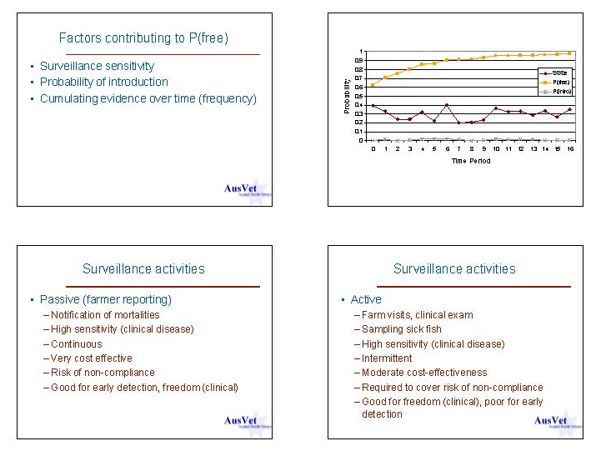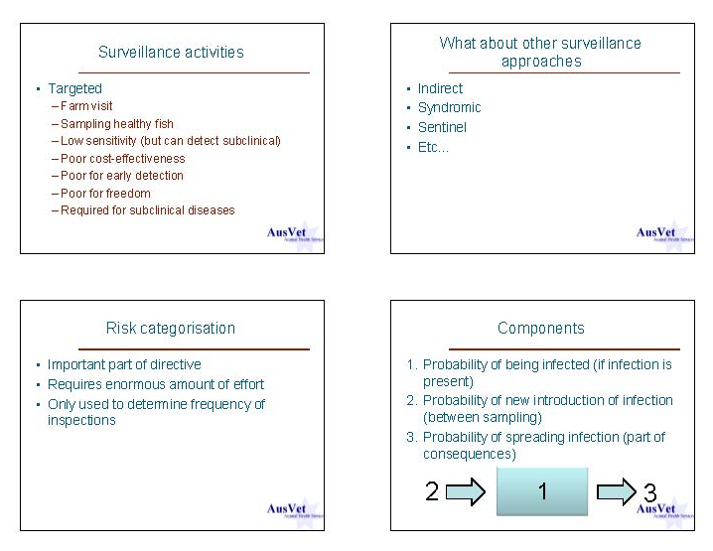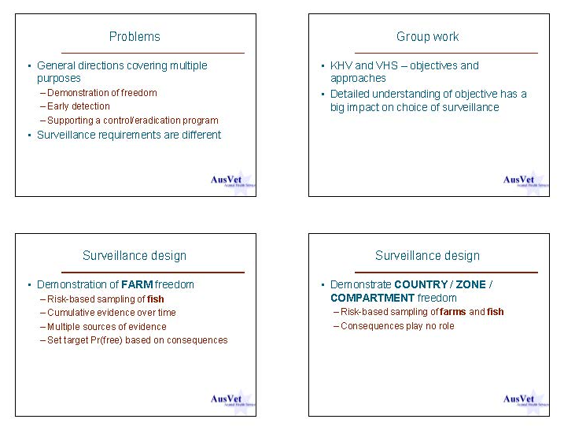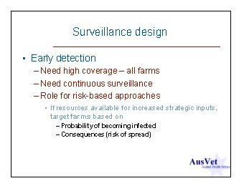

Risk factors and risk categorization
Facilitators: B. Bang Jensen & T. Lyngstad

The purpose of the groupwork was to collate and discuss the most important challenges to risk-ranking of farms within the member states according to the directive 2006/88/EC.

There were 11 participants in the group (plus the facilitators), and they first got to get acquainted by having to present the person sitting next to them after having conducted a short interview.
Thereafter, Birgit Oidtmann from Cefas, UK was invited to give a presentation of the model used for risk-ranking in the UK (Ref: Oidtmann, BC., Crane, CN., Thrush, MA., Hill, BJ & Peeler, EJ. (2011): Ranking freshwater fish farms for the risk of pathogen introduction and spread. Preventive Veterinary Medicine, 102, 329-340.)

Then the participants were divided into 4 groups, and given the following questions:
- Would it be possible to apply one or more of the methods presented today in your country? Why/ why not?
- What data are available in your country for risk-ranking of farms?
- How should any method be altered in order to make it useable to your country?
- How do you make sure, that the risk-ranking is performed equally to all farms within your country?
- How could it be ascertained that the risk-rank of a farm in one country, corresponds to the rank in another?
- (Optional) Could this risk-ranking be applied for all diseases? What would it take to make it applicable to all?
Subsequently, the participants discussed the topics in plenum within the group, and presented a summary of these to the rest of the workshop on the following day.

Comments from the discussions:
What are the challenges to risk-ranking?
- Variations in administration, both within and between member states
- Geographical challenges, including river systems shared with other administrative units
- Many different farming systems
- Reliability of data received from fish farmers
- Fish is low priority in many countries
- Lack of competence/ knowledge on risk factors/ fish diseases
- Comparison between countries is difficult - but not necessary according to guidelines
Which methods can be used for risk-ranking?
- Start with the basic level –as provided in the 2008/896/EC. It is up to the individual MS to decide the level of complexity that they want to use.
- The models from Lower-Saxony, Switzerland and UK are good inspiration for taking it to the next step
What are the incentives for risk-ranking –within each MS and across the countries?
- Economic aspects, cost benefit relationship
- Incentives for surveillance, importance of industry varies between and within countries
- Is it necessary to risk-rank farms that are within health category V (Known to be infected, not subject to surveillance program)? This is maybe not clear.
About the directive:
- The 2006/88/EC gives basic biosecurity requirements. But it is up to the individual MS to decide if they want a higher level.
- The directive is made so that it is applicable in all MS, therefore, there is room for variation and refinement within each MS.
- Be aware that surveillance is used in different contexts in the directive

Disease risk in space and time –Implications for surveillance
Peder Jansen
Norwegian Veterinary Institute
Ullevålsveien 68, 0106 Oslo
Norway
E-mail: peder.jansen@vetinst.no

Presentation: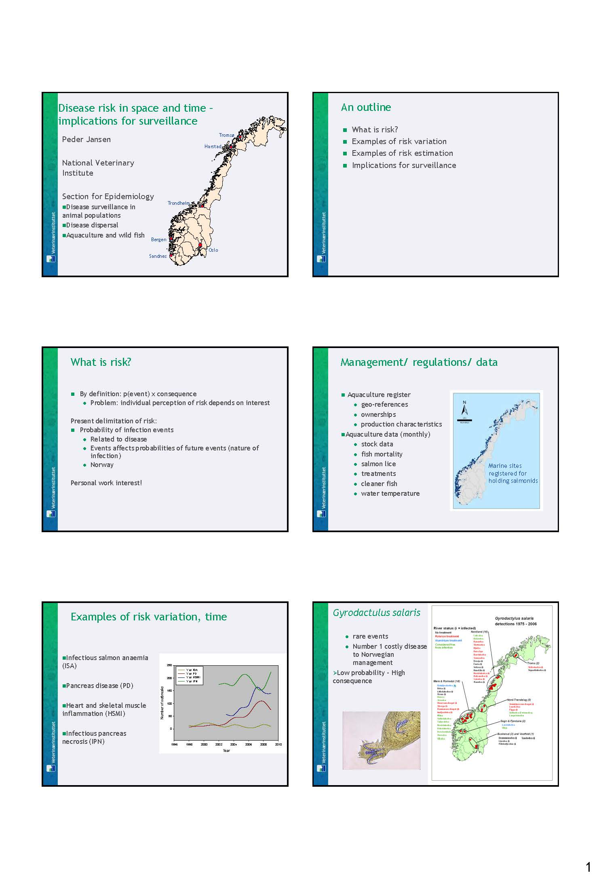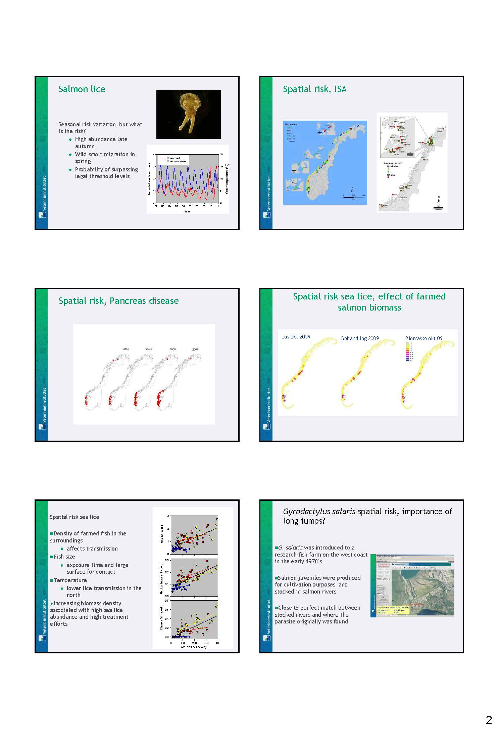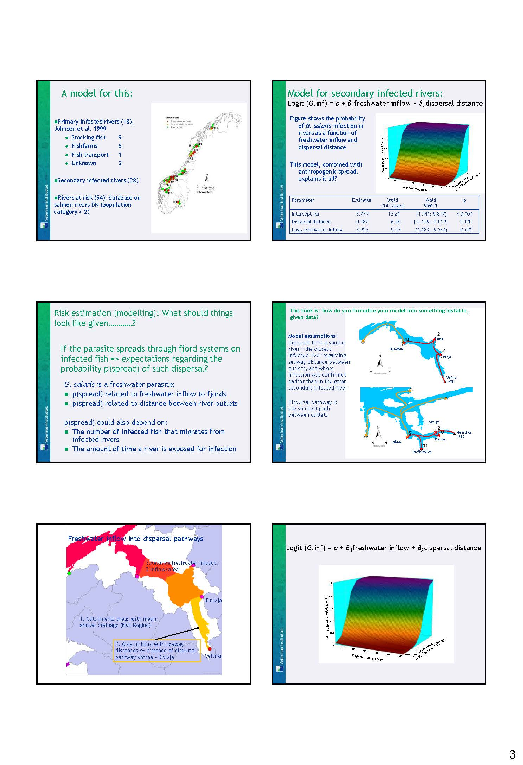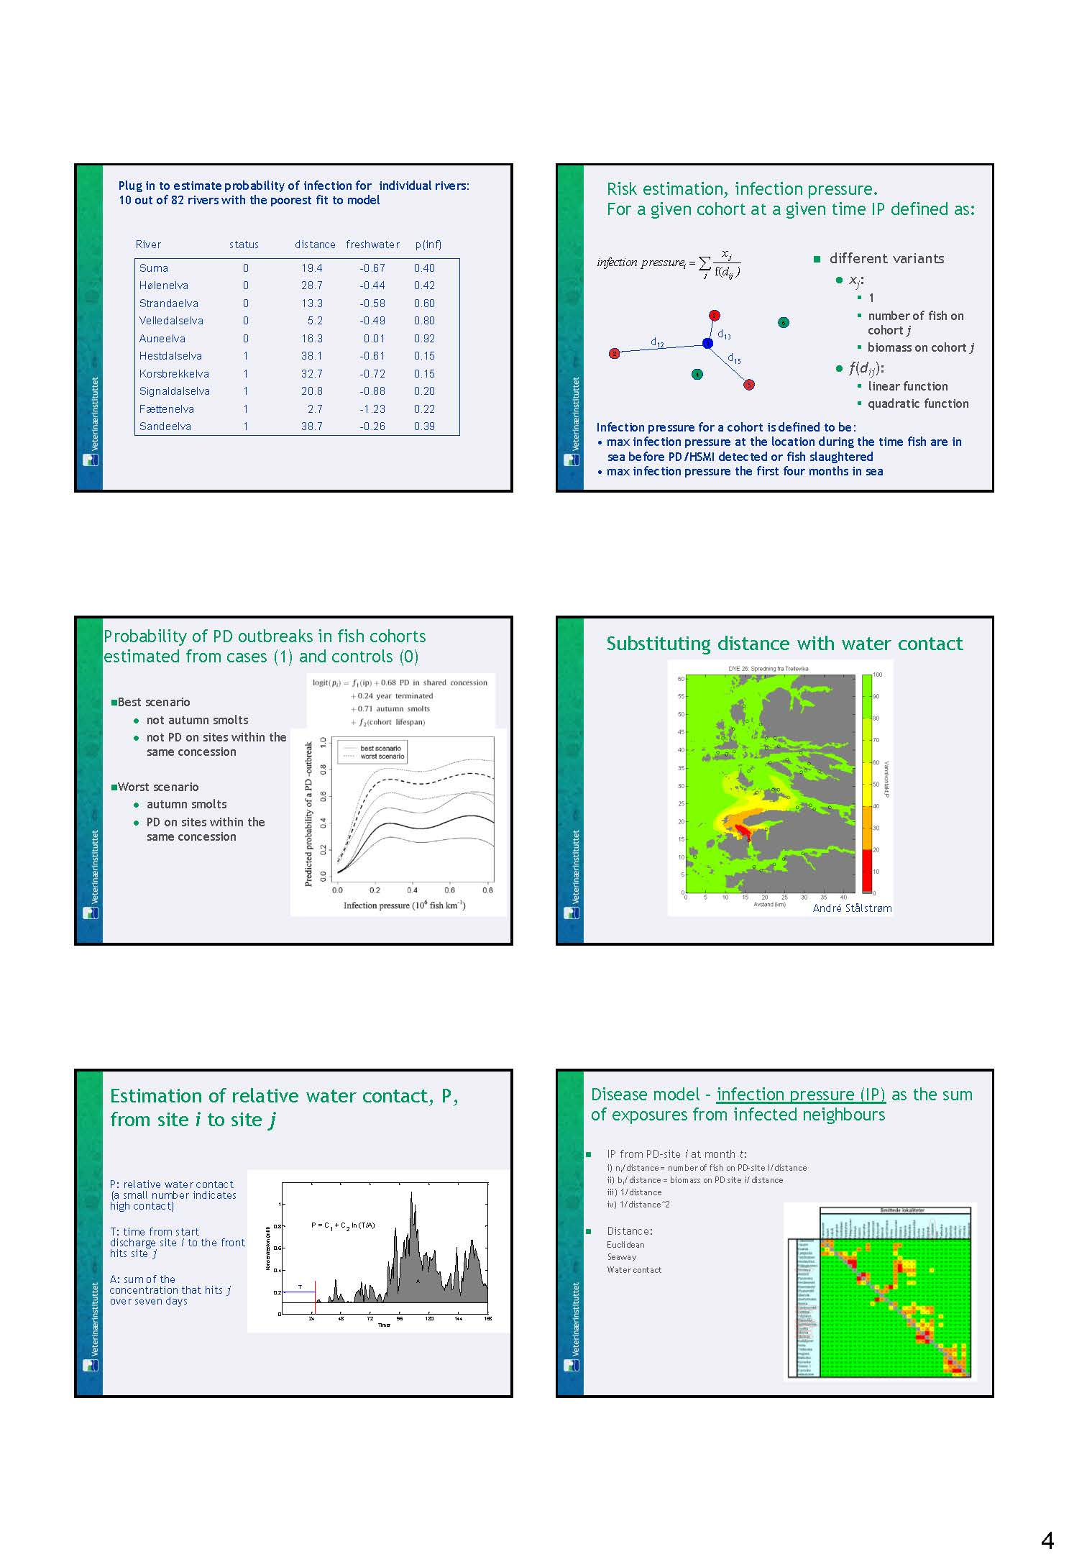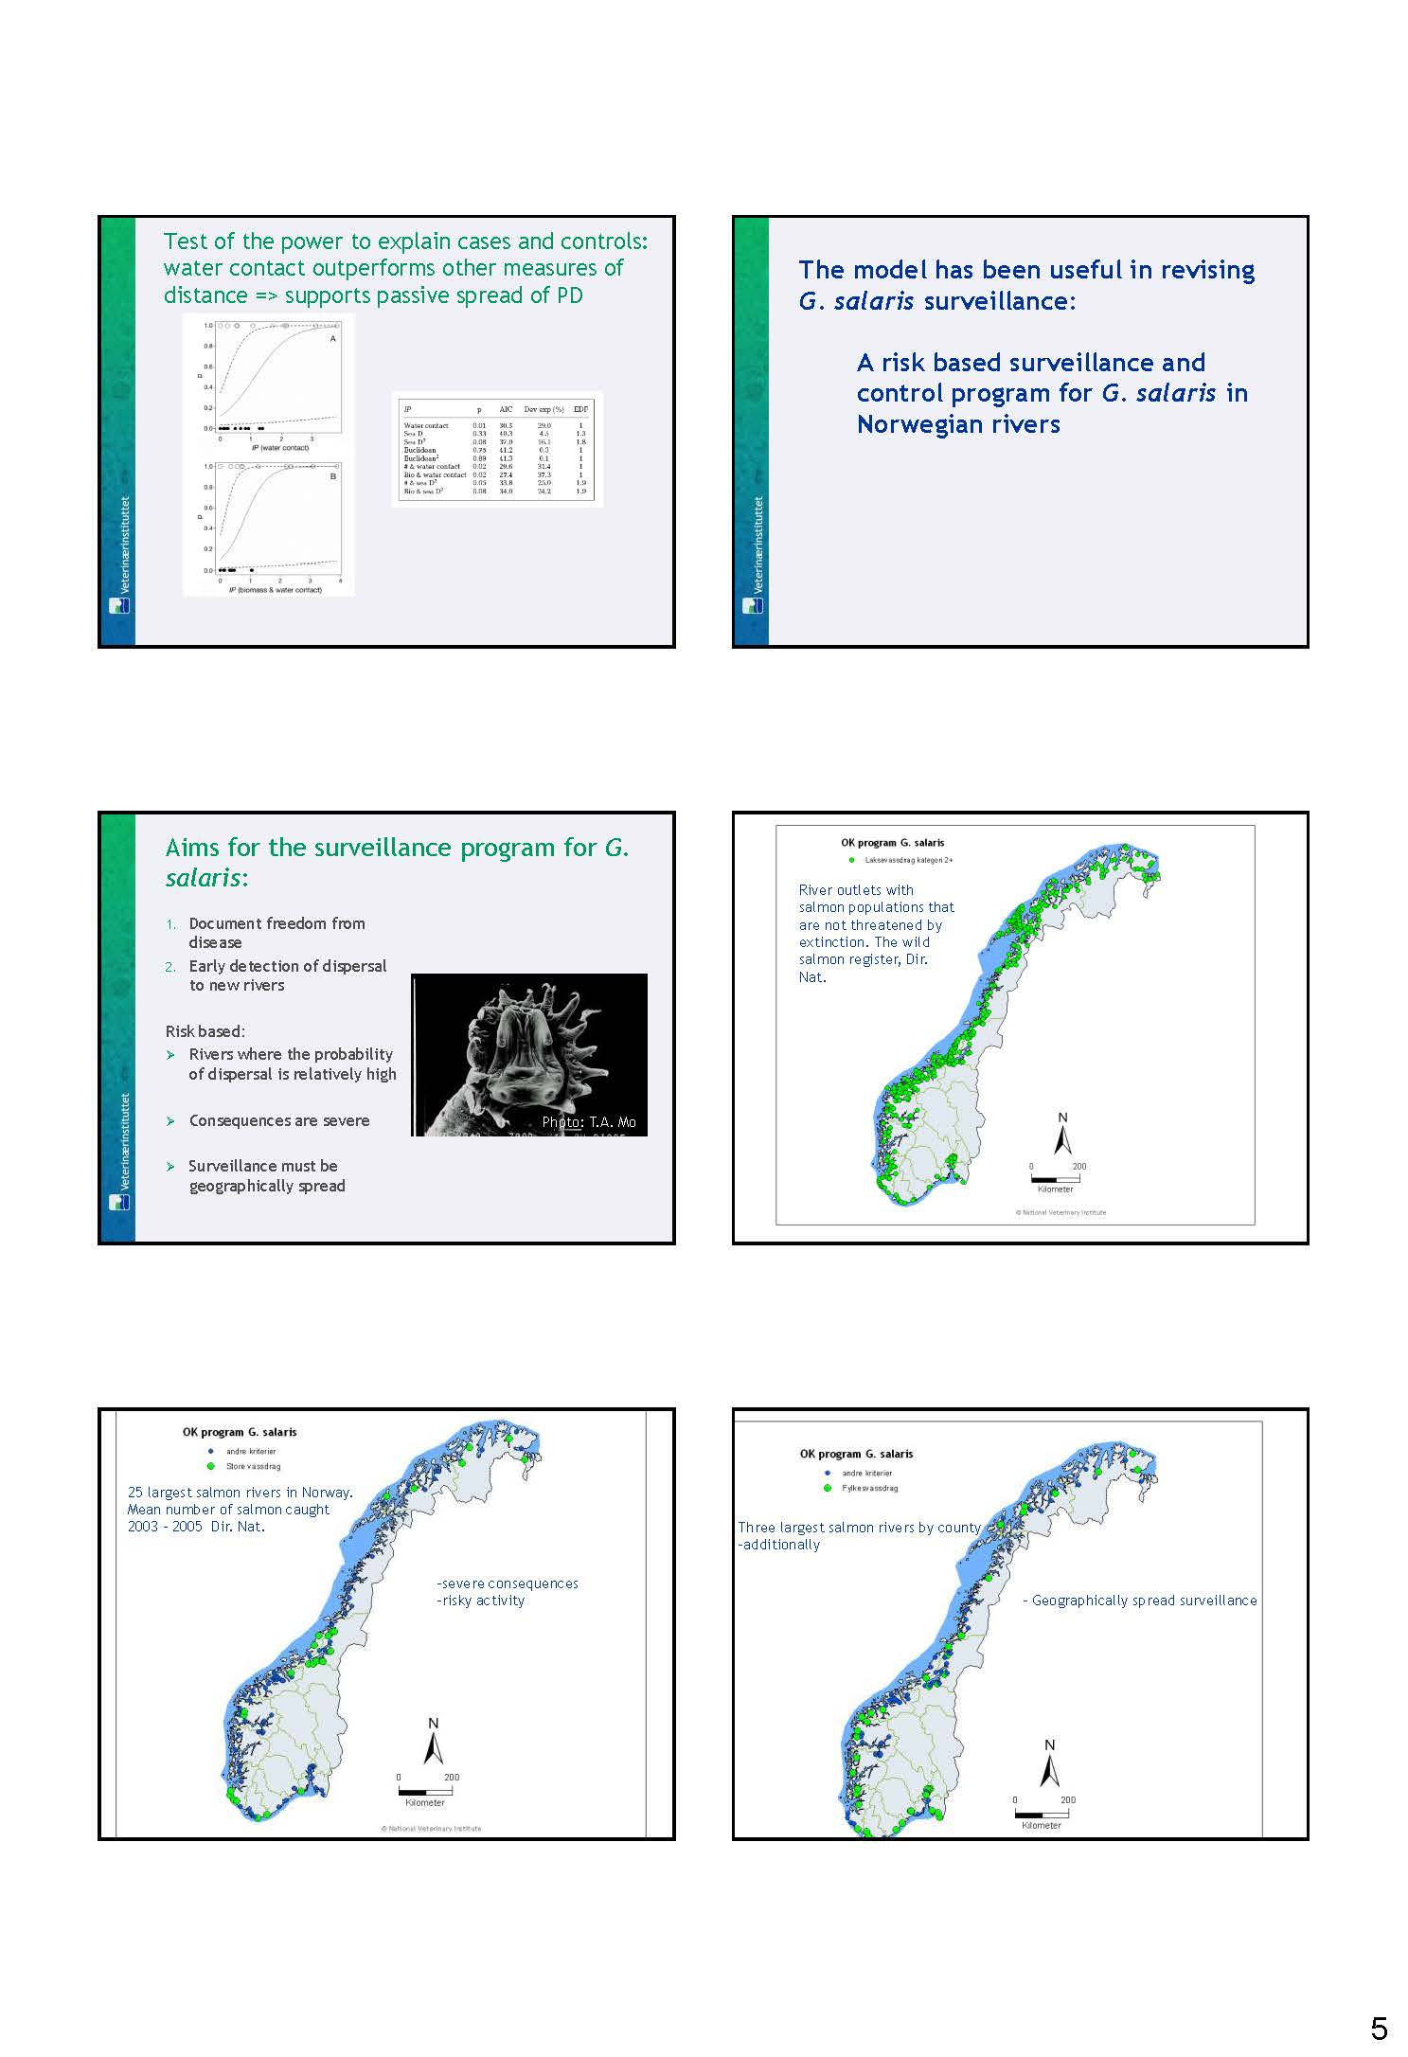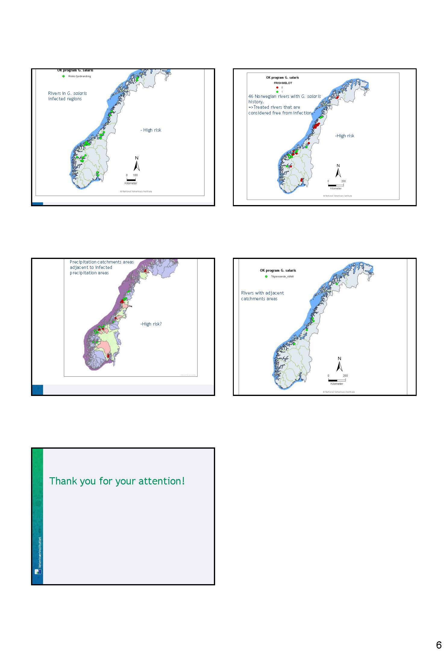

Use of molecular epidemiology in tracing disease

T. Lyngstad
Norwegian Veterinary Institute
Ullevålsveien 68, 0106 Oslo
Norway
E-mail: trude.lyngstad@vetinst.no
Abstract:

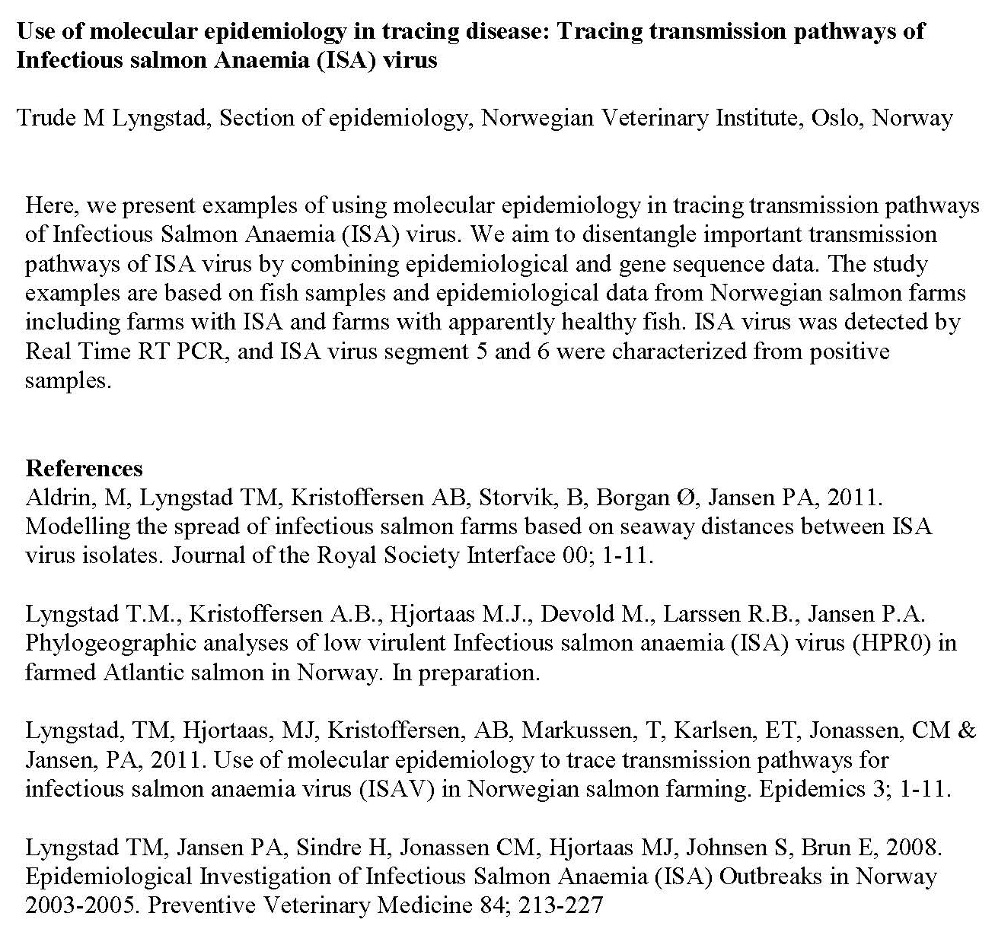

Economic aspects of surveillance programmes
B. Bang Jensen
Norwegian Veterinary Institute
Ullevålsveien 68, 0106 Oslo
Norway
E-mail: britt-bang.jensen@vetinst.no

Presentation: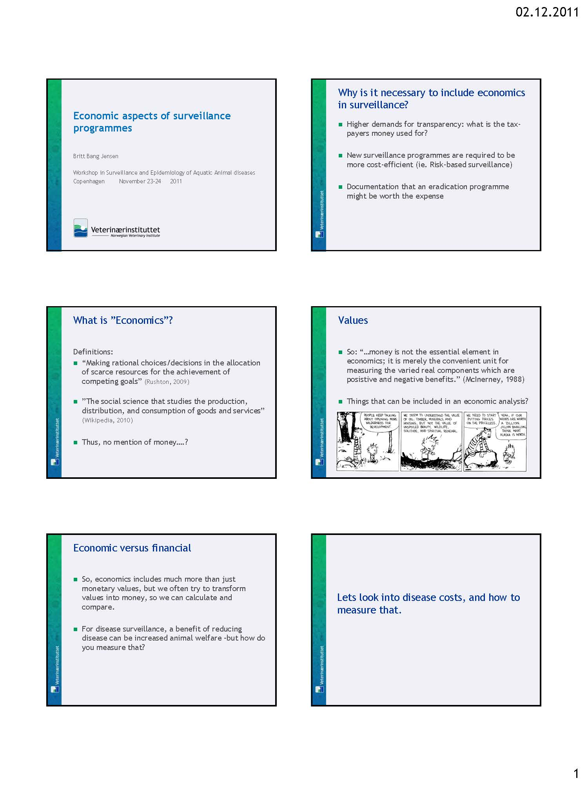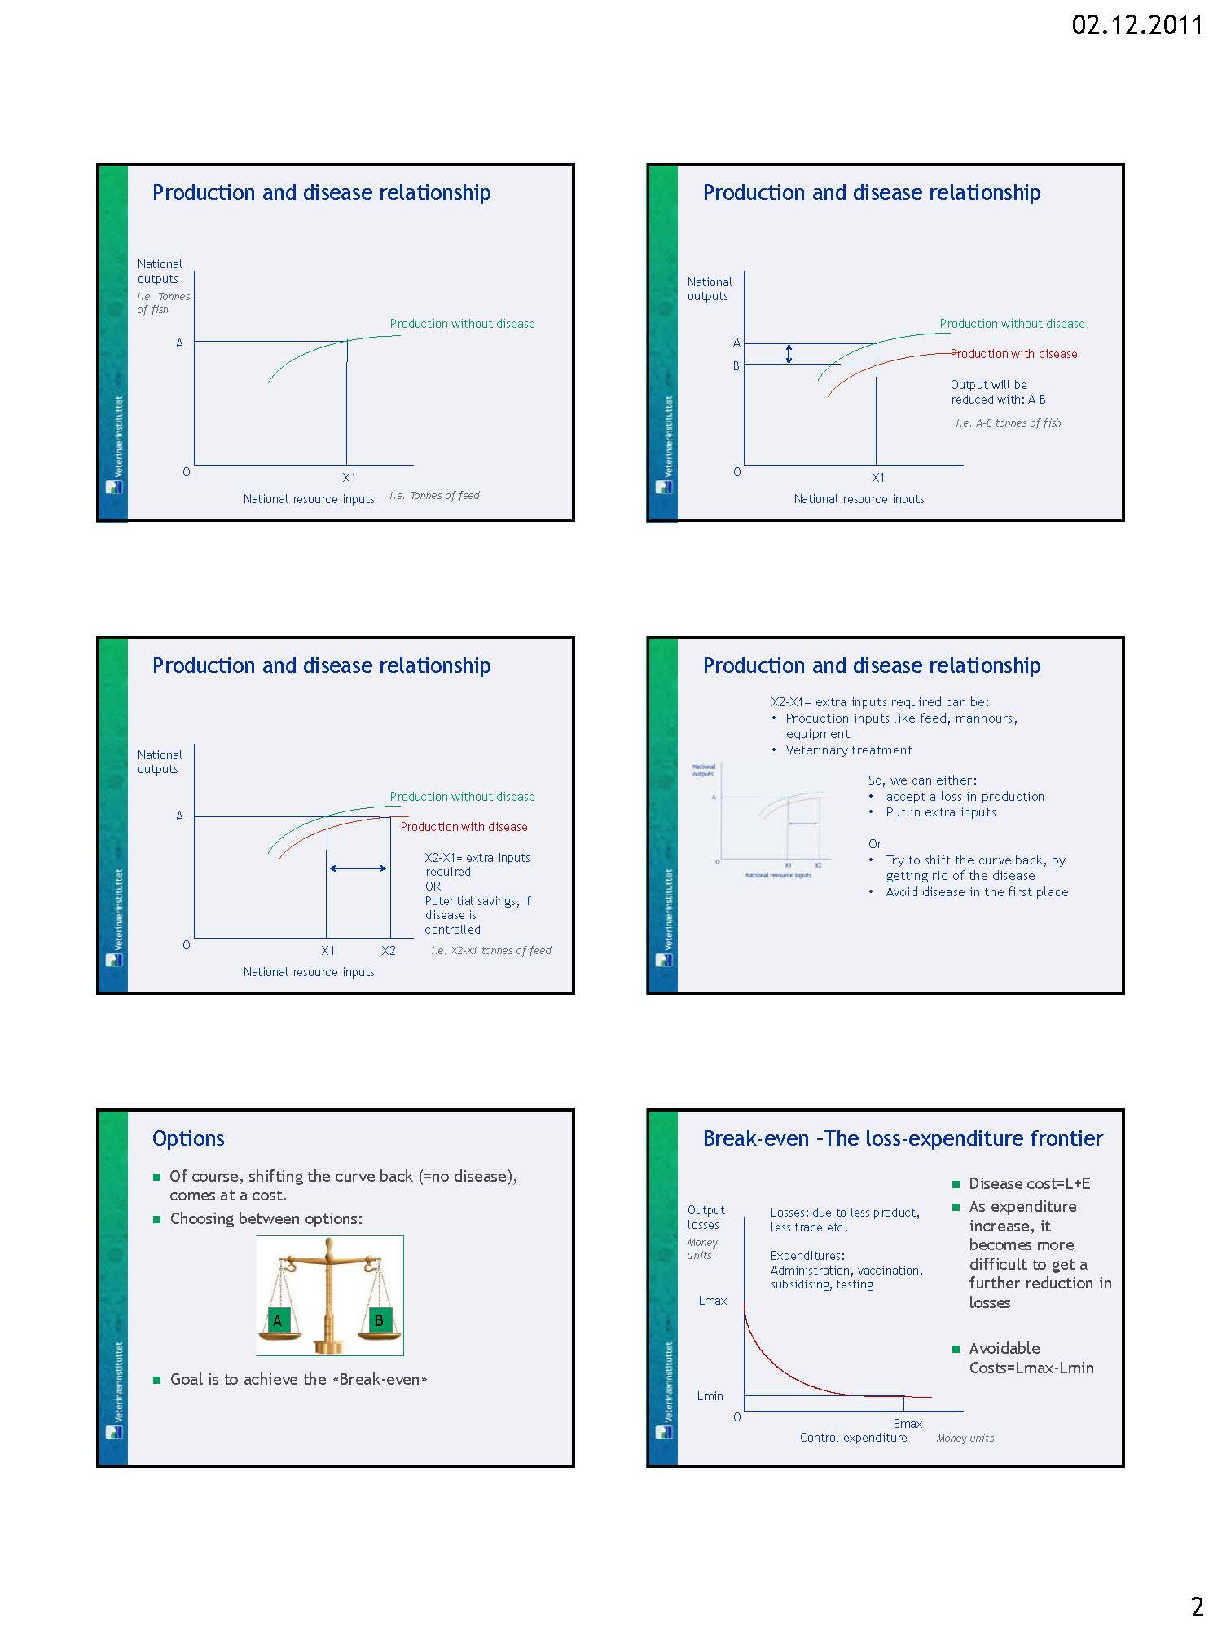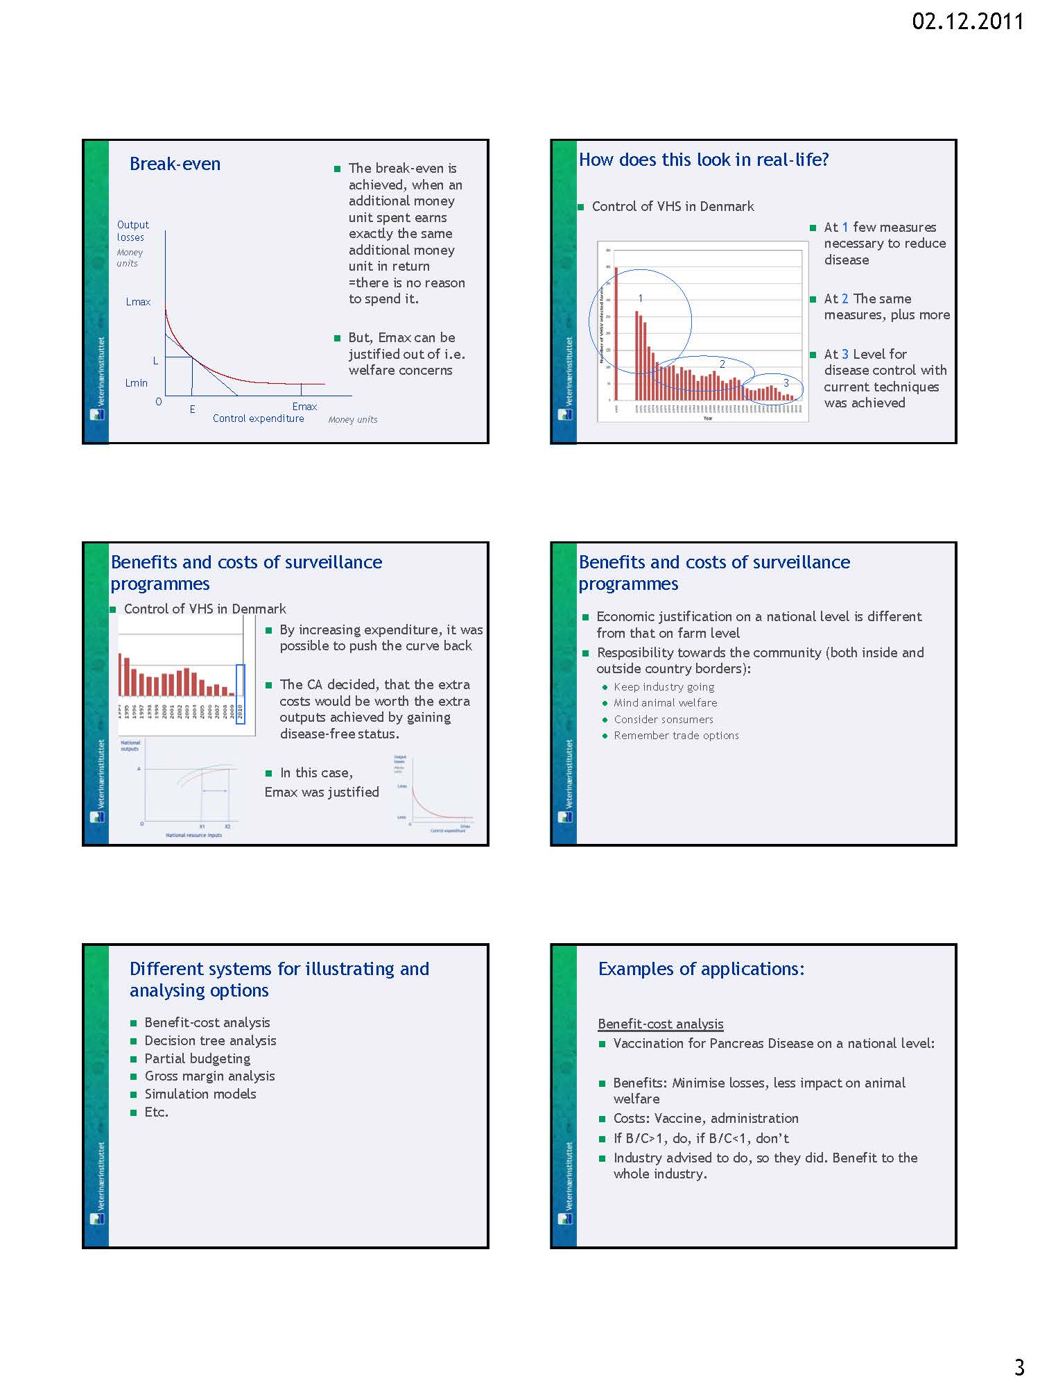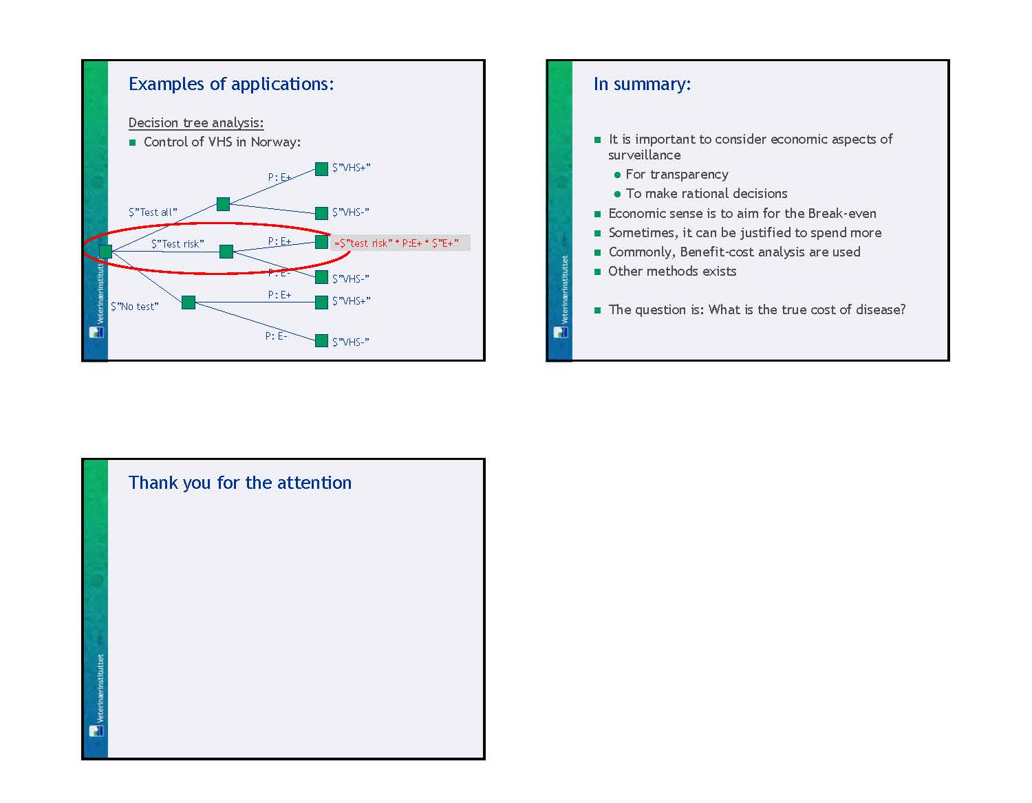

Workshop wrap-up
At the end of the second day, we tried to draw up the “take-home messages” from the workshop, based on the topics that had been discussed most.

These included:

Incentives: It is important to understand the incentives for implementing surveillance, for implementing biosecurity or for developing eradication programs both from farmers, competent authorities and scientists.

Fit for purpose: It is crucial to understand that the appropriate regime including sampling, testing etc., depends on the purpose.

Definition of risk: There are at least two different definitions of risk: Probability of an event occurring or probability of an event is happening combined with the consequences of the event. When talking about and working with risk, it is important to know which definition is being used.

Council Directive 2006/88/EC: Specifically, the directive needs to cover many different animal species, in many different areas and administrative units and with many different types of APBs (intensive, semi-intensive, extensive, large and small scale etc.). Therefore, the Directive is using a more general approach. But the individual Member States are free to modify, as long as they apply to the basic instructions.

Risk based surveillance: Knowledge on risk factors is necessary for design of surveillance systems. Tracing of pathogens / spread of disease are important tools for detecting risk factors, and should be included in modeling of risk factors for surveillance purposes.

Farmer reporting: The inherent systems for reporting could be better used when designing surveillance programs etc. But again, the incentives need to be clear.

Aquatic epidemiology: Aquatic epidemiologists should be involved in fish meetings/issues –this should be recognized by the CA. There is a need for education of aquatic epidemiologists. The OIE collaborating centre can help with that (http://eraaad.ca/)

Evaluation of workshop
In the week immediately after the workshop, an evaluation was carried out, using an e-survey. 30 participants responded (response rate 60%). The questions and answers are presented below.

- Was the information given prior to the workshop appropriate?
Too little | Appropriate | Too much | Total
1 | 26 | 3 | 30
Comments to Q1:
- A short abstract for the talks would have been helpful (but not completely necessary)
- The reading material should have been distributed earlier
- It was very good having documents/scientific papers before the workshop in order to be able to have an idea of the major topics
- Was the program appropriate?
Not at all | Too few topics | Appropriate | Too many topics | Total
0 | 2 | 23 | 5 | 30
Comments to Q2:
- Given the short time of 2 days, it might have been good to focus on a limited number of aspects of epidemiology, or to have longer time.
- I hope it would be the first one of a series of workshop in order to have the possibility to go more in depth or the different topics and to have more time to think about them
- How did the reading material fit with the programme?
Not at all | Bad | Well | Very well | Total
0 | 4 | 18 | 8 | 30
Comments to Q3:
- The background reading was very helpful, and a good amount
- How much did you get out of the group work?

Group | Nothing | A little | Appropriate | A lot | Total
Screening strategies & tracing of pathogens | 0 | 2 | 4 | 3 | 9
Special challenges regarding surveillance in shell & molluscs | 0 | 0 | 1 | 1 | 2
Design of surveillance programmes | 0 | 2 | 3 | 6 | 11
Risk factors and risk categorization | 0 | 3 | 4 | 1 | 8

- How did the workshop live up to your expectations?
Not at all | A little | Appropriate | Better | Much better | Total
0 | 3 | 11 | 11 | 5 | 30
Comments to Q5:
- There could have been more about the diseases and risks concerning a few diseases as examples
- Too short
- It might be good for the next time to give Caraguel and Cameron more time for their parts while the case studies on the second day could be shorter
- This was the first time we have a joint workshop on the topic, so for me it feels natural that both programs and content was a bit "spiky".
- I was hoping for more/longer group work time.
- I loved it / it was very interesting and helpful
- New practical knowledge to be directly implemented
- What was the worst part of the workshop?
- Group work time was much too short and group work organization was a bit chaotic (at least in our group)
- Short duration
- The location
- In the group work sessions we were divided into very small groups but I feel it would have been better to have more time discussing with the whole group work
- The rush presentations, a lots of slides skipped. Not all the presentations were given on paper
- I was forced to attend the workshop on my own support, but it was worth it.
- Too little time for preparing the tasks in the practical part.
- I think it was superbly organized. The worst part was that the EU requires a copy of the boarding pass, which is impossible for us who travel with an electronic
- The end of workshop was the worst part of the workshop.
- In my workgroup there were few people interested and therefore they didn't participate to the discussion
- What was the best part of the workshop?
- In general, I got a good overview over the relevant topics, and I liked that most talks were interactive.
- Opportunities to discuss practical challenges with participants
- Targeted audiences
- The group work (4 respondents)
- Cameron's presentations (5 respondents)
- The talks by the delegates from Switzerland and Germany on their risk ranking
- Dr. Lyngstads presentation (1 respondent)
- Dr. Bang Jensens presentation (2 respondents)
- Dr. Caraguels presentation (2 respondents)
- Do you have any suggestions for future workshops?
- A future workshop should be more focused, longer (4 days), fewer presenters, more consistent and in depth treatment of the topics. Based on most of the participants' apparent level of experience, a 'training workshop' rather than 'workshop' would be more useful (4 respondents)
- More time for group work / more time for discussion
- An element of future workshops should be to review the exchange of communications / improvements member states have made since previous workshops - the workshops should continue to be about networking and dialogue as well as elements of training in tools of epidemiology
- It would be useful to have a rotation of the participants to all the working groups. It was hard to choose (2 respondents)
- More focus to each member states specific problems
- It would be good to have more time spent discussing solutions rather than just problems, so people could gain ideas to implement in their countries
- Perhaps is better to give more time reserved to presenters and presentations and also it will be nice to have all the presentation on paper
- More practical training concerning fish farming and factors affecting early detection of diseases. To learn how to motivate fish farmers and competent authority to make inspections in practice. Field courses arranged in different part of EU regarding type of fish farming practices.
- In future workshops, there should be three topics: Educational (basic epidemiology and statistics), an important focus area (whatever is important in the EU at the moment), good examples of solutions or approaches
- A continuation to this one would be great
- Better selection of participants
- Do you have any other feedback you would like to share?
- The workshop was very well organized and planned. (4 respondents)
- My overall impression is good and I thank for the invitation and the opportunity that I have heard some interesting lectures and I have met colleagues and also some new scientists in this field.
- The workshop offered a good introduction into a complex and broad field.
- I think that every Institute who deals with aquaculture should give a name of an epidemiologist who should take part to these workshops. Then a mailing list could be created.
- Keep up the good work. Thank you for your hospitality (2 respondents)
- Nice workshop, but not much new for me personally. I was surprised there were so many with very much experience. I think the workshop was planned for people that have little experience or have just started working in this field.
- Venue was good - nice refreshments and lunches. Coming from a non-aquatics background, I found the delegates very friendly and welcoming, and it was a great opportunity to get to know a few people working in an area in which I am becoming increasingly involved in.

References
Cameron, A. (2002) Survey Toolbox for Aquatic Animal Diseases. A Practical Manual and Software Package. Recommended reading: P.61-66 of chapter 4 & entire chapter 5. Link: http://www.ausvet.com.au/resources/AquaToolbox.pdf (Background for the presentation: “Basic concepts in sampling and testing for aquatic diseases)

Commission Decision 2008/896/EC of 20 November 2008 on guidelines for the purpose of the risk-based animal health surveillance schemes provided for in Council Directive 2006/88/EC. Official Journal of the European Union, 322, 30-38 (Background for presentations and groupwork on risk categorization)

Council Directive 2006/88/EC of 24 October 2006 on animal health requirements for aquaculture animals and products thereof, and on the prevention and control of certain diseases in aquatic animals, Official Journal of the European Union, 328 (2006), 14-56. Recommended reading: Chapter II, V, VI and annex III. 38 (Background for presentations and groupwork on risk categorization)

Oidtmann, BC, Crane, CN, Thrush, MA, Hill, BJ, Peeler, EJ (2011) Ranking freshwater fish farms for the risk of pathogen introduction and spread. Preventive Veterinary Medicine, 102, 329-340. (Especially for the group: Risk factors and risk categorization)

Stentiford, GD, Bonami, J-R, Alday-Sanz, V (2009) A critical review of susceptibility of crustaceans to Taura syndrome, Yellowhead disease and White Spot Disease and implications of inclusion of these diseases in European legislation. Aquaculture, 291, 1-17 (Especially for the group: Special challenges regarding surveillance in shellfish and molluscs)

Stentiford, GD, Oidtmann, B, Scott, A, Peeler, EJ (2010) Crustacean diseases in European legislation: Implications for importing and exporting nations. Aquaculture, 306, 27-34 (Especially for the group: Special challenges regarding surveillance in shellfish and molluscs)

Stärk, KDC, Regula, G, Hernandez, J, Knopf, L, Fuchs,K, Morris, RS, Davies,P (2006) Concepts for risk-based surveillance in the field of veterinary medicine and veterinary public health: Review of current approaches. BMC Health Services Research, 6,20 (Supplement for presentations and groupwork on surveillance)

Closing remarks
Since the implementation of the Council Directive 2006/88/EC with new demands concerning authorisation, health categorisation and risk based surveillance in aquatic animal production units, a significant need for upgrading knowledge and harmonisation has been recognised by the EU Reference Laboratories for aquatic animals. The opportunity arose when the OIE collaborating centre for Aquatic Epidemiology and Risk Assessment was established offering superb knowledge and teaching opportunities. Thus with the sustaining of the European Commission, the EURL fish was, in collaboration with the OIE reference laboratory, given the chance to organise this workshop in epidemiology and risk assessment. It was apparent, however, that the number of topics to be covered was very large in relation to the time given. Thus the workshop should rather be recognised as an introduction to the field rather than a full training course. The comprehensive teaching material distributed prior to the workshop together with all the presentations given in the report should provide the participants with sufficient knowledge and inspiration to implement risk based surveillance schemes in their home country, as most participant were selected based on their working areas, skills and field of interests.
Hopefully this workshop is the first of a series of courses in epidemiology and risk assessment in aquatic animals that will provide a strong scientific background for expanding epidemiology in aquatic animals in Europe.
The European Union Commission is acknowledged for their generous financial contribution and technical support to the workshop. DTU-Vet for offering their excellent facilities for teaching, group work, coffee and lunch breaks for free.
Secretary Eva Haarup Sørensen, DTU-Vet is deeply acknowledged for her excellent, kind and enthusiastic technical organisation of the workshop taking care of venue, registration, folders, all financial issues and questions, etc.etc.
All speakers are thanked for their very comprehensive and excellent presentations.
And finally but not least Dr. Britt Bang Jensen, NVI, for her very competent and efficient organisation of this workshop including the program, contacts with all speakers, report writing etc. and for keeping us all busy and in time for the workshop.

Aarhus, 10.01.2012
Niels Jørgen Olesen
EURL Fish Diseases

